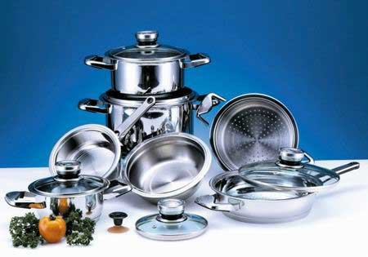

Термінологічний ілюстрований словник з англійської мови
для кухарів

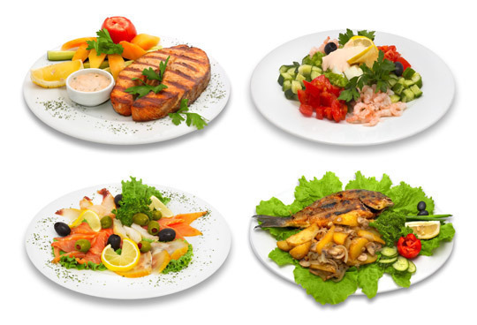

ДЕРЖАВНИЙ ПРОФЕСІЙНО-ТЕХНІЧНИЙ НАВЧАЛЬНИЙ ЗАКЛАД
НІКОПОЛЬСЬКІЙ ЦЕНТР ПРОФЕСІЙНОЇ ОСВІТИ

Лисенко М.М.

Термінологічний ілюстрований
словник з англійської мови
для кухарів

Нікополь
2014
Термінологічний ілюстрованийсловник з англійської мовидля кухарів. – Нікополь: НЦПО, 2014., 178с.

Словник розрахований на широке коло користувачів: учнів та викладачів профтехосвіти, а також усіх, хто вивчає англійську мову. Всі терміни проілюстровані, що дозволяє краще вивчити та зрозуміти значення слова.
Словник побудований на основі сучасної лексики англійської та української мов, містить понад 700 слів і словосполучень. Дібрані до термінів ілюстрації сприятимутьуспішному оволодінню англійською мовою та формуванню професійних навичок кухарів, розвитку інтелектуальних здібностей.

Упорядник:
Лисенко М.М.

Рецензент - ЕсаулкоО.О. - заст. директора з НР НЦПО

Відповідальний редактор - Клопінська І.О.-методист НЦПО

Зміст
ЇЖА –FOOD……………………………………………………………....7
Овочі –Vegetables……………………………………………………………..…..8
Цибулеві овочі - Bulb vegetables…………………………………………….9
Бульбоплідні овочі - Tuber vegetables……………………………………..11
Салатно-шпинатні овочі - Stalk vegetables………………………………..13
Капустяні овочі - Leaf vegetables…………………………………………..15
Плодові овочі - Fruitvegetables……………………………………………18
Коренеплоди - Rootvegetables…………………………………………….22
Гриби–Mushrooms………………………………………………………...25
Бобові –Legumes……………………………………………………………28
Фрукти –Fruits…………………………………………………………………..32
Кісточкові фрукти - Stonefruits…………………………………………...33
Ягоди - Berries……………………………………………………………...35
Сухофрукти - Dryfruits…………………………………………………….37
Цитрусові фрукти - Citrusfruits…………………………………………..40
Тропічні фрукти - Tropical fruits…………………………………..………42
Дині –Melons………………………………………………………………..46
Спеції –Spices…………………………………………………………………….48
Приправи – Сondiments………………………………………………………...52
Трави –Herbs…………………………………………………………………….56
Крупи–Cereal……………………………………………………………………59
Зернові продукти - Сereal products……………………………………………62
Борошно та манна крупа - Flour and semolina……………………………63
Хлібні вироби –Bread……………………………………………………....65
Макароні вироби –Рasta…………………………………………………...69
Азіатськалокшина- Asian noodles………………………………………...72
Рис –Rice…………………………………………………………………….74
Кава та чай - Coffeeandtea…………………………………………………...76
Шоколад – Сhocolate……………………………………………………………78
Цукор –Sugar……………………………………………………………………80
Жири та олії - Fats and oils……………………………………………………..82
Молочні продукти - Dairy products…………………………………………...84
М'ясо - Meat……………………………………………………………………...88
Різновиди мяса -Variety meat…………………………………………….88
Дичина–Game…………………………………………………………….90
М'ясо свійської птиці – Poultry…………………………………………...92
Різновиди шматків м’яса – Varietycutsofmeet…………………………94
Яйця – Eggs……………………………………………………………………….97
Делікатеси – Delicatessen………………………………………………………...99
Молюски – Mollusks…………………………………………………………….102
Ракоподібні – Crustaceans……………………………………………………...105
Хрящові риби – Cartilaginousfishes…………………………………………..107
Кісткові риби -Bonyfishes……………………………………………………..109

КУХНЯ –KITCHEN………………………………………………….115
Вироби зі скла – Glassware…………………………………………………...116
Посуд - Dinnerware……………………………………………………………119
Столове срібло – Silverware…………………………………………………..123
Кухонний посуд – Kitchenutensils…………………………………………..126
Різновиди кухонних ножів - Examples ofkitchen knives……………...127
Інструменти для відкриття - For opening……………………………….130
Посуд для шліфування і натирання –Forgrindingandgrating………..132
Посуд для вимірювання – Formeasuring……………………………….134
Посуд для проціджування та сушіння – Forstraininganddraining…..137
Посуд для випічки - Baking untensils……………………………………139
Різний посуд – Miscellaneous utensils……………………………………143
Кухонне приладдя - Cookingutensils………………………………………..146
Предмети домашнього вжитку – Domesticappliances…………………….149
Алфавітний покажчик………………………………………………………..154
Додатки………………………………………………………………………….164
Використана література………………………………………………………178

FOOD
ЇЖА
Humans eat a wide variety of foodstuffs derived directly or indirectly from vegetable or animal sources.

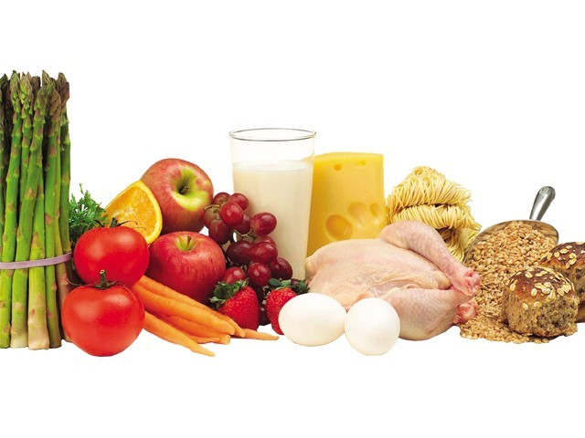

Vegetables
Овочі
Plants used as foodstuffs; a simple way to classify vegetables is to group them according to their edible part. The sweet fruit category of plants constitutes another food category (fruits).

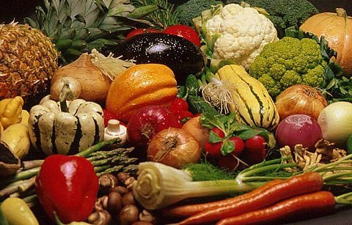

Bulb vegetables
Цибулеві овочі
The main edible part of these vegetables is their bulb, the underground structure where the plant’s nutrient reserves are stored.

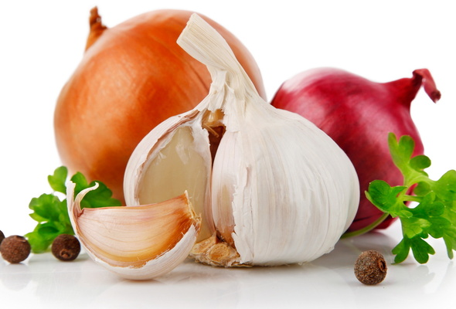

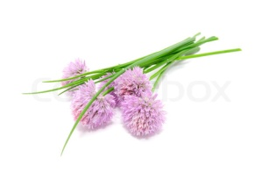 | chive []- шніт-цибуля  Smallest member of the onion family; its stem is used primarily to season various hot and cold dishes.
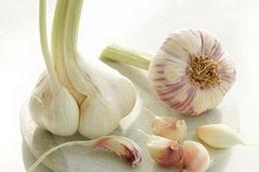 | garlic []- часник  The bulb is composed of bulblets called cloves; the germ at its center can make garlic difficult to digest.
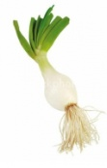 | green onion[] - зелена цибуля  Mild onion picked before fully ripe; it is usually sold with the stem, in bunches. It is often eaten raw in salads or cooked in sautéed dishes.
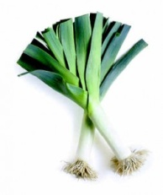 | leek []- цибуля-порей  The white part is the most popular, but the green part adds flavor to puréed soups and stews; it is often combined with potatoes in a cold soup called vichyssoise.
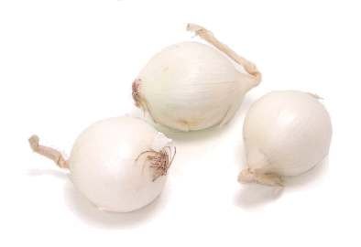 | pearl onion[] –біла цибуля  Small white onion picked before fully ripe; it is primarily used to make pickles or as an ingredient in stews such as boeuf bourguignon.
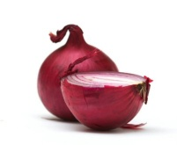 | red onion []- червона цибуля  The sweetest of the onions, it is often eaten raw, in salads or sandwiches.
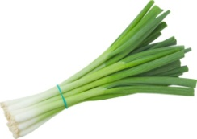 | scallion[]- цибуля-шалот  Its bulb is less developed than that of the green onion; the white part is used like the onion and the green is used to season a variety of dishes.
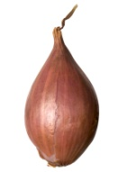 | shallot []- цибуля-шалот  It has a more subtle flavor than the onion or the chive; it is eaten raw or cooked and often used as a flavoring ingredient in sauces.
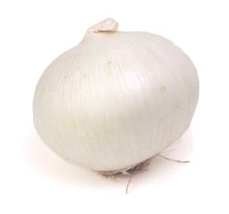 | white onion[]- біла цибуля  Mild and sweet, this onion is widely used as a flavoring ingredient; it is often eaten raw or deep-fried in rings.
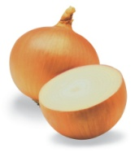 | yellow onion []- жовта цибуля  The most common onion, widely used as a flavoring ingredient, either raw or cooked; it is also the essential ingredient in onion soup.
Tuber vegetables
Бульбоплідні овочі
Tubers that are eaten like vegetables; they consist of underground growths containing the plant’s nutrient reserves.

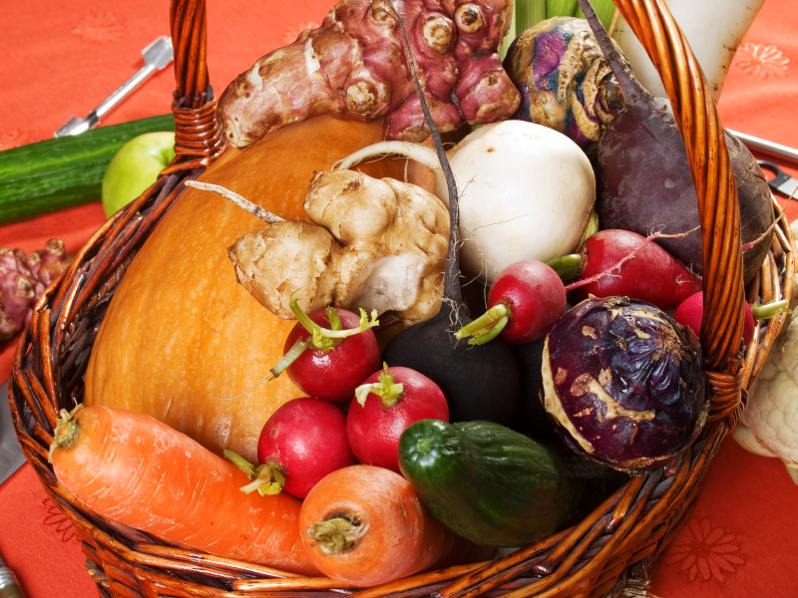

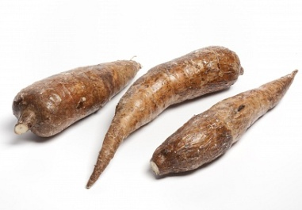 | cassava []- маніока  The sweet variety is eaten like the potato; the bitter one is used to make tapioca.
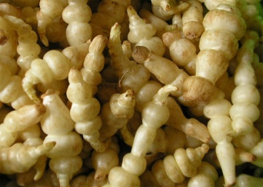 | crosne - кросне  Native to Asia, where it is very popular although little known elsewhere; it has a slightly sweet flavor and is used and prepared like the potato.
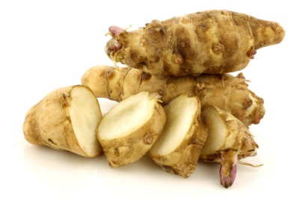 | Jerusalem artichoke[] - топінамбур  Eaten raw, cooked or marinated; it has sweet, crunchy, juicy flesh.
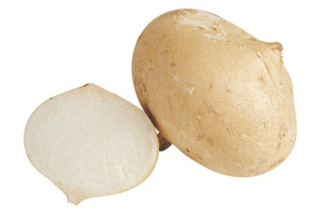 | jicama - хікама  Its flesh is sweet, crunchy and juicy; it is eaten raw in salads, as an hors d’oeuvre or with dips; it adds a crunchy element to cooked dishes.
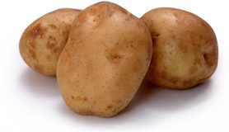 | potato []- картопля  The best-known tuber; eaten especially as a vegetable side dish, either steamed, deep-fried or mashed.
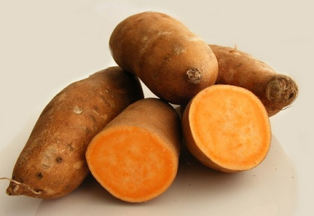 | sweet potato[]- солодка картопля  Sweeter than the potato and not of the same family; a staple of Creole cooking.
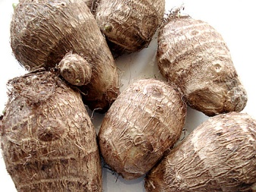 | taro []- таро  Its starchy, sweet flesh is a staple in several tropical countries; eaten raw, preferably very hot and prepared like the potato.
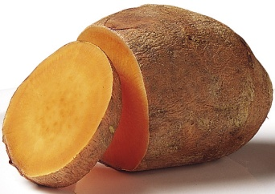 | yam - ямс  A staple food in many countries, especially in South America and the West Indies, where it is eaten cooked, prepared like the potato.
Stalk vegetables
Салатно-шпинатні овочі
Edible plants whose stems are consumed like vegetables; the leaves of some varieties are also edible.

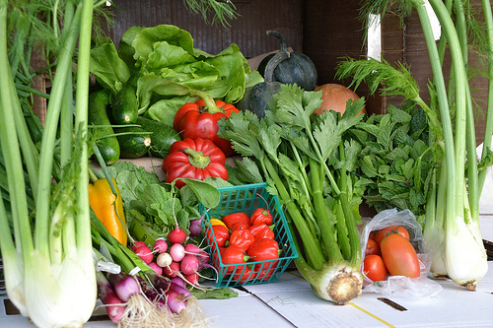

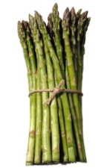 | asparagus []- спаржа  Often thought of as a luxury, it is picked before fully ripe; whether served hot or cold, it is always cooked.
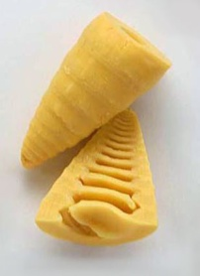 | bamboo shoot [] - бамбук  Very popular in Asia, this plant can only be eaten once cooked; it is an essential ingredient in sukiyaki, a typical Japanese dish.
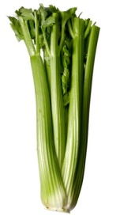 | celery[] - селера  One of the best-known and most popular stalk vegetables, it is often served raw with dips; the leaves and seeds are used to season a variety of dishes.
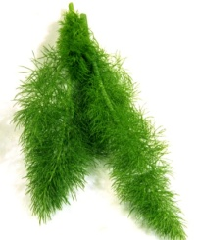 | fennel[] - кріп  Mainly associated with Italian cooking; the bulb is eaten as a vegetable while the leaves and seeds are used to season a variety of dishes.
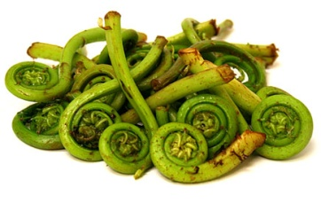 | fiddlehead fern []– паростки папороті  When coiled, this young shoot is ready to eat; it is especially popular in salads, pasta dishes and omelettes.
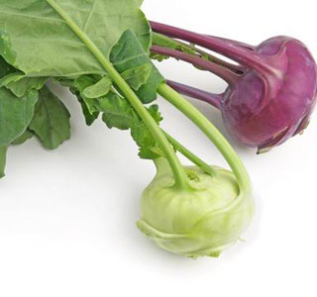 | kohlrabi []- кольрабі  Very popular in Central and Eastern Europe, where its bulbous stem is eaten raw or cooked like turnip; its cabbage-flavored leaves can also be eaten.
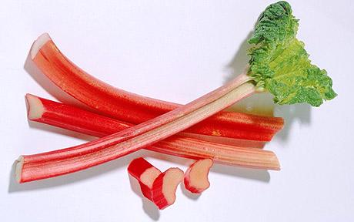 | rhubarb []- ревінь  The stems are eaten like fruit: raw, dipped in sugar or salt, or made into a compote.
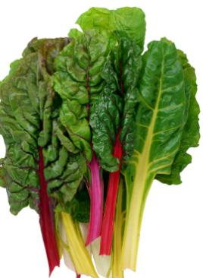 | Swiss chard []– Мангольд, листовий буряк  A member of the beet family, grown for its ribs, prepared like celery or asparagus, and for its leaves, often said to resemble spinach.
Leaf vegetables
Капустяні овочі
Leaves of edible plants consumed as vegetables.

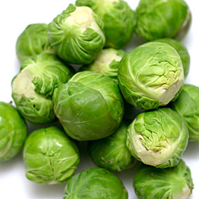

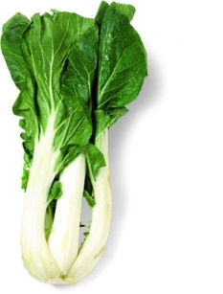 | bok choy - китайська капуста  The stems of this Chinese cabbage are juicy and crunchy; it is served in soups, with rice and in many Chinese dishes.
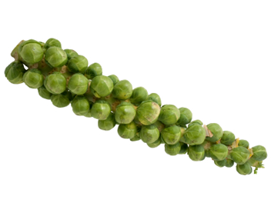 | Brussels sprouts []- Брюссельська капуста  The smallest member of the cabbage family is only eaten cooked and whole as a vegetable side dish.
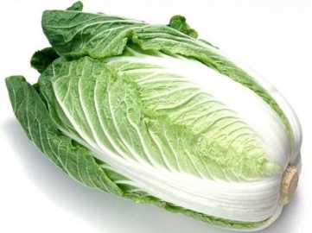 | celery cabbage []- пекінська капуста  A crunchy refreshing Chinese cabbage, mostly eaten cooked.
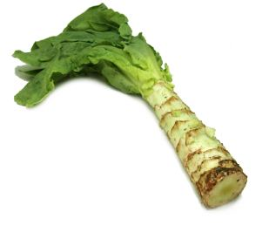 | celtuce - гібридселерита салату  A celerylike vegetable that is derived from lettuce; it combines the flavors of celery and lettuce.
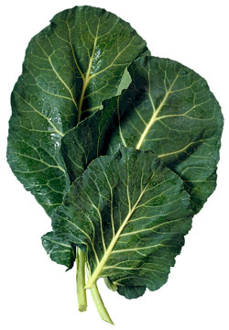 | collards - капуста  It has thick, strongly flavored leaves and tough central ribs; it is eaten like spinach, either raw or cooked.
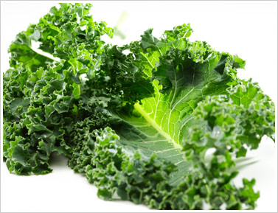 | curled kale [] – капуста кормова  Its very curly, stringy tough leaves have a strong flavor; it is almost always eaten cooked.
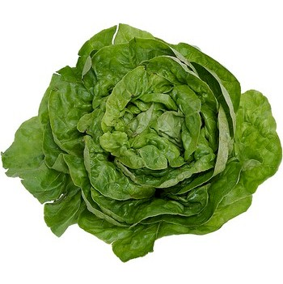 | escarole [] - ескаріоль  Its leaves are less bitter than those of the curled endive, to which it is related; it is usually eaten raw, in salads.
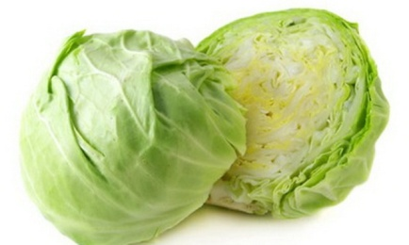 | green cabbage []–капуста білокачанна  When finely chopped, it is the main ingredient in coleslaw; it is also added to soups and stews.
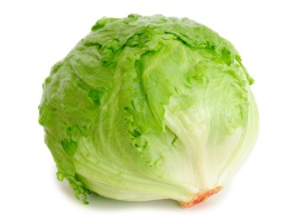 | iceberg lettuce [] – качанний салат  The most widely sold lettuce in North America, it was initially covered with ice during transport, hence its name.
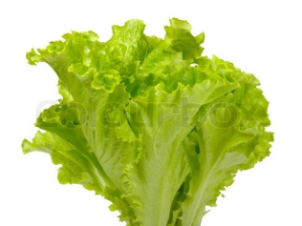 | lettuce []– салат-латук  Lettuce having soft wavy leaves with curly edges; like most types of lettuce, it is usually eaten raw, in salads or sandwiches.
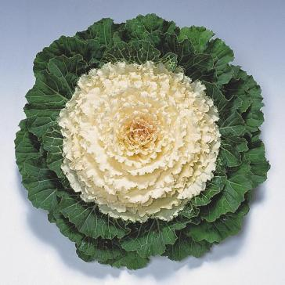 | ornamental kale []- декоративна капуста  Related to the curled kale; its differently colored leaves are added to salads, soups and rice, or used to garnish serving platters.
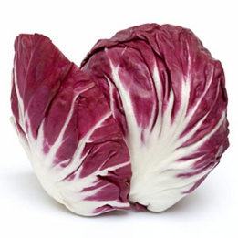 | radicchio - радіккіо  Red endive native to northern Italy and having a somewhat bitter taste; it is often served with other types of lettuce.
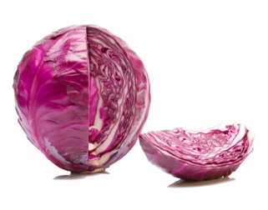 | red cabbage [] - капуста червонокачанна  Milder-tasting than other cabbages, it is usually eaten raw and finely chopped in salads.
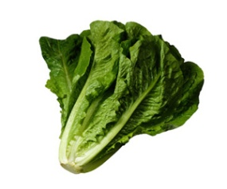 | romaine lettuce [] – салат ромен  Lettuce with firm crisp leaves used especially to make Caesar salad.
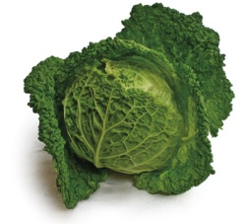 | savoy cabbage []- савойська капуста  Cabbage with somewhat flexible leaves, making it well suited to preparing cabbage rolls.
Fruitvegetables
Плодові овочі
Fruits of edible plants consumed as vegetables.

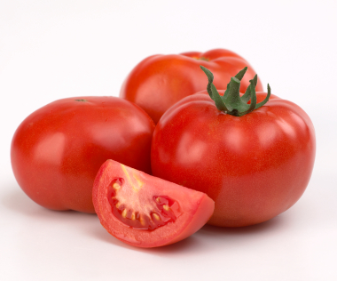

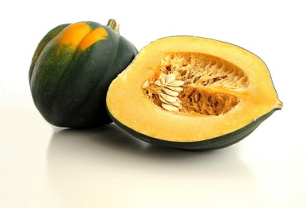 | acorn squash [] - гарбуз великий столовий  Its smooth hard skin turns orange when fully ripe; the delicate, slightly fibrous flesh tastes of pepper and hazelnuts.
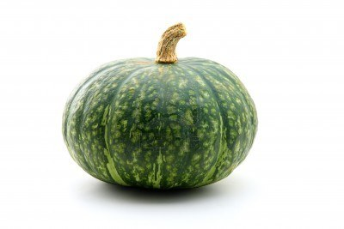 | autumn squash []- гарбуз  The rind can be yellow, orange or green; often confused with the pumpkin, it can be recognized by its pedicel, which is soft and enlarged where it attaches to the vegetable.
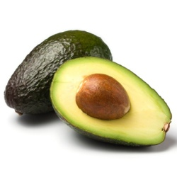 | avocado []- авакадо  Fruit of the avocado tree; its smooth greenish flesh is eaten raw, in salads or mashed.
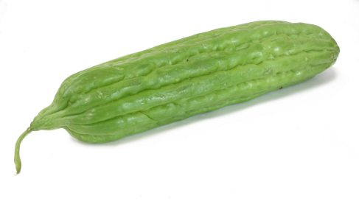 | bitter melon [] – гірька диня  Too bitter to be eaten raw, it is an ingredient in various kinds of Asian cooking, such as soups or steamed dishes.
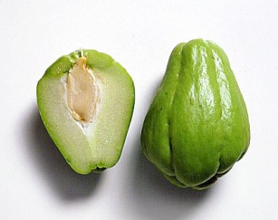 | chayote - чаоте  This squash, grown mainly in tropical countries, is used in Creole cooking; the central stone can be eaten once cooked.
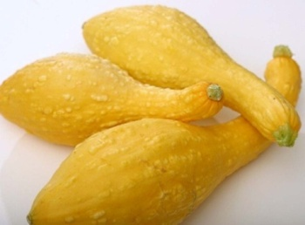 | crookneck squash []- неправильний гарбуз  The soft edible rind is covered in small ridges; best if picked very early, it can be eaten raw or cooked.
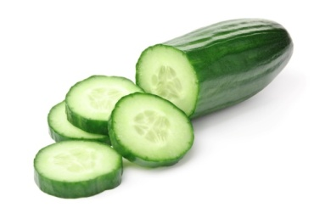 | cucumber []- огірок  Related to squash and melons, it bears seeds and is usually eaten raw.
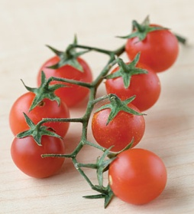 | currant tomato [] – смородинові помідори  Very flavorful tomato characterized by its sweetness and long shelf life.
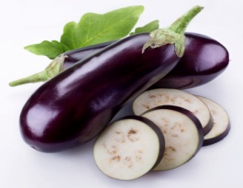 | eggplant []- баклажан  Yellowish and spongy-fleshed vegetable that is sometimes sweated with salt to alleviate its bitter taste.
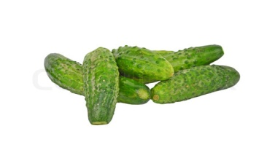 | gherkin []- корнішон  Picked when not yet ripe, it is often pickled in vinegar and eaten as a condiment; it is also served raw in salads.
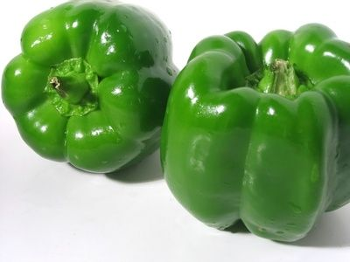 | green sweet pepper []- зелений солодкий перець  Mild pepper picked before fully ripe, it is used in many typical Mexican and Portuguese dishes.
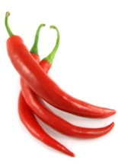 | hot pepper []- гострий перець  Cutting it or removing the seeds moderates its spicy burning taste.
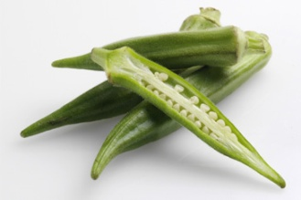 | okra []- окра  Vegetable containing a substance used to thicken soups and ragouts, it is used in many Creole dishes.
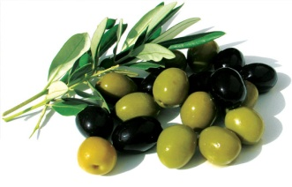 | olive []- оливка  Inedible when raw, the olive is treated to reduce its bitter taste, then cured in brine or sometimes in oil.
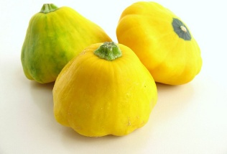 | pattypan squash[] -патисон  When very ripe the flesh turns hard and white; its firm flesh has a flavor similar to the artichoke.
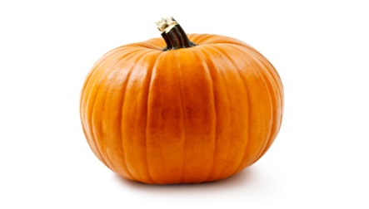 | pumpkin []- гарбуз  Used primarily in North America, it can be recognized by its hard fibrous pedicel; its flesh is widely used in soups and desserts and its edible seeds are dried.
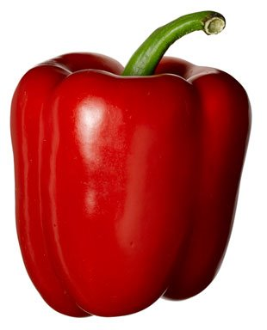 | red sweet pepper []- червоний солодкий перець  Mild pepper picked when ripe, it is very sweet and has a higher vitamin C content than the green sweet pepper.
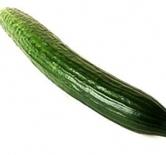 | seedless cucumber []- огірки без насіння  European variety grown exclusively in greenhouses without fertilization.
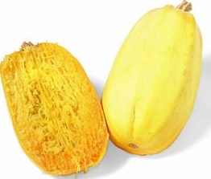 | spaghetti squash [] – спагеті гарбуз  Derives its name from its cooked flesh, resembling spaghetti, which it can replace in most recipes.
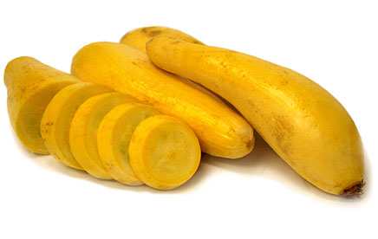 | straightneck squash[] – прямий гарбуз  The result of genetically altering the crookneck squash to eliminate the thin crooked neck; it is eaten raw or cooked.
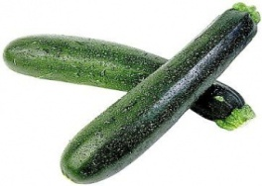 | summer squash []- літній гарбуз  Picked when ripe, the seeds are removed and the flesh eaten raw or cooked; it bears edible flowers.
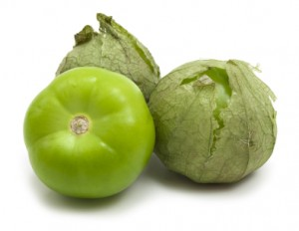 | tomatillo - томата  Picked when green, this berry is used to make sauces and is an essential ingredient in many Mexican dishes.
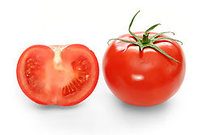 | tomato []- помідор  Native to Central America, this fruit is essential to Italian, Provençal, Greek and Spanish cooking.
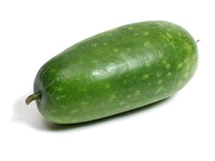 | wax gourd []– восково-пляшковий гарбуз  Its firm flavorful flesh is often used in puréed soups or spicy dishes.
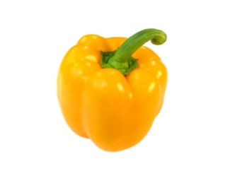 | yellow sweet pepper [] -жовтий солодкий перець  Mild pepper picked when ripe, it is strongly scented and has a sweet taste; it is often used in salads.
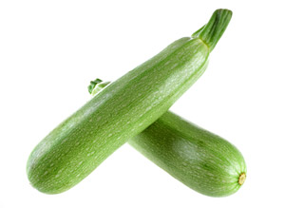 | zucchini - цукіні  Small white-fleshed squash picked before fully ripe; it is an essential ingredient in ratatouille.
Rootvegetables
Коренеплоди
The fleshy roots of edible plants consumed as vegetables.

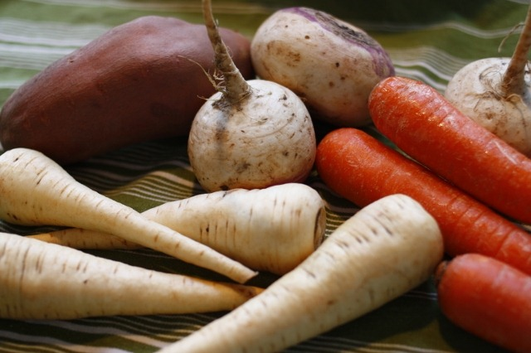

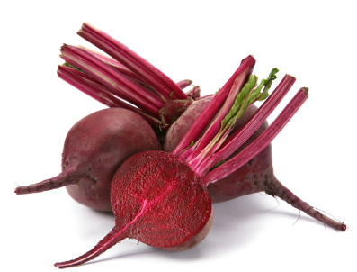 | beet []- буряк  Its usually red flesh contains a juice that stains readily; it is eaten raw, pickled or cooked, most famously in borscht, a hearty soup from Eastern Europe.
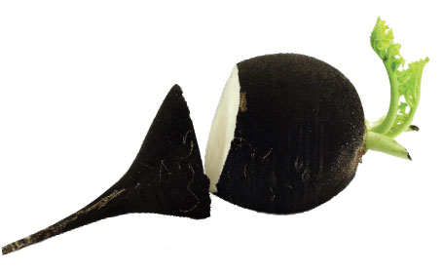 | black radish []- чорна редька  Popular in Eastern Europe, although less juicy than the red radish; it can be cooked or sweated with salt to alleviate its bitter taste.
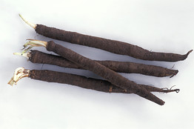 | black salsify[] - чорні козельці  Closely related to salsify, its cream-colored flesh is less stringy and more flavorful; it is an ingredient in dishes such as soups and ragouts.
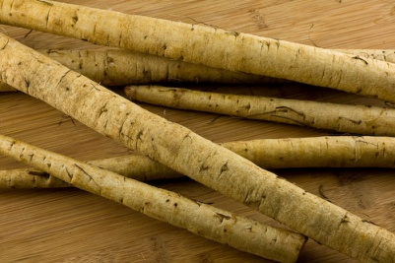 | burdock [] - лопух  Root of a plant harvested before the floral stem develops; it is used as a vegetable or as a flavoring ingredient.
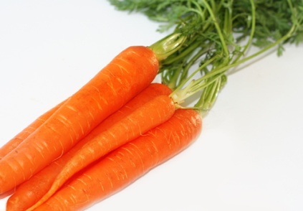 | carrot[]- морква  Eaten in a variety of ways: plain, in salads, in deserts, as a vegetable side dish or a juice.
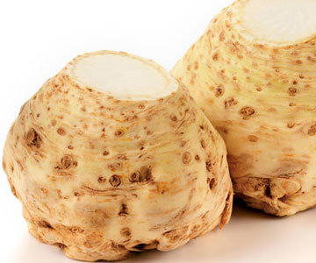 | celeriac [] - корінь селери  A slightly spicy kind of celery; the raw vegetable, combined with mustard mayonnaise, becomes the classic celeriac remoulade.
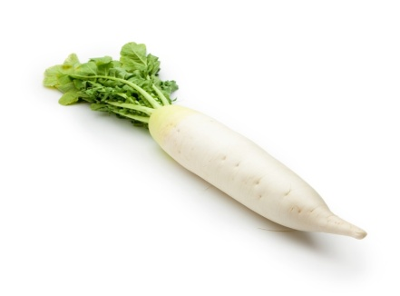 | daikon - дайкон  Its somewhat mild-tasting flesh, leaves and sprouted seeds are prepared in various ways; in Japan, it is served with sashimi.
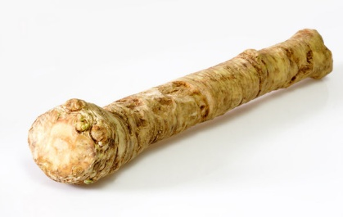 | horseradish []- хрін  Often used as a flavoring ingredient, especially in sauces; its strong flavor becomes milder when mixed with cream or mayonnaise.
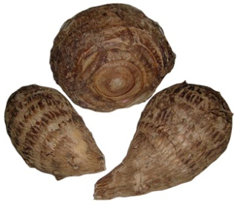 | malanga - маланга  A staple in the West Indies, where it is grated and used to make fried doughnuts called acras; its strong taste hints of hazelnuts.
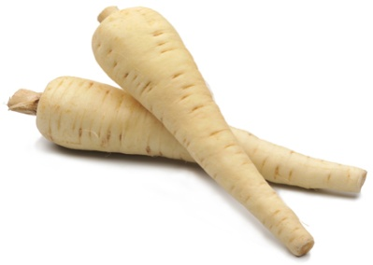 | parsnip []- пастернак  The yellowish flesh of this little-known vegetable has a slightly nutty taste and a texture similar to the turnip; it can be eaten raw or cooked.
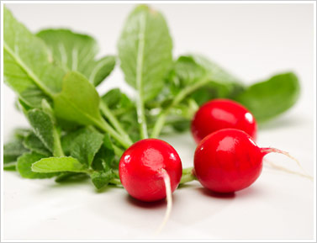 | radish [] - редіс  Juicy and crunchy, it is eaten raw, as an hors d’oeuvre or in salads; it is also popular served cooked or pickled, especially in Asia.
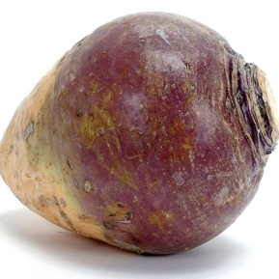 | rutabaga[]- бруква  Larger and stronger-tasting than the turnip, it can be recognized by its usually yellow flesh and by the bump on its top.
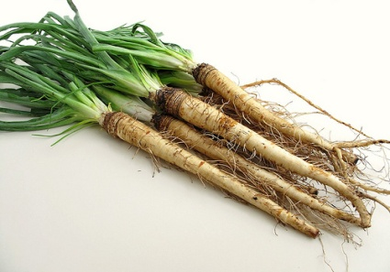 | salsify[]- козельці  Its sweet mild flavor is often said to resemble the oyster’s; its young leaves are also edible.
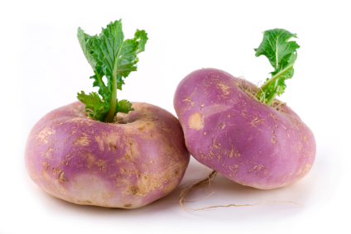 | turnip []- ріпа  Often confused with the rutabaga, this white-fleshed vegetable is eaten raw or cooked and prepared like carrots.
Mushrooms
Гриби
Vegetable that grows in damp cool places; its edible varieties are served as condiments or as an ingredient in a variety of foods.

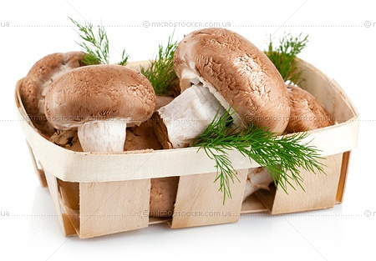

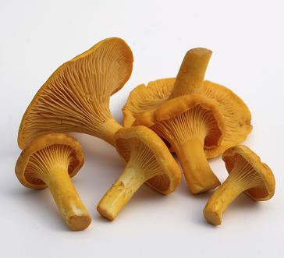 | chanterelle [] – лисичка справжня  Pleasantly fragrant and valued by gourmets, especially those in Europe; it is served most often with meat or omelettes.
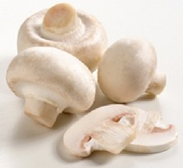 | cultivated mushroom[]- печериці  The most widely cultivated and consumed mushroom; it is eaten raw, in salads or with dips, or cooked, primarily in sauces and on pizza.
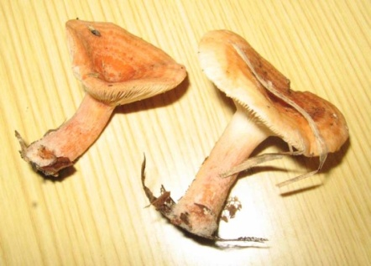 | delicious lactarius [] - смачні грузді  Secretes an orange milk when broken open; it is used primarily in spicy sauces, especially in Spain and the south of France.
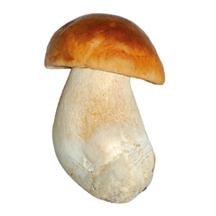 | edible boletus []- білий гриб  Squat, it can grow up to 10 in in height and diameter; it is usually cooked in oil, braised or served in an omelette.
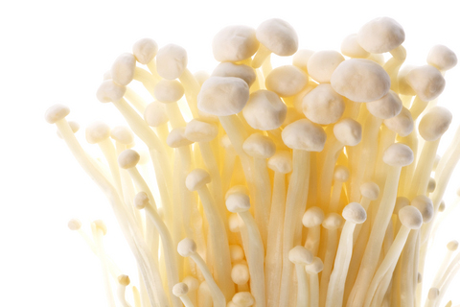 | enoki mushroom []- гриб енокі  Long-stemmed, soft-fleshed resistant mushroom very popular in Asia; it is eaten raw, in salads, or cooked, in soups and Oriental dishes.
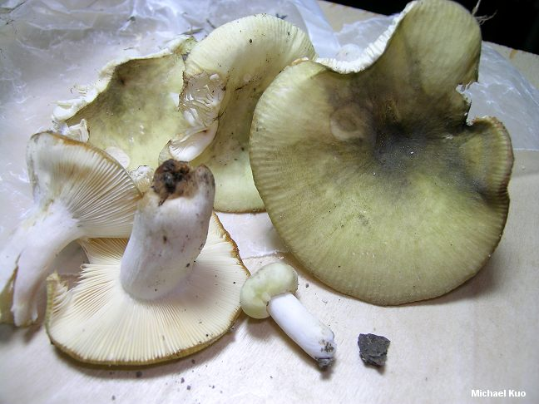 | green russula []- зелені сироїжки  Its white brittle flesh has an aroma of hazelnut; it can be eaten raw or cooked, preferably grilled.
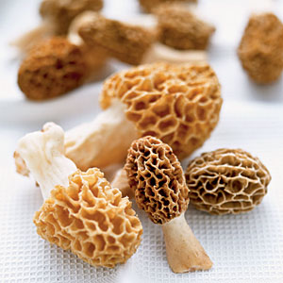 | morel []- зморшки  The darker the specimen, the more flavorful its thin fragrant flesh; it should be thoroughly cooked to eliminate toxic substances.
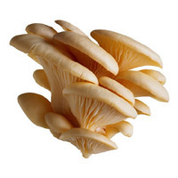 | oyster mushroom []- гливи  Grows on trees or on dead wood; its soft white flesh is a valued ingredient in sauces, where it can substitute for the cultivated mushroom.
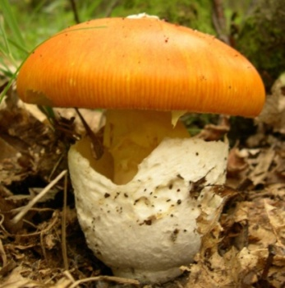 | royal agaric []- королевський гриб  Equally flavorful raw or cooked, it has been famous since ancient times; it is not to be confused with the poisonous fly agaric, which it resembles.
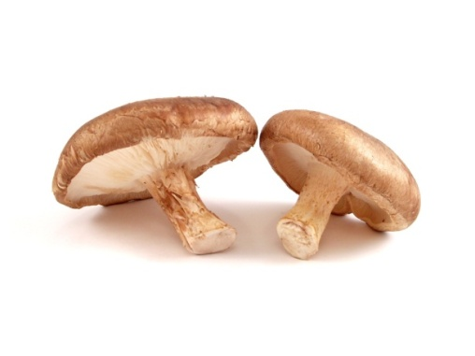 | shiitake mushroom []- шиитаке  The equivalent of the cultivated mushroom in Japan, where it is widely grown for use in Oriental dishes and sauces and for its therapeutic value.
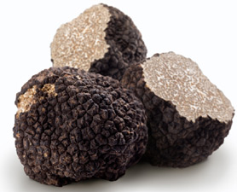 | truffle []- трюфель  Underground mushroom hard to find and perceived as a luxury food; it is usually associated with game and poultry.
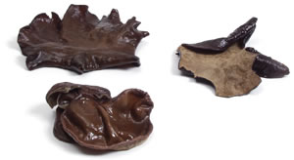 | wood ear [] - вухо дерева  Its tasteless gelatinous flesh is popular in Asia; it is usually eaten in soups or with vegetables.
Legumes
Бобові
The main edible part of these pod-shaped fruits is their seeds, consumed fresh, dried or sprouted; if dried, they often require soaking before they can be cooked.

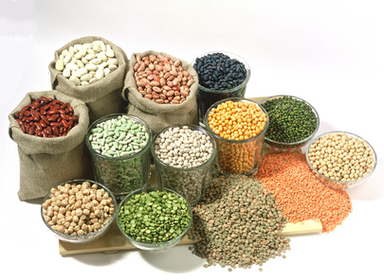

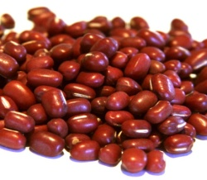 | adzuki bean []- квасоля адзукі  Has a delicate flavor and is often served with rice; in Asian countries, the paste made from these beans can replace tomato paste.
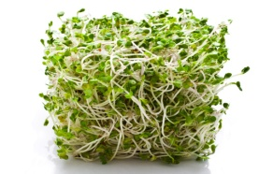 | Alfalfa[]- люцерна  The sprouted seeds are added raw to sandwiches or used in various cooked dishes.
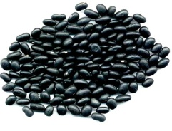 | black bean []- квасоля чорна  Available mainly in Central and North America, it is a staple of Mexican cooking.
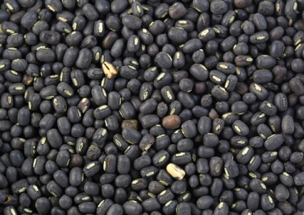 | black gram [] – чорний дрібний турецький горошок  A favorite in Asia, where it is used to make a popular black sauce; in India, it is mixed with rice to make pancakes and a spicy purée.
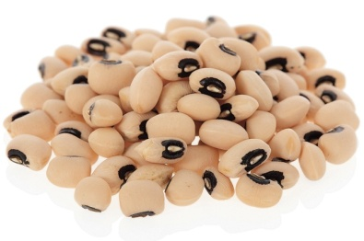 | black-eyed pea [] - чорноокий горох  This flavorful seed has a black spot that resembles an eye, hence its name; it is typical especially of southern American cooking.
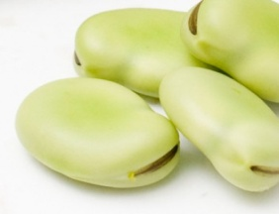 | broad beans[]–кормові боби  Starchy and strong-tasting, they are typically puréed; they are also eaten whole and added to soups and stews.
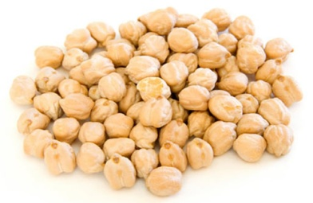 | chick peas [s]- горох  Basic ingredient of hummus and falafel and found in couscous; they are also used to make various southern French dishes such as estouffade.
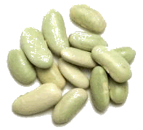 | flageolet []- флажолет  Thin flat and less starchy than most other legumes, this bean is a favorite in France, where it is traditionally served with leg of lamb.
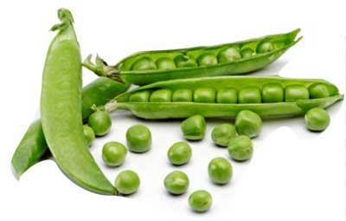 | green peas [s]- зелений горох  Delicious freshly picked, they are also available frozen or canned; a component of mixed vegetables and of dishes labeled "à la jardinière".
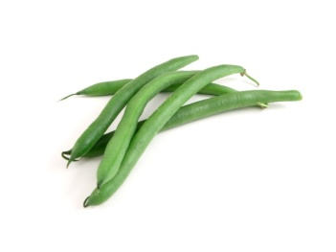 | green bean []- зелена квасоля  The young green pod is usually served as a vegetable side dish, sometimes with sauce or butter.
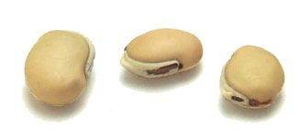 | lablab bean [] – індійський біб  Characterized by a white ridge; it can be sprouted or ground into flour.
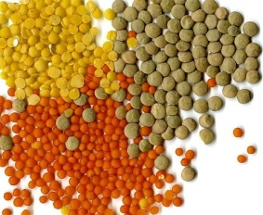 | lentils [s] - сочевиця  A main ingredient of hearty soups, they can also be puréed and made into croquettes; in India, they are often paired with rice.
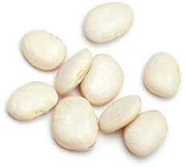 | Lima bean [] - квасоля ліма  Has a mild flavor and a starchy texture and is generally green- or cream-colored; when puréed, it can replace the potato.
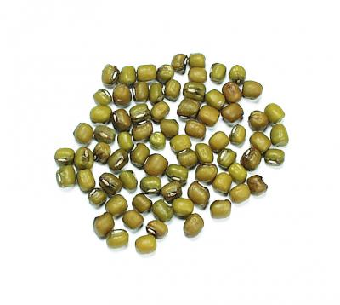 | mung bean [] – квасоля маша  In Asia they are either puréed or ground into flour; in the West they are more commonly eaten sprouted, especially in chop suey.
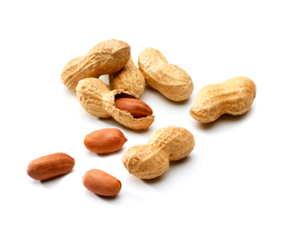 | рeanut[]- арахіс  Often served as a snack, it is also made into a butter and a vegetable oil and, in some countries, into a spicy sauce served with a variety of dishes.
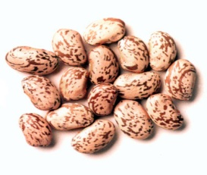 | pinto bean []- квасоля пінто  When cooked, their spots disappear and they turn pink; because of their creamy texture, they are mostly used to make purées.
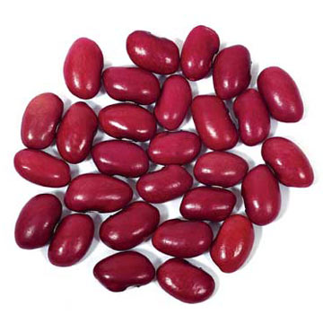 | red kidney bean []- червона квасоля  One of the best-known beans, it is used to make the Mexican dish called chili con carne; it retains its shape when cooked so is often canned.
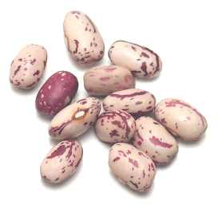 | roman bean []– квасоля римська  A staple of Italian cooking, it resembles the pinto bean, although often larger and darker; it absorbs the flavor of the foods it is cooked with.
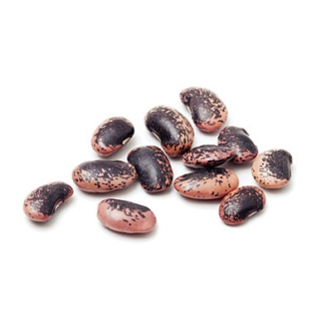 | scarlet runner bean []– квасоля вогненна  The seeds are eaten fresh or dried, in which case they are prepared like the red kidney bean; a favorite accompaniment to onions, tomatoes and tuna.
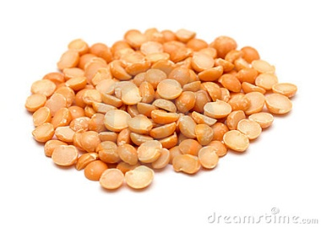 | split peas [s]–лущений горох  These pea seeds, dried and split in two, are generally puréed and used in various kinds of soups.
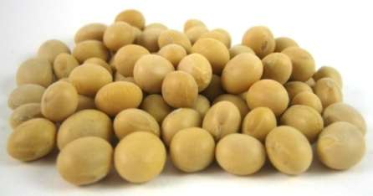 | soybeans []- соя  Produces a kind of milk used mainly to make tofu and also a vegetable oil; when fermented, it is the main ingredient in soy sauce.
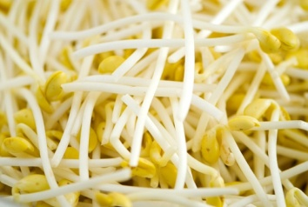 | soybean sprouts []- соєві паростки  After sprouting for a few days they are ready to be eaten, either raw or lightly cooked; they are characteristic of Chinese cooking.
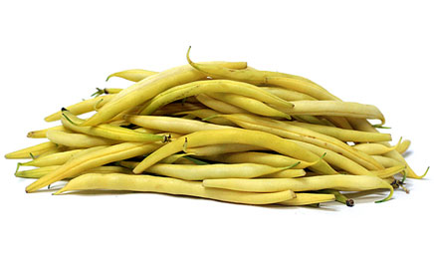 | wax bean []– воскова квасоля  Somewhat juicier than the green bean, it is sometimes eaten raw but mostly cooked, as a vegetable side dish.
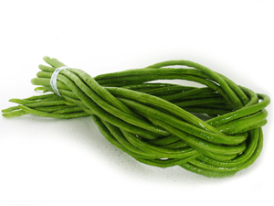 | yard-long bean [] - довга квасоля  Although mostly eaten fresh and whole, like the green bean, it is less juicy and sweet; its pods measure up to 3 ft in length.
Fruits
Фрукти
Usually sweet vegetables, primarily consumed at breakfast, as a snack or for dessert, and used extensively in pastry and candy making.

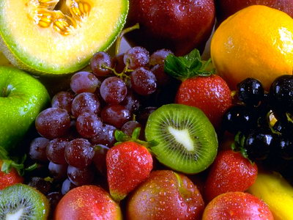

Stone Fruits
Кісточкові фрукти
Fruits whose somewhat juicy flesh surrounds a hard, usually inedible stone.

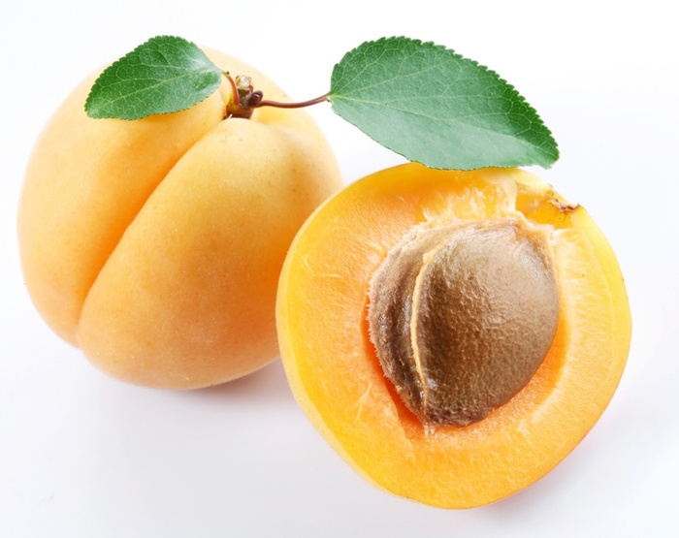

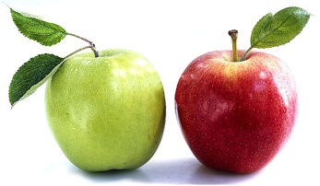 | apple [] - яблуко  There are 7,500 known varieties; it is used to make cider and is also eaten raw or made into juice, jelly, compote or desserts, such as pie or strudel
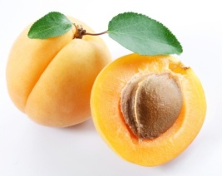 | apricot []- абрикос  Often eaten dried or candied, its orange flesh can be mushy if picked before fully ripe; the kernel inside the stone contains a toxic substance.
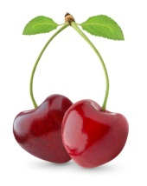 | cherry []- вишня  An essential ingredient in Black Forest cake and, candied, in fruitcake; when artificially colored and flavored, it is used as a cocktail garnish
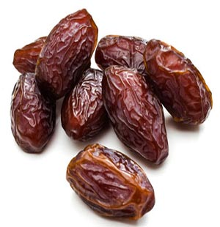 | date [] - фінік  Has a high sugar content and is often sold dried; in North America, it is primarily associated with baked goods, such as squares, muffins and cakes.
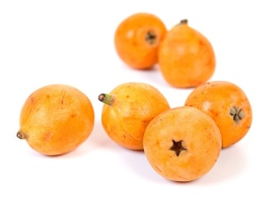 | Japanese plum []- японська слива  Has thin skin, sometimes covered in fine hairs, that envelops juicy, somewhat sour flesh; whether raw or cooked, it tastes somewhat like cherries or plums.
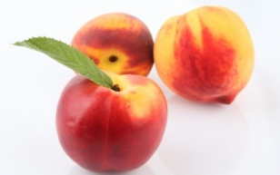 | nectarine []- нектарин  Differentiated from the peach by its smooth, more colorful skin and by its more flavorful flesh; like the peach, it is eaten raw or used in certain desserts.
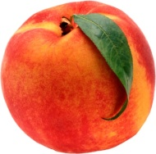 | peach []- персик  A velvety skin covers its juicy fragrant flesh; it is especially enjoyed plain, in juice and in various desserts, such as the classic peach melba.
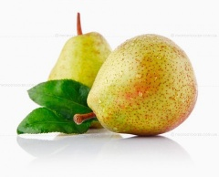 | pear []- груша  Among its many and varied uses, it forms the basis for a fruit brandy; it is picked before fully ripe to prevent the flesh from acquiring a granular texture.
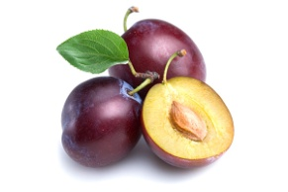 | plum [] - слива  Of various colors and sizes, it is excellent either raw or cooked and is used especially to make chutney; the dried plum is called a prune.
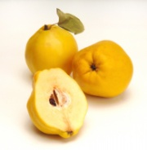 | quince []- айва  Fruit of the quince tree, native to warm climates; inedible raw, it is traditionally made into jams and jellies.
Berries
Ягоди
Small fleshy fruits containing one or several usually edible seeds; when they grow together in clusters, each fruit is called a seed.

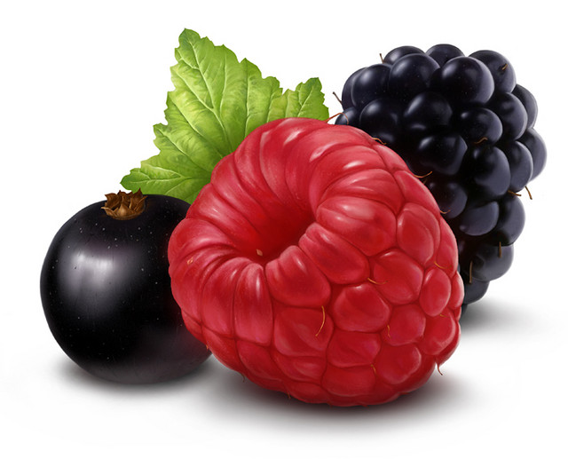

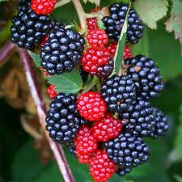 | blackberry [] - ожина  Grows on canes as does the raspberry, and is used like that fruit; the several trailing species are comminly called dewberries.
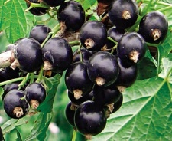 | black currant []- чорна смородина  Black berry primarily used to make coulis, jellies, wine and liqueurs such as crème de cassis, an ingredient in kir.

blueberry []- чорниця
Little known outside its native North America, it is primarily eaten plain or in desserts; the lowbush variety is the sweetest.
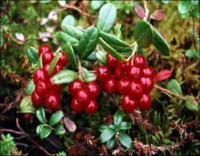 | cranberry []- журавлина  Too tart to be eaten raw, it is primarily used for making desserts, sauces or juice; a traditional accompaniment to turkey in North America.
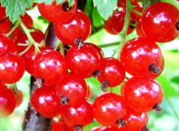 | currant [] - смородина  Small red or white currant primarily eaten cooked due to its sour taste; its juice can replace vinegar in salad dressing.
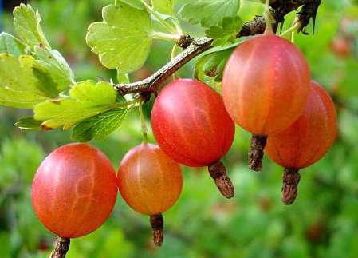 | gooseberry [] - агрус  Larger than the clustered berries, it is especially popular in Europe; the British use it to make a chutney that is served with mackerel.
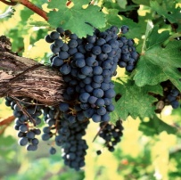 | grape [] - виноград  This variously colored fruit of the vine is enjoyed worldwide, either plain, cooked, dried or in juice; it is also the main ingredient in wine.

raspberry [] - малина
Generally red, there are also different-colored varieties; slightly tart and very fragrant, it makes an excellent coulis that can be incorporated into desserts.

red whortleberry []- брусниця
Closely related to the cranberry, this small tart berry is somewhat bitter and rarely eaten raw; it is used instead to make sauces, jams and desserts.

strawberry [] - полуниця
The cultivated strawberry was bred from the smaller and more fragrant wild strawberry; it is very flavorful and is used raw or cooked, primarily in desserts.
Dry Fruits
Сухофрукти
Often called nuts, these fruits usually have a hard dry covering called the shell that encloses an edible kernel.

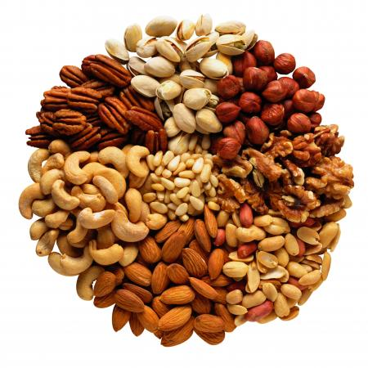

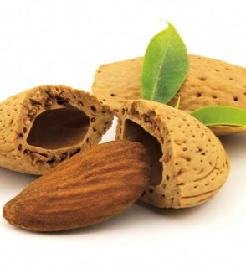 | almond [] - мигдаль  Primarily used to garnish chicken and fish, and to make almond paste, candies (nougat and pralines) and an essence that flavors Amaretto and a variety of foodstuffs.
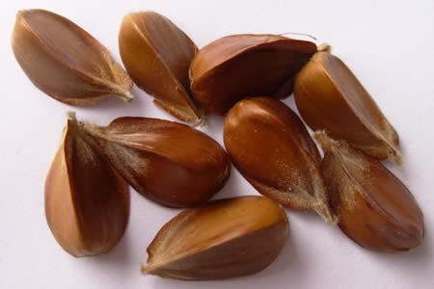 | beechnut [] - буковий горіх  Fruit of the common beech tree, its flavor resembles the hazelnut’s; more flavorful toasted than raw, it also yields a cooking oil.
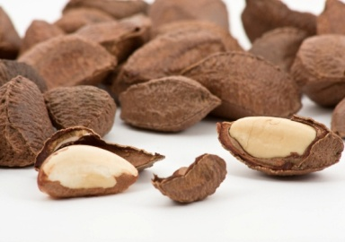 | Brazil nut []- бразильський горіх  Often served as an appetizer; it is also made into candy, such as when chocolate-coated. It replaces coconut in some recipes.
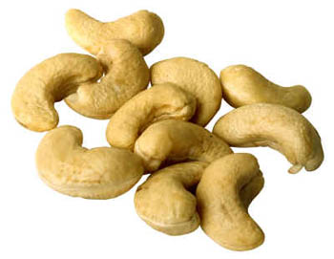 | сashew [] - горіх кеш'ю  This fruit of the cashew tree is always sold shelled; its shell is covered by a juicy fleshy edible layer known as the cashew apple.
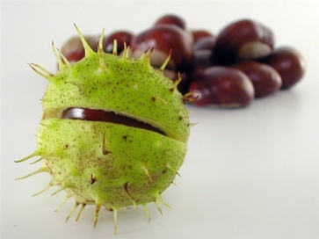 | chestnut [] - каштан  Designates the fruit of the chestnut tree; Europeans often serve it with game and poultry. When puréed, it is the main ingredient in the dessert known as Mont Blanc.
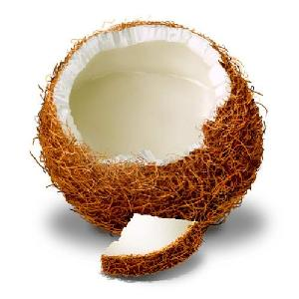 | coconut [] - кокос  The whitish meat, known as copra, surrounds a cavity containing a refreshing liquid, not to be confused with coconut milk, which is derived from the grated flesh.
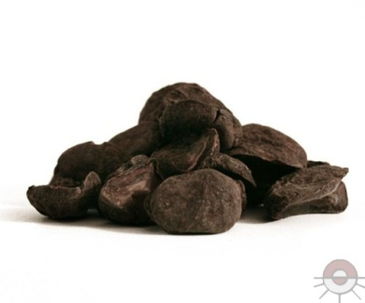 | cola nut []- горіх кола  Used in drink preparations such as Coca-ColaTM; it contains stimulants that are slightly less potent than those in coffee.
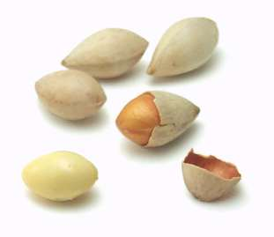 | ginkgo nut []- гінкго гайки  Extensively used in Japanese cooking but little known in the West, this nut is either eaten as is or is used in Asian dishes.
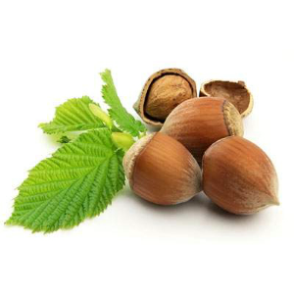 | hazelnut [] - лісовий горіх  Primarily used to make paste, butter or a kind of flour used in cakes and cookies; in candy making, it is often combined with chocolate
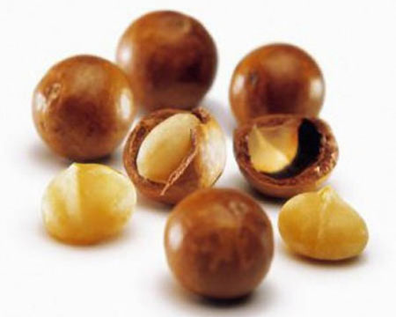 | macadamia nut []- горіх макадамі  A popular candy ingredient, it is often sold coated in chocolate or honey; it is also a popular ingredient in mixed vegetables, curries, salads and desserts.
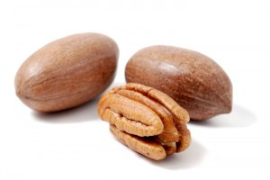 | pecan nut []– горіх-пекан  Native to North America, it is used to make certain savory dishes and numerous desserts, such as the traditional pecan pie
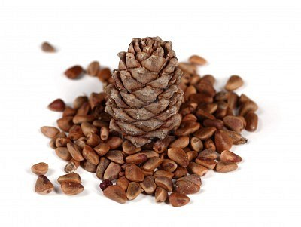 | pine nut []- кедровий горіх  Edible seed inside the cone of certain species of pine that is often used in cooking and baking.
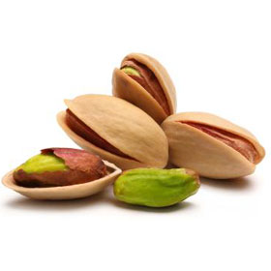 | pistachio nut [] - фісташковий горіх  Its greenish kernel is covered with a brown skin; it is extensively used in Mediterranean and Asian cooking, as well as in pastry and candy making.
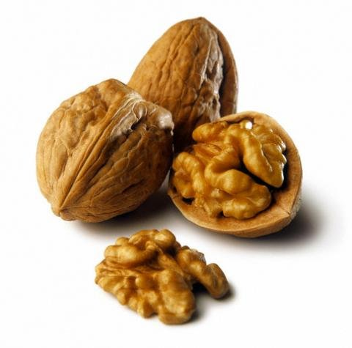 | walnut - волоський горіх  A green covering, the husk, covers the shell; the walnut is served as an appetizer, or added to a variety of desserts, salads, sauces and main dishes
Citrus fruits
Цитрусові фрукти
Somewhat acidic fruits with a high vitamin C content comprising numerous sections and covered with a rind that has an external layer called zest.

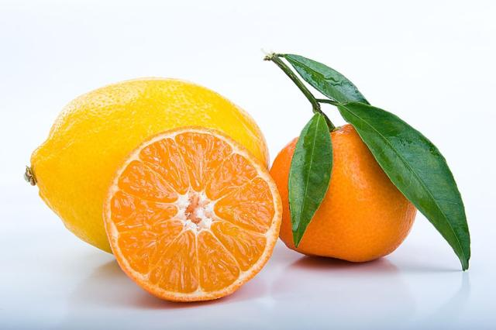

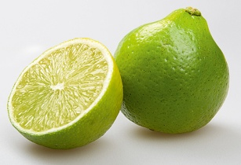 | bergamot [] - бергамот  Because its greenish flesh is inedible, it is primarily used for the zest and essential oil derived from its rind, especially in Earl Grey tea.
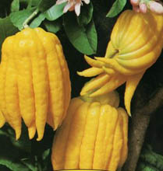 | citron []- цитрон  Extensively grown in Corsica and Israel, this somewhat dry fruit is rarely found fresh and is mostly sold candied.
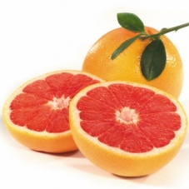 | grapefruit []- грейпфрут  The pink grapefruit is sweeter and less bitter than the white one that has yellow flesh; it is often cut in half and eaten plain, with a spoon.
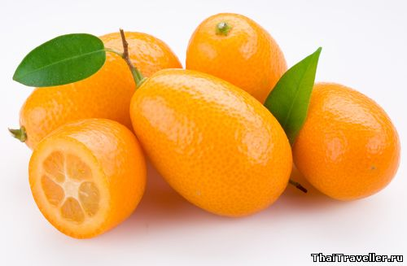 | kumquat []- кумкват  Small citrus fruit, .75 to 2 in long with a sweet tender rind that can be eaten unpeeled; its flavor is enhanced through light steeping.

lemon []- лимон
Highly acidic, it is especially used to flavor various recipes and enhance the flavor of certain foods; it is the main ingredient in lemonade.
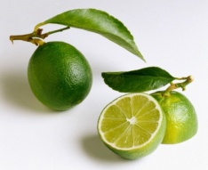 | lime []- лайм  Intensely fragrant and used like the lemon; it is an essential ingredient in ceviche, a raw marinated fish dish.
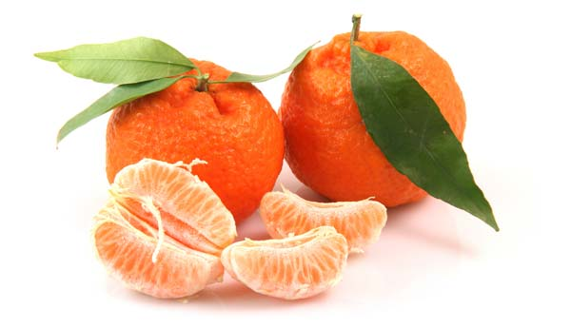 | mandarin []- мандарин  Similar to a small, slightly flattened orange, it is less acidic than most citrus fruits and is often eaten as is; it peels easily.
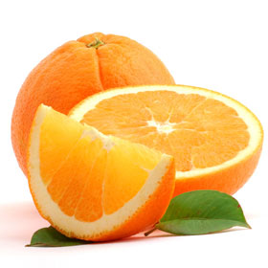 | orange [] - апельсин  Widely available, it is often eaten plain or in juice, and it goes well with duck; it yields a flavor essence and an essential oil.
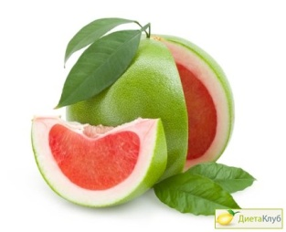 | pomelo []- помело  Extremely popular in many Asian countries, it has only recently become available in the West; less juicy than the grapefruit, it is mostly cooked or candied.
Tropical fruits
Тропічні фрукти
A variety of fruits, usually of exotic origin, more or less available in the West.

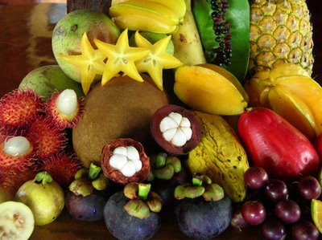

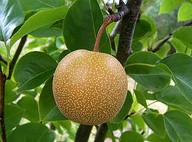 | Asian pear[]- Азіатська груша  Most popular Asian fruit, primarily eaten plain; its flesh is sweet and juicy, like the pear’s, and crunchy, like the apple’s.
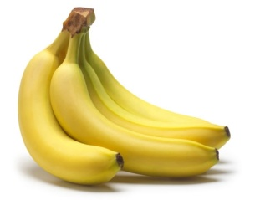 | banana[]- банан  Eaten as is, sautéed, fried or flambéed with rum; it is a classic garnish for ice-cream dishes and is also used in muffins and cakes.
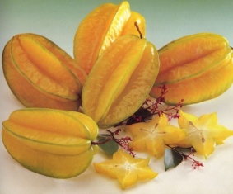 | carambola - карамбола  Within the delicate edible skin is a juicy, slightly acidic flesh that can be eaten raw or cooked, as a fruit or vegetable.
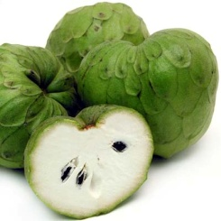 | cherimoya - черімойя  The skin and the seeds inside the slightly granular flesh are inedible; the flesh is sprinkled with orange juice and eaten with a spoon.
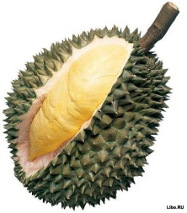 | durian - дуріан  Large fruit that emits a disagreeable odor when ripe; its sweet creamy flesh is often eaten plain while the seeds are used like nuts.
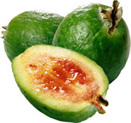 | feijoa - фейхоа  Has sweet fragrant, slightly granular flesh; after peeling, it is eaten raw or cooked, plain or in various desserts.
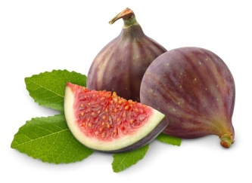 | fig [] - інжир  Among its many varieties are the black, the green and the purple fig; whether fresh or dried, it is mostly eaten raw, but can also be cooked.
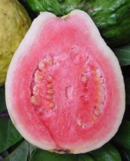 | guava [] - гуаява  Very popular in South America, its fragrant, slightly acidic flesh is eaten raw or cooked, with or without the skin and seeds.
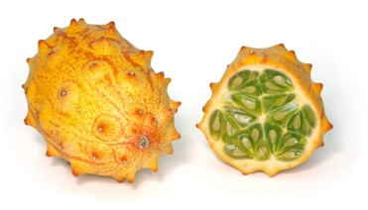 | horned melon []- рогата диня  Its green flesh contains soft edible seeds, similar to those of the cucumber; it is often peeled and then made into juice.
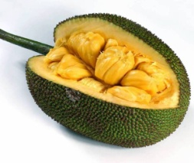 | jackfruit []- джекфрут  This very large fruit has edible seeds than can be boiled or roasted; the starchy flesh is eaten as a fruit or vegetable, either raw or cooked.
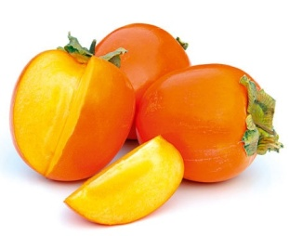 | Japanese persimmon []- Японська хурма  This national fruit of Japan is often eaten plain, with a spoon; the fuyu variety is eaten like an apple.
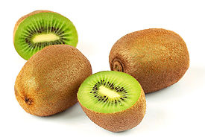 | kiwi []- ківі  Its juicy, slightly acidic green flesh has a high vitamin C content; delicious plain, its downy skin is generally discarded, although it can be eaten.
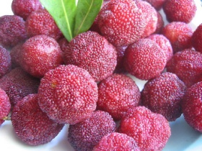 | litchi [] – лічі, нефеліум  Its juicy crunchy translucent flesh is more fragrant than the longan’s; it is often eaten raw and the Chinese serve it with fish or meat.
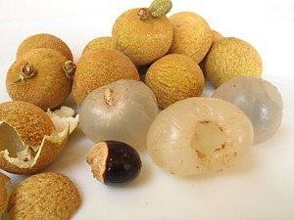 | longan - лонган  Stone fruit, related to the litchi, whose whitish translucent flesh is sweet and juicy; the peeled and stoned fruit is often eaten plain.
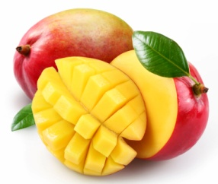 | mango []- манго  Fruit with a flattened stone and a skin that should be discarded, as it irritates the mouth; it is mostly eaten ripe, but sometimes used green, as a vegetable.
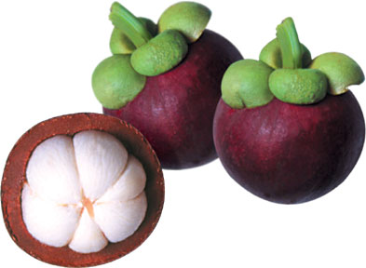 | mangosteen []- мангостан  Within the inedible skin that hardens as the fruit ages, there is a sweet juicy white flesh that is divided into sections; it is eaten as is, like an orange.
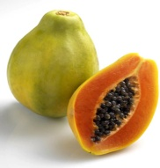 | papaya []- папайя  Its usually orange, juicy flesh is eaten like the melon and contains spicy, edible seeds; when green, it is eaten like winter squash.
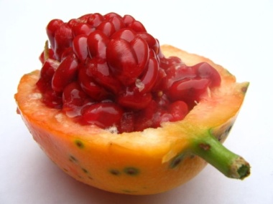 | passion fruit [[]]- маракуя  Within its inedible skin that wrinkles when ripe, there is a highly aromatic gelatinous pulp; delicious plain, it is used to flavor fruit punches and cocktails.
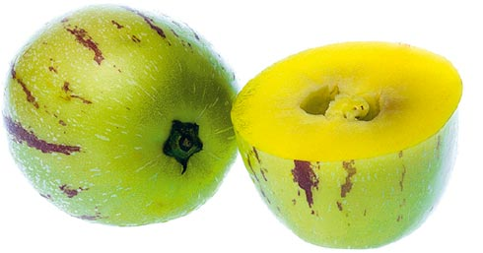 | pepino []- пепіно  The orange or yellow flesh is slightly starchy. Before fully ripe, it is often cooked and prepared like a squash; once ripe, it is eaten like a melon.
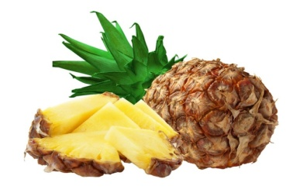 | pineapple []- ананас  Once the inedible rind has been removed, it is eaten raw, cooked or in juice; in North America, it is traditionally served with ham.
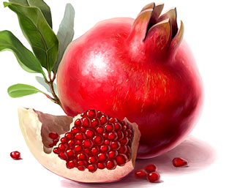 | pomegranate []- гранат  The edible part is the small, very juicy berries enclosed within the fruit’s membranes; it is used to make grenadine syrup, an ingredient in drinks and desserts.
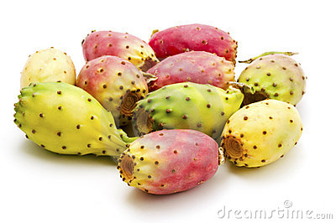 | prickly pear []- опунція  Fruit of a member of the cactus family; the spines and skin should be removed before eating the flesh, plain or sprinkled with lemon or lime juice.
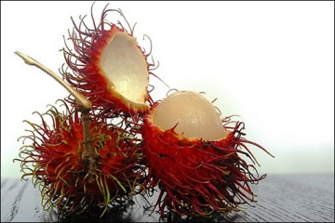 | rambutan []- нефеліум  The shell, covered in soft spikes, splits easily to reveal flesh like the litchi’s but less fragrant; it is used like the litchi.
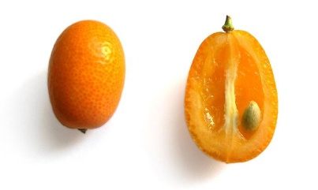 | sapodilla - саподілла  Has juicy fragrant, slightly granular flesh that tastes like honey and apricots; it is easy to peel and is eaten raw or cooked.
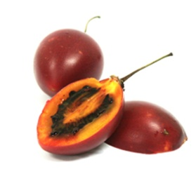 | tamarillo[]- тамарілло  Within the inedible skin there is a firm, slightly acidic flesh. If very ripe, it can be eaten raw; otherwise, it is often cooked like a vegetable.
Melons
Динні
Related to squash and cucumbers, these tender fruits are juicy sweet and refreshing; they are primarily consumed raw.

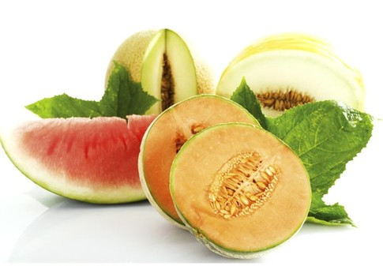

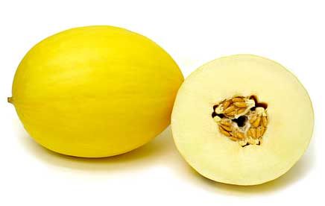 | canary melon []- диня кенери  Has sweet whitish flesh that is rose-tinted near the central cavity; it becomes very fragrant when ripe.
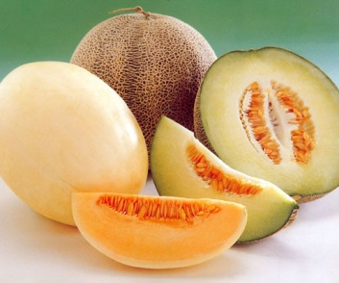 | cantaloupe []- мускусна диня  This orange-fleshed melon is characterized by its patterned textured ribs; the most widely cultivated variety is the charentais.
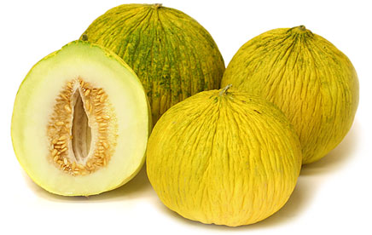 | casaba melon []– зимова диня  The flavor of its creamy white flesh, often less fragrant than that of other melons, can be enhanced with lemon or lime juice.
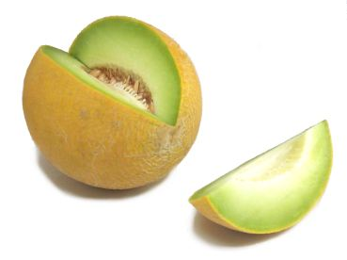 | honeydew melon [] - нектарна диня  Owes its name to its very sweet, green flesh; its smooth firm rind turns creamy-yellow as it ripens.
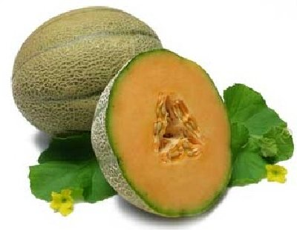 | muskmelon []–диня-канталупа  Named for the characteristic musky smell of its flesh; it has a textured rind and its flavorful flesh is pink or orange.
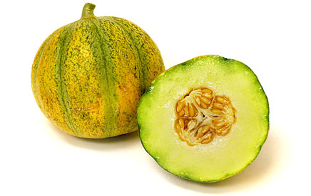 | Ogen melon [] – диня Оген  Small round melon with a hard smooth ribbed rind; its very juicy flesh is either dark pink or pale green.
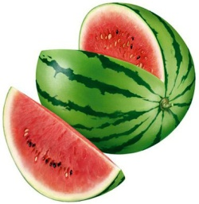 | watermelon []- кавун  This thirst-quenching fruit, named for its high water content, is primarily eaten plain, in slices.
Spices
Спеції
Plant substances, often of exotic origin, used primarily for their flavor and pungency to enhance the taste of various recipes.

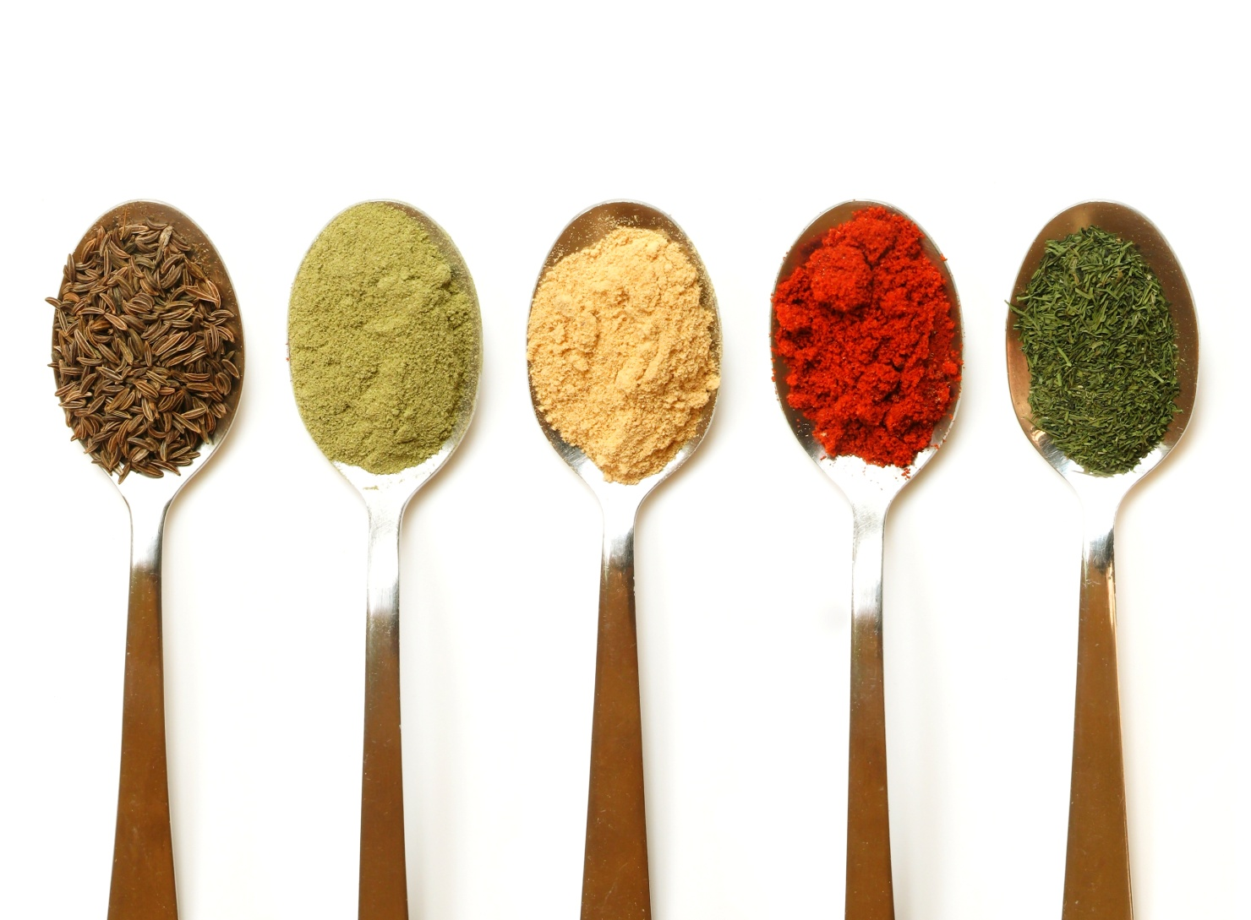

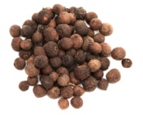 | allspice [] - перець гвоздичний  Also called Jamaican spice; it is used to flavor savory or sweet dishes and certain liqueurs.
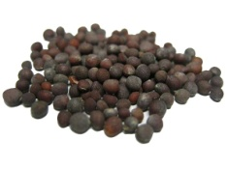 | black mustard [] - чорна гірчиця  The flavorful pungent seeds have a high concentration of essential oil; they are used whole, ground or as a flavoring agent.
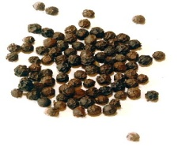 | black pepper [] -чорний перець  The most pungent and aromatic of the peppers, it comes from small berries that are picked while still green, then dried.
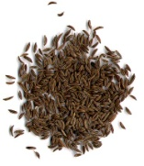 | caraway [] - кмин  Its sharp bitter flavor enhances the flavor of stewed dishes; it is used primarily in Eastern Europe, India and Arab countries.
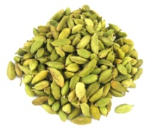 | cardamom [] - кардамон  The pod is green, brown or white, depending on whether it was sun- or oven-dried, or bleached; its delicate peppery flavor characterizes Indian curry.
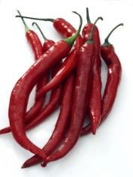 | cayenne chile [] - перець стручковий кайєнський  Dried red chile powder used specifically to make Tabasco® sauce; it is so hot that one pinch is enough to season an entire dish.
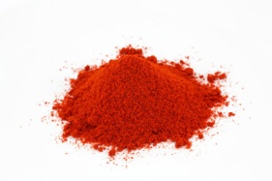 | chili powder [] - мелений перець  Spice blend composed mainly of dried ground chiles, whose strength varies depending on the chiles used; it is widely used to flavor and color rice and pasta.
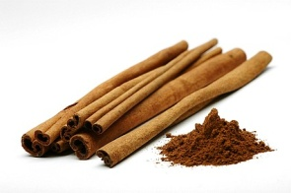 | cinnamon [] - кориця  Dried bark of the cinnamon tree, sold in sticks, ground or as an essential oil; it is often associated with candy, sweet dishes and hot drinks.
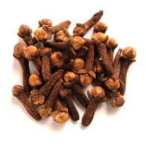 | clove [] - гвоздика  The dried floral bud of the clove tree. Whole, it is often used with ham or simmered onion dishes; when ground, it flavors items such as gingerbread.
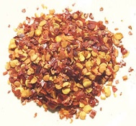 | crushed chiles []- мелиний чілі  Dried crushed chiles that contribute flavor and spiciness to a variety of recipes; they are commonly used in pasta dishes.
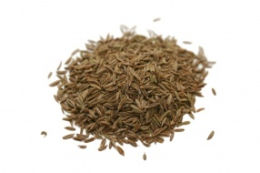 | cumin []- кмин  Extensively used in traditional Arab, Indian and Mexican dishes, it has a strong smell and a warm, slightly bitter flavor.
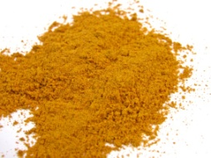 | сurry [] - каррі  A staple of Indian cooking, the pungency of this blend of spices varies, depending on how much pepper or chile is used.
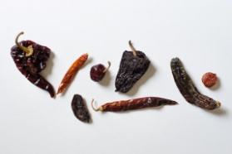 | dried chiles []– сушений чілі  The smaller dried chiles are generally stronger than the large ones, which can be dry-roasted before use to bring out their flavor.
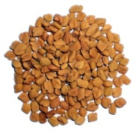 | fenugreek [] - гуньба  Once roasted, the seeds have a bittersweet aftertaste; they are used in Indian cooking or, when sprouted, added to salads.
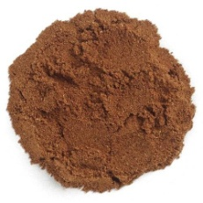 | five spice powder[]– п’ять мелених спецій  A blend of five ground spices used in Chinese cooking; it includes star anise, cloves, fennel seeds, cinnamon and pepper.
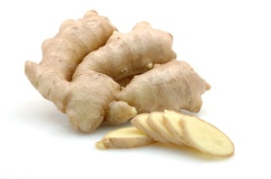 | ginger []- імбир  A staple of Asian cooking and a classic garnish for sushi; it is also used ground, especially in breads and cookies.
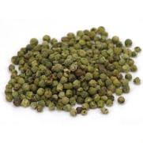 | green pepper[] – зелений перець  Small berries picked while still green and usually dried or preserved in brine or vinegar; this pepper is mild but very fragrant.
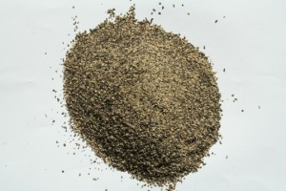 | ground pepper [] – мелений перець  Although one of the most widely used cooking spices, it loses its flavor faster than peppercorns, from which it is derived.
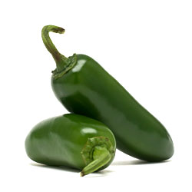 | jalapeño chile [] – японський чілі  Relatively mild chile, native to Mexico and sold fresh, dried or marinated; it turns red when ripe.
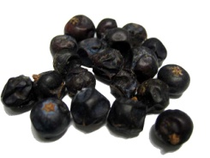 | juniper berry[] - яловець  Fruit of the juniper tree with a resinous smell and slightly bitter flavor; it is the basis for gin and also flavors marinades, sauerkraut, meat and pâtés.
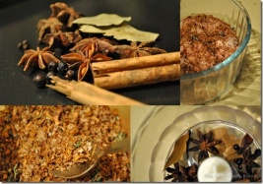 | marinade spices []– спеції для маринаду  A mixture of spices added to fruit and vegetable preserves, chutney and vinegar; its composition varies.
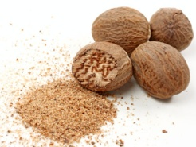 | nutmeg []– мускатний горіх  Its flavor complements milk products but quickly decreases once the nut is ground; its red membrane, known as mace, is also used as a spice.
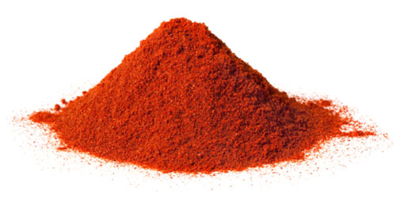 | рaprika[] –перець стручковий або червоний  Extensively used in Hungarian cooking, this somewhat hot powder combines dried sweet red pepper and red chiles; it is used to flavor and color numerous foods, such as eggs and potatoes.
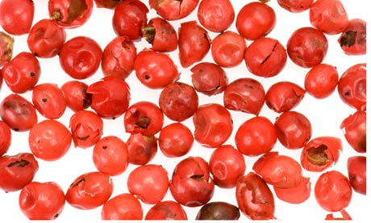 | pink pepper [] – рожевий перець  These dried berries, with a delicate fragrant and mildly pungent flavor, do not grow on the pepper tree but on another plant; it is used like pepper.
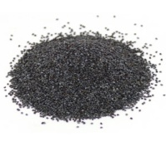 | poppy seeds []- мак  Their nutty flavor, which intensifies with cooking, works especially well in bread, cakes and pastries; it also yields a cooking oil.
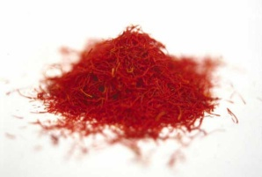 | saffron []- шафран  The most expensive spice, actually derived from the handpicked and dried stigmata of the crocus flower; it is an essential ingredient in paella and bouillabaisse.
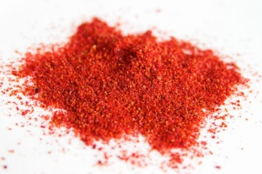 | sumac []- сумах  Dried berries, sometimes ground, with a slightly acidic, lemony taste; it is very popular in the Middle East, especially in salads and fish dishes.
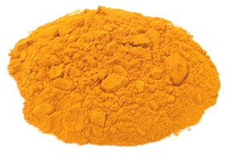 | turmeric []- куркума  Similar to ginger, it is cooked and ground into powder; among other uses, it is added to Indian curries and chutneys and provides the color for American mustard.
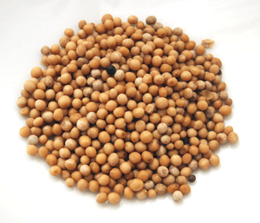 | white mustard []– біла гірчиця  Its seeds are larger and less pungent than the black mustard’s and are used especially to make American mustard.
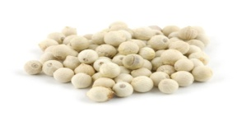 | white pepper [] – білий перець  Small berries picked when very ripe, then dried and skinned; this pepper is less pungent than black pepper.
Сondiments
Приправи
Natural or artificial substances used in cooking to bring out the flavor in a dish or to complement it.

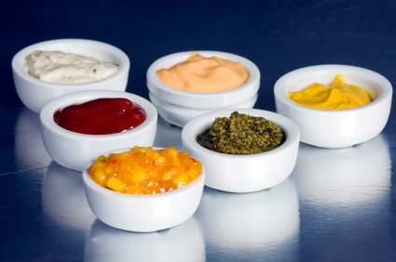

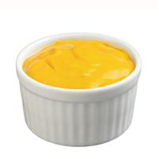 | American mustard []– американська гірчиця  Very mild, the traditional North American accompaniment to hot dogs and hamburgers; its bright yellow color comes from turmeric.
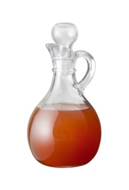 | apple cider vinegar []– яблучний оцет  Cider-based product whose strong taste makes it unsuitable for salads; it is used primarily for deglazing or as an ingredient in fish and seafood dishes.
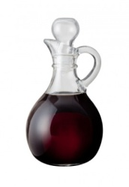 | balsamic vinegar [] – бальзамічний оцет  Well-known condiment made from sweet white grapes and aged in wooden casks; its low acidity makes it ideal for use in salads or in hot foods.
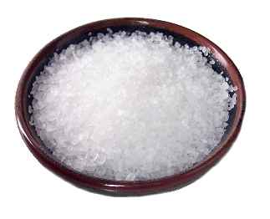 | coarse salt [] - сіль  This somewhat refined version is sometimes used in cooking or to sweat vegetables and preserve foods.
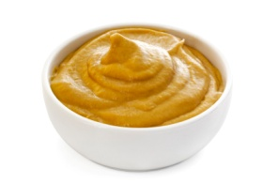 | Dijon mustard [] – гірчиця діжонська  This strong mustard comes from Dijon, France; it is served with meat and is used in making sauces, salad dressings and various kinds of mayonnaise.
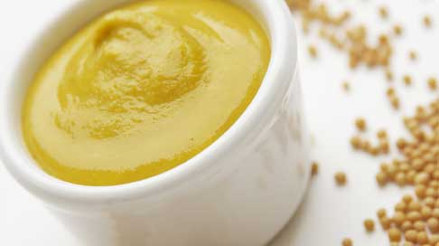 | English mustard [] – англійська гірчиця  Very strong mustard, sold either prepared or powdered, traditionally served with roast beef and ham.
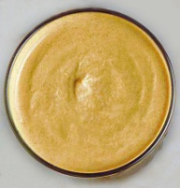 | German mustard [] - німецька гірчиця  Medium strong and slightly sweet mustard that goes well with sausages and deli meats.
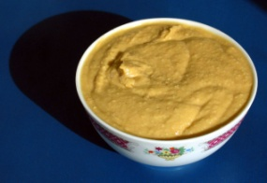 | hummus [] –пюре з нуту  Lebanese condiment made from puréed chickpeas and sesame oil, commonly served as an hors d’oeuvre or with crudités.

ketchup []- кетчуп
Medium spicy, traditionally English tomato purée made from numerous different recipes.
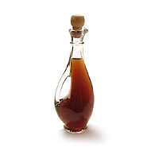 | malt vinegar [] – солодовий оцет  Made from sprouted barley juice, it is much too strong for salad dressings; it is used instead to make mixed pickles and chutneys.
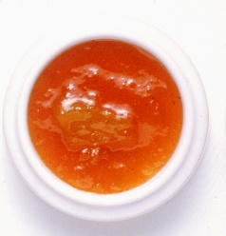 | mango chutney []– чатні мангове  Thick sweet-and-sour relish, originating in India and made with mangoes, sugar and vinegar; it can be served with a variety of dishes.
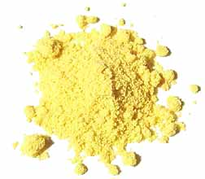 | powdered mustard []– гірчичний порошок  Can be incorporated into shortening, used as a seasoning or mixed with water to make a paste that resembles prepared mustard.
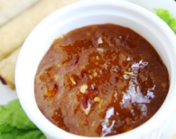 | plum sauce []– сливовий соус  Sweet-and-sour Chinese sauce primarily served with deep-fried or roasted dishes, such as pork and roast duck.

rice vinegar []– рисовий оцет
It is made from fermented rice wine and is very popular in Asian cooking; the Japanese version is sweet while the Chinese one is spicier.

sea salt [] – морська сіль
Unlike rock salt, which is whiter and comes from the subsoil, this usually grayish salt is derived from seawater through evaporation.
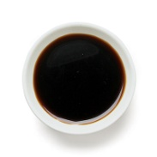 | soy sauce []– соєвий соус  A key condiment in Asian cooking, this extremely salty sauce is made from soybeans and is used as a flavoring ingredient, dip or marinade.
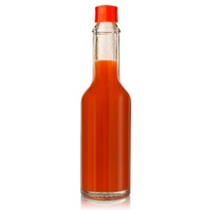 | Tabasco® sauce[] - гостра перцева приправа  Native to Louisiana, this sauce is made from crushed red chile peppers and is so pungent that a few drops are enough to season a whole dish.
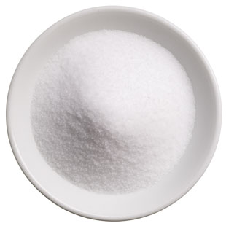 | table salt [] - столова сіль  A standard table condiment and also commonly used in cooking, it is always refined.
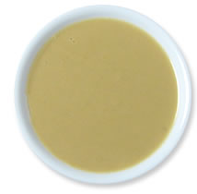 | tahini - тахині  Thick creamy nutty-tasting paste, made of ground sesame seeds; it is added to sauces and served with brochettes, bread, fruit and vegetables.
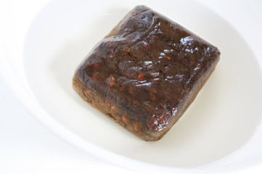 | tamarind paste []– індійська паста  Made from the fruit of the tamarind tree, this slightly acidic paste is used as a foodstuff and as a condiment in Asian cooking.
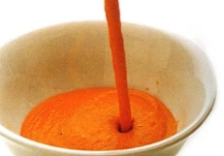 | tomato coulis []– томатний соус  Tomato purée of medium thickness that is served either hot or cold, as a sauce.
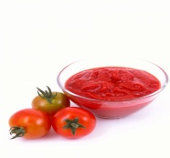 | tomato paste []– томатна паста  Tomato coulis reduced until it turns into a paste; it is used to make ragouts and sauces.
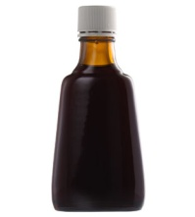 | vanilla extract []– ванільний екстракт  Aromatic substance extensively used in baking; it is often made of artificial ingredients that are less tasty than real vanilla, which is more expensive.
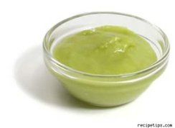 | wasabi - васабі  Its very pungent taste enhances meat and fish dishes, such as Japanese sushi and sashimi.
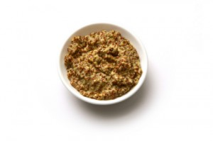 | wholegrain mustard [] - цільнозернова гірчиця  Native to Meaux, France, this mild spicy mustard is made from partly crushed seeds, giving it a grainy texture.

wine vinegar []– виноградний оцет
White wine vinegar is less fragrant than the red; the former goes well with fish and seafood while the latter brings out the flavor of blander foods.
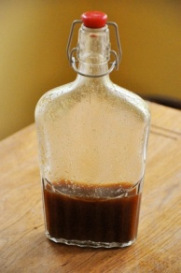 | Worcestershire sauce []– гостра соєва приправа  British sauce whose exact recipe is kept secret by the manufacturer; its robust flavor goes well in cocktails, sauces, soups and many other dishes.
Herbs
Трави
Aromatic fresh or dried plants used separately or mixed to bring out the flavor of recipes; they often make excellent infusions.

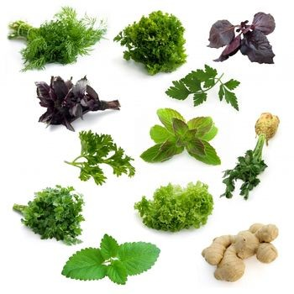

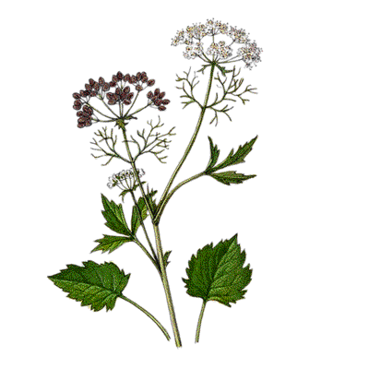 | anise []- аганус  Extensively used in making candy (licorice) and liqueurs (pastis), its edible leaves and seeds can flavor savory as well as sweet dishes.
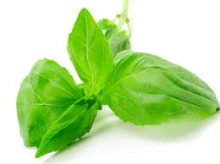 | basil []- волошка  A popular choice for seasoning tomato and pasta dishes, it is also one of the main ingredients in pistou and Italian pesto.
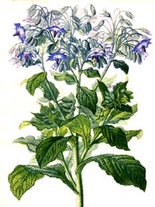 | borage[]- огірочник  Delicious in yogurt, cream cheese or salad dressing; the young leaves can be used in salads.
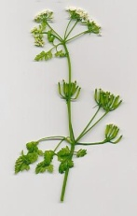 | chervil []- кервель  Has a subtle delicate taste and is used like parsley; it is often included with tarragon, parsley and chives in a traditional blend known as fines herbes.
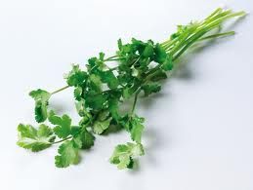 | coriander []- коріандр  Its leaves are used like parsley and it has edible musk- and lemon-scented seeds; the roots can be substituted for garlic.
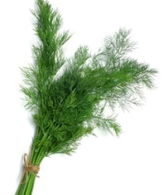 | dill []- кріп  Used primarily for its leaves and seeds, it imparts flavor to vinegar and pickles as well as to salmon and herring.
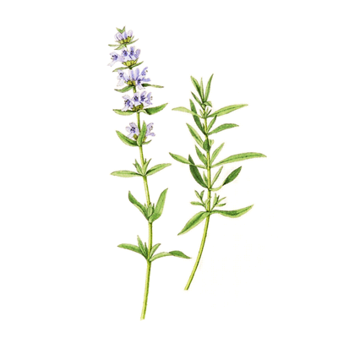 | hyssop []- гісоп  The highly aromatic leaves are mostly used in salads, soups, ragouts and fruit platters, as well as in some liqueurs, such as Chartreuse and Benedictine.
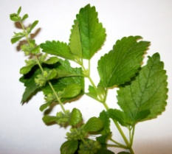 | lemon balm []- лимоник  Its lemon-scented leaves are used extensively in Asian cooking; it goes well with bitter foods.
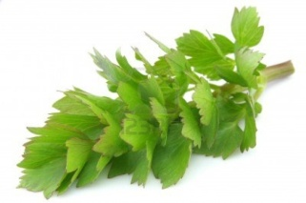 | lovage [] - любисток лікарський  Resembles celery but with a stronger flavor; it is particularly tasty with potatoes and also goes well with ragouts, sauces and salads.

mint – м’ята
Gives a refreshing taste to numerous sweet and savory dishes, such as lamb; its aromatic essential oil is used to flavor candy, liqueurs and many other types of food.
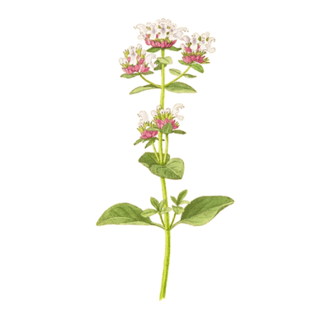 | oregano []- ореган  Wild, slightly more flavorful variety of marjoram; extensively used in Mediterranean cooking, it goes especially well with tomato dishes.
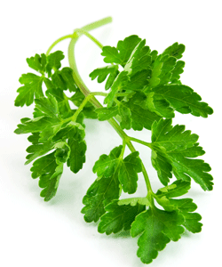 | parsley []- петрушка  The smooth flat-leafed parsley is less bitter and more fragrant than curly-leafed parsley; it is used to flavor numerous recipes, such as tabbouleh.
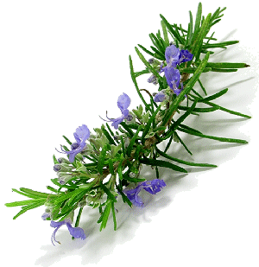 | rosemary []- розмарин  Its fairly pungent, aromatic flavor is very popular in southern France and in Italy, where it is used especially in sauces and marinades, and with roast meat.
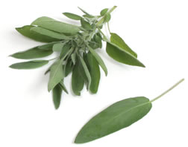 | sage []- шавлія  Its pungent flavor complements a variety of dishes; it is often used with pork, duck and goose, as well as in Italian veal dishes.
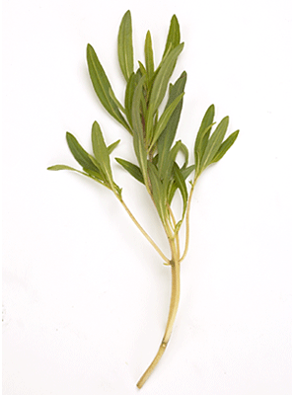 | savory [] - чабер  Reminiscent of thyme, its flavor enhances legumes, meat and stuffing; it is also used to flavor vinegar and goat’s milk cheeses.
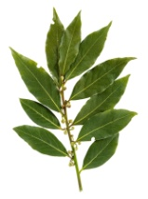 | sweet bay [[] – лавр благородний  The dried leaves must be used sparingly; it is an ingredient in bouquets garnis and is used to flavor soups and stews.
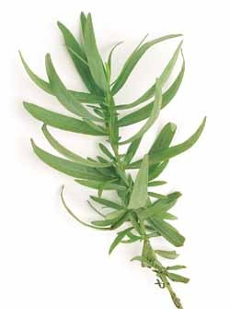 | tarragon []– полинь естрагон  Has a slightly bitter, peppery anise flavor that complements bland foods; it is often used with chicken and is always used in béarnaise sauce.
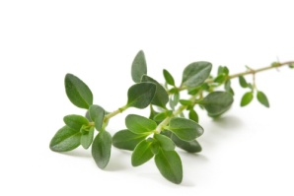 | thyme - чебрець  Used with parsley and sweet bay to make bouquets garnis; because it withstands lengthy cooking, it is a popular choice for flavoring soups and stews.
Cereal
Крупи
Plants that are often cultivated on a large scale; their grains have been a major food staple for humans and certain domestic animals for centuries.

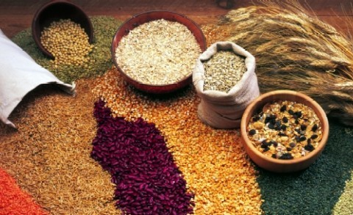

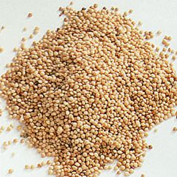 | amaranth [] - щириця  These highly nutritious, slightly peppery grains can be eaten as is after cooking, sprouted or ground into flour.
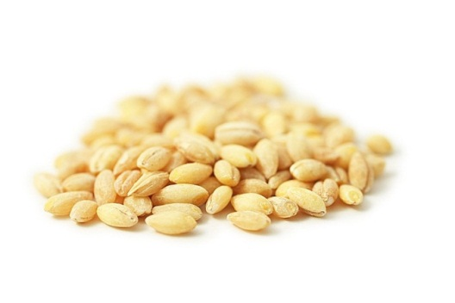 | barley [] - ячмінь  Barley can be either hulled or pearled to remove its outer husk; it is often added to soups and ragouts and is also made into malt for brewing beer.
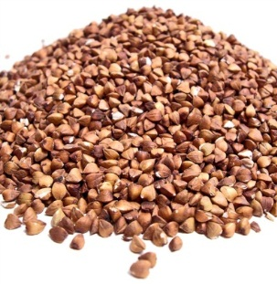 | buckwheat [] - гречка  Eaten in soups and as porridge, it is also ground into a flour traditionally used to make crepes and pancakes.
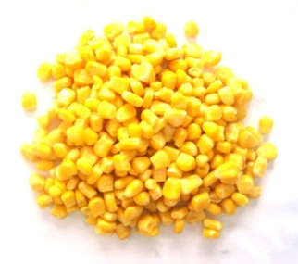 | corn [] - кукурудза  Native to America, it is eaten as a vegetable, made into popcorn or ground into flour; it also yields a starch, a syrup and a cooking oil.
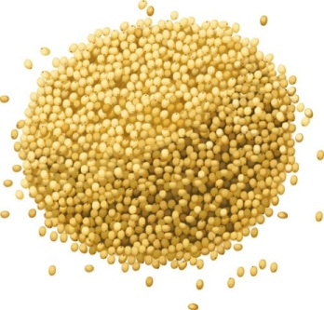 | millet - просо  With its strong flavor, it is mostly used for making pancakes and porridge; when sprouted and ground, millet is an ingredient in breads and muffins.
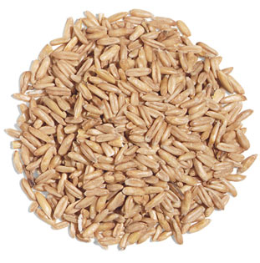 | oats [] - овес  Often eaten as porridge, it is also an ingredient in date squares, fruit crisp toppings, muffins, cookies and pancakes.
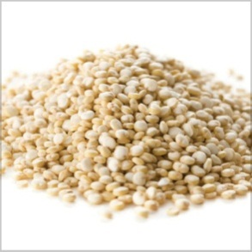 | quinoa [] - лобода, квінова  Grains should be thoroughly rinsed before cooking; it is used in South America to make an alcoholic drink called chicha.
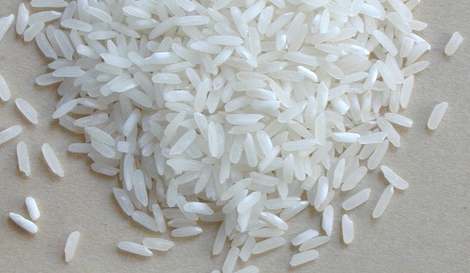 | rice []- рис  A universal staple, used as a side dish, in sweet and savory dishes such as risotto and paella, and for its by-products (noodles, sake).
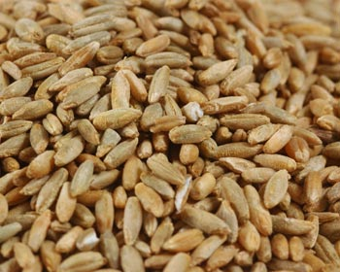 | rye []- жито  Yields a flour that can be combined with wheat flour to make bread; it is also used in brewing (beer) and distilling (whisky).
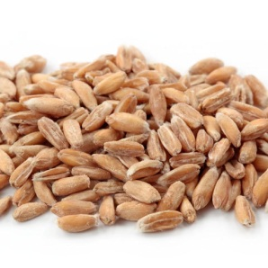 | spelt wheat [] - пшениця спельта  Wheat variety with small brown grains that, once hulled, can be used like rice.
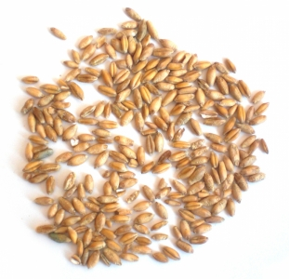 | triticale [] - тритікале  A wheat and rye hybrid, it is mostly used to make crepes and pasta.
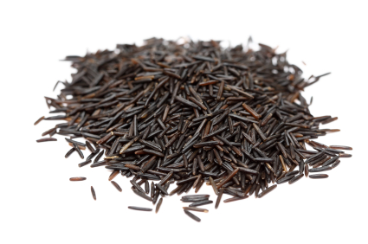 | wild rice []– канадський рис  Seeds from a North American aquatic plant; it is richer and higher in protein than rice and has a strong nutty flavor. It is sometimes mixed with other kinds of rice.
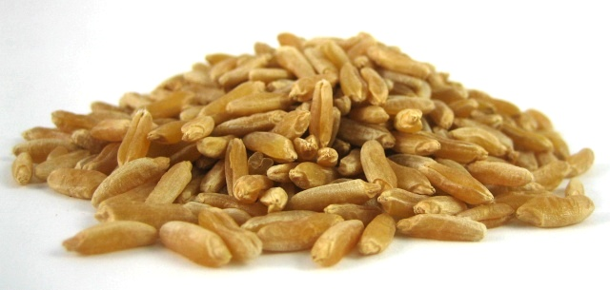 | wheat [] - пшениця  Cereal cultivated for its grain, of great significance in human food production; it is used to produce foodstuffs such as flour, bread and semolina.
Сereal products
Зернові продукти
Cereals that have been processed in various ways to make ground (flour, semolina), unground (rice) or manufactured products (bread, pasta, noodles).

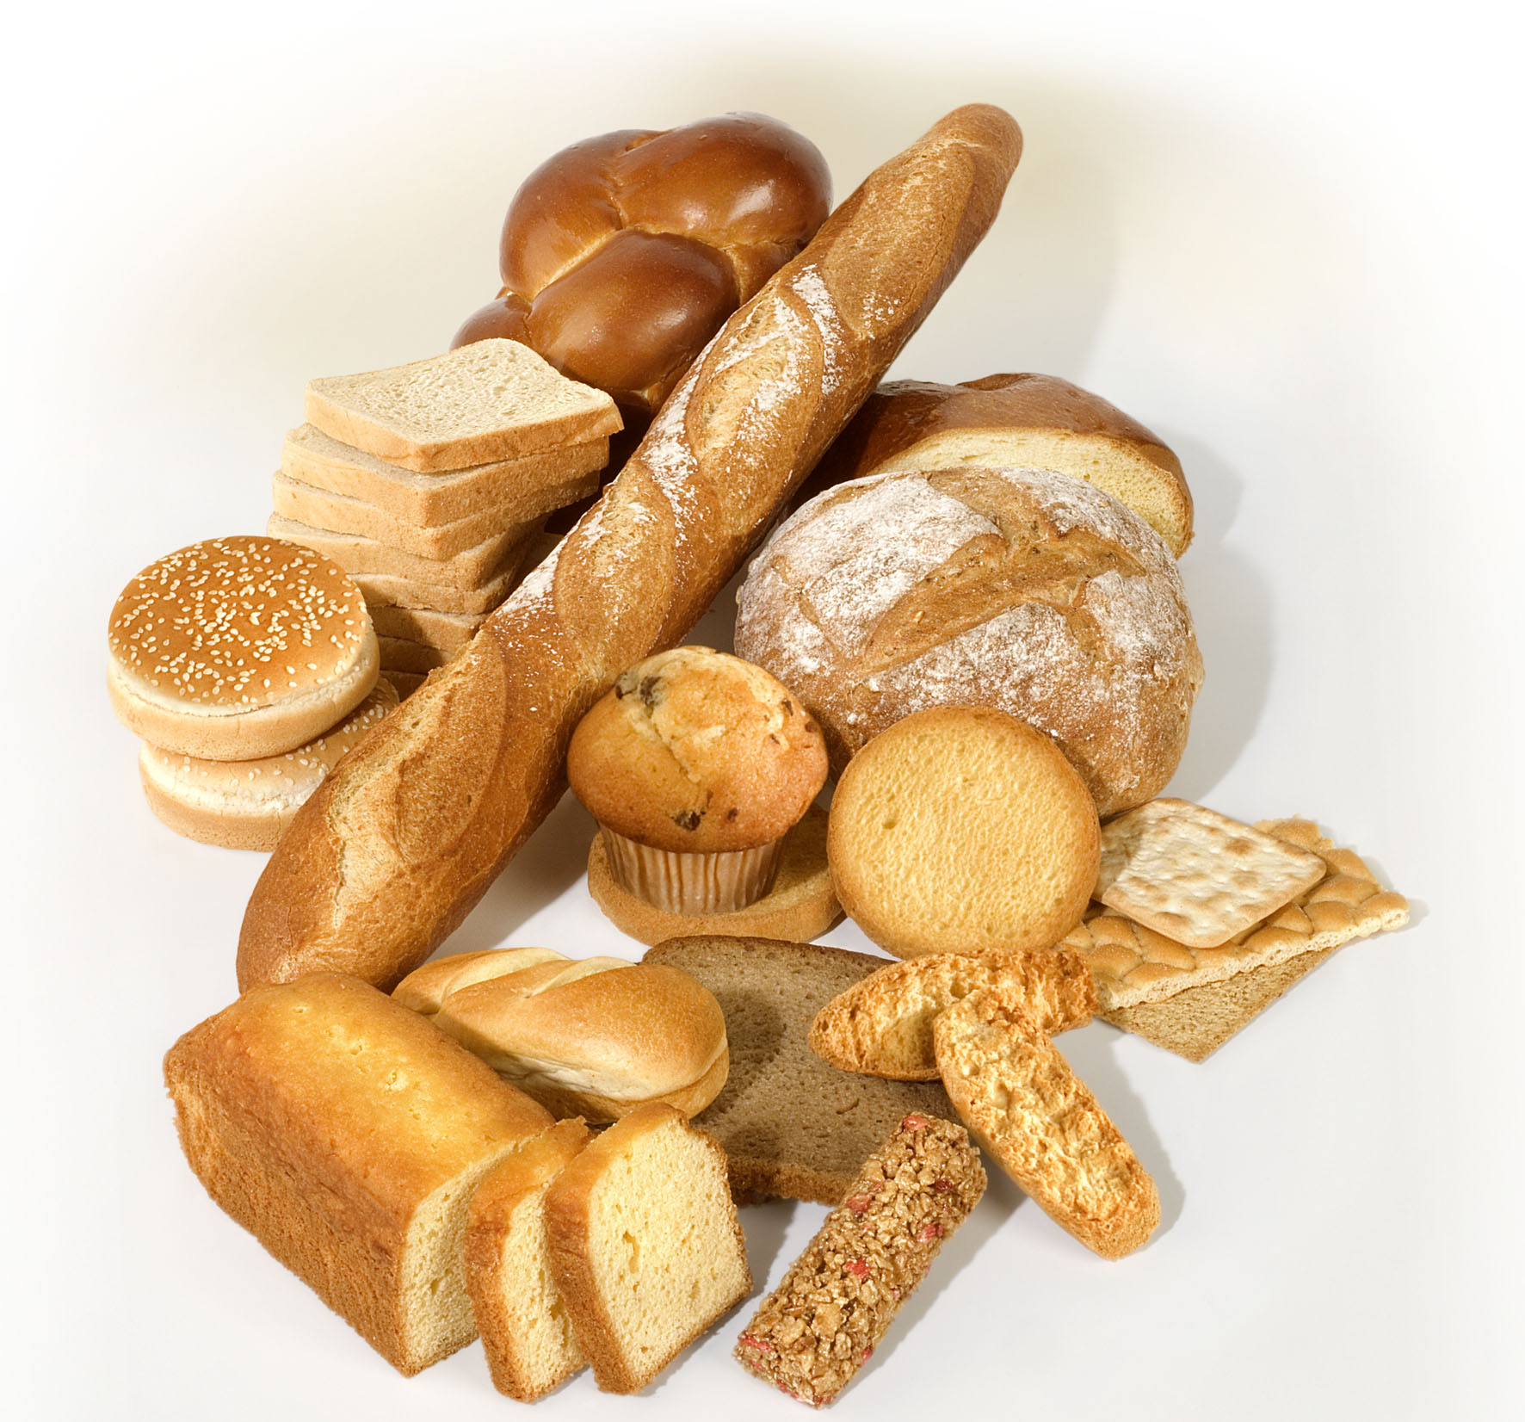

Flour and semolina
Борошно та манна крупа
Products obtained by grinding grains and cereals; semolina is usually coarser and more granular than flour. Without a modifier, these words generally refer to wheat.

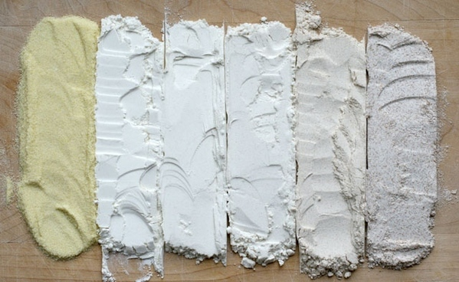

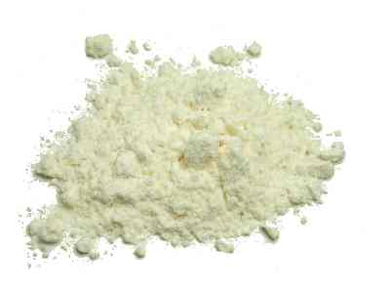 | all-purpose flour [] - борошно  This blend of ground hard and soft wheat has many uses, but is primarily used to thicken sauces or to make bread and pastry.
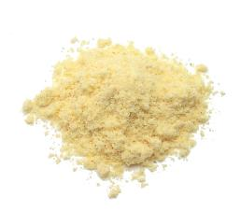 | corn flour []– кукурудзяне борошно  Primarily added to crepe, cake, muffin and bread mixes; it must be combined with wheat flour if the mixture is intended to rise.
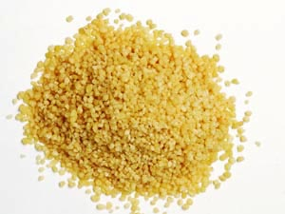 | couscous []- кускус  Hard wheat semolina that is formed into grains and used to prepare an eponymous dish of the Maghreb; it is traditionally steamed over broth.
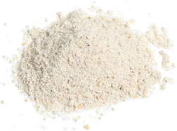 | oat flour [] - вівсяне борошно  Since it does not rise during cooking, it must be combined with wheat flour to make bread and other leavened products; it makes these products heavier.
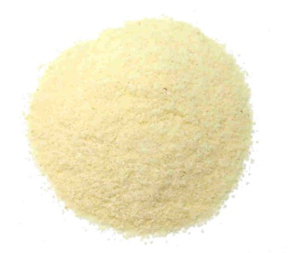 | semolina []– манна крупа  Refers to the granular flour derived from hard wheat, used to make pasta; fine semolina can also be eaten as a cereal (cream of wheat).
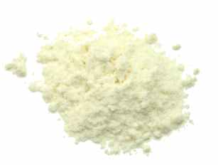 | unbleached flour []- небілене борошно  Like white flour, it comes from grinding wheat grains from which the bran and germ have been removed, but it is not artificially whitened.
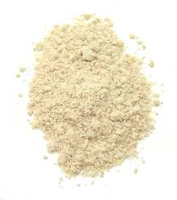 | whole-wheat flour [] - пшеничне борошно  Because it is produced by grinding the entire grain, none of the nutrients is lost; the grain’s outer layer, known as bran, gives it a brownish color.
Bread
Хлібні вироби
Food made from flour, water and salt, often containing an agent (leaven or yeast) that makes it rise.

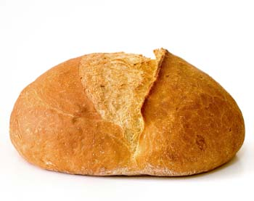

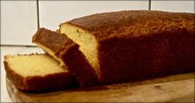 | American corn bread []– американський кукурудзяний хліб  The crumb of this corn flour-based bread is golden in color; it is easy to make and very popular in the southern United States.

bagel - бублик
Jewish ring-shaped roll traditionally coated in sesame seeds; it is usually served warm, with cream cheese.

baguette []– довгий французький хліб
This light crusty, typically French bread is often served with a meal and also goes well with cheese and pâté; it must be eaten fresh.
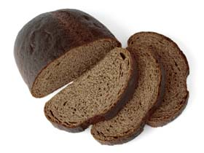 | blackryebread []– чорний житній хліб  Made from rye flour, this dense strong-tasting bread goes particularly well with seafood and smoked foods.
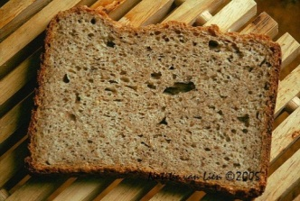 | cracked rye bread []– тріснутий житнійхліб  Thin crusty flat bread made with rye flour, usually eaten with cheese.

croissant []- рогалик
A small roll of layered or puffed dough, frequently eaten as a plain or stuffed pastry; it is also used to make hors d’oeuvres and sandwiches.
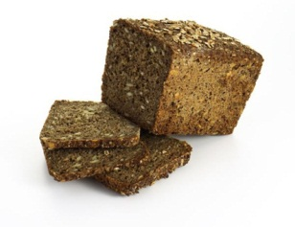 | Danish rye bread []– датський житній хліб  This bread is usually sweeter and lighter than German rye bread; it often contains molasses.

earloaf[]– колосиста буханка хліба
Baguette made so it can be easily broken into pieces by hand.
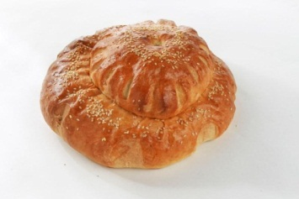 | Englishloaf [] – англійська буханка хліба  Thin-crusted, round or rectangular bread of British origin; it is primarily used to make toast, canapés, croque-monsieurs and sandwiches.
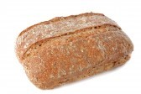 | farmhousebread []– фермовий хліб, домашній хліб  Its thick, often floury crust and slightly acidic-tasting interior can last a long time without becoming stale; it can be used in a variety of ways.

French bread [] - батон
Long crusty loaf resembling an oversized baguette; it stays fresh somewhat longer than the typical baguette.
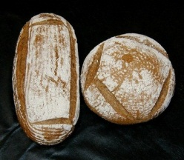 | German rye bread [] – німецький житній хліб  Dark dense bread with a strong, slightly acidic taste, made with rye and wheat flour; it has a long shelf life.

Greek bread []- грецький хліб
Round loaf with a golden crust, sometimes sprinkled with sesame seeds; olive bread is one of its many variants.
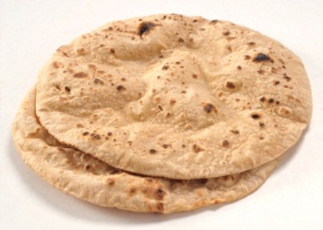 | Indian chapati bread []– індійський хліб  Flat crusty, slightly puffy bread, eaten warm with vegetables and rice or used as a spoon to scoop up food.
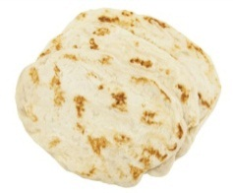 | Indian naan bread [[]]- маїсовий хліб  The yogurt in the dough of this soft light sweetish bread helps it rise; it is eaten plain or stuffed.
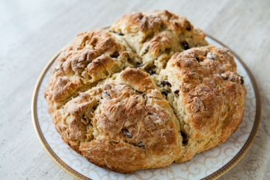 | Irish bread [] – ірландський хліб  The crust of this bread is marked with a cross; it is made with baking powder, which gives it a cakelike consistency.

Jewish challah [] – єврейська хала
Light soft sweetish bread traditionally served on the Sabbath and other Jewish festivals; it is usually braided.

multigrain bread [] – багато зерновий хліб
Usually contains 80% white flour, whole wheat flour or a mixture of the two, to which other cereals (oats, rye, etc.) are added.
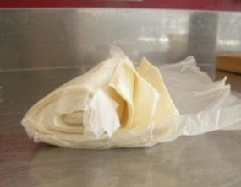 | phyllo dough [] - тісто філо  Flexible wafer-thin dough of Greek origin, used to prepare hors d’oeuvres and pastries, such as baklava.
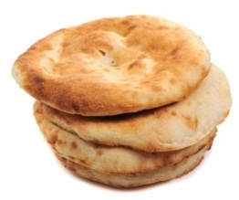 | pita bread [] - лаваш  Flat bread originally from the Middle East; its crust forms a pocket that can be filled with hot or cold kinds of stuffing.
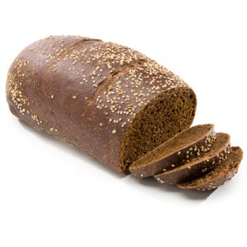 | Russianpumpernickel[] - російський хліб з грубого не просіяного житнього борошна  Made with a mixture of wheat and rye flour, it has a thin but resilient crust; it goes well with soups and ragouts.
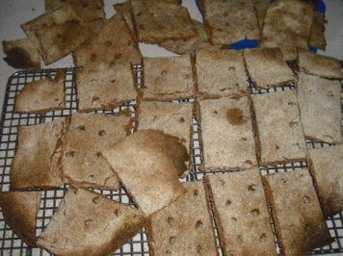 | Scandinavian cracked bread [] – скандинавський тріснутий хліб  Thin crusty flat bread usually made with wheat or rye flour; it is generally served with soup, salad or cheese.
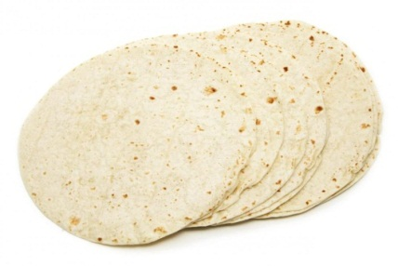 | tortilla []– плоский маїсовий коржик  Disk of unleavened bread made with corn flour that is the basis for many Latin-American dishes; it can be eaten plain, with a filling or cooked.
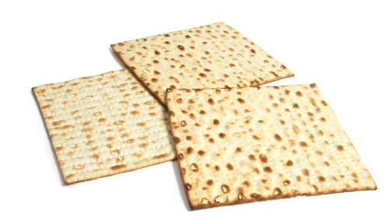 | unleavened bread []– прісний хліб  Light and crusty unleavened bread, eaten mainly during Jewish Passover; it is easily digested and has a long shelf life.

white bread [] – білий хліб
Bread made with white flour that comes in a variety of shapes, thickness and textures; it is less nutritious than wholemeal bread.
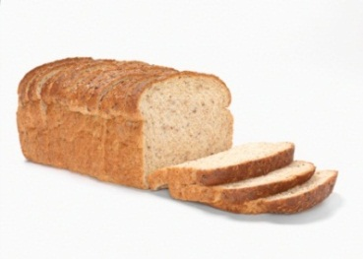 | wholemealbread[] – хліб з не просіяної муки  Because it is made with whole wheat flour, it is highly nutritious and contains more minerals and protein than white bread.
Рasta
Макароні вироби
Made from hard wheat semolina and water, shaped into various forms and dried; it is an essential ingredient in Italian cooking that is bought ready-made.

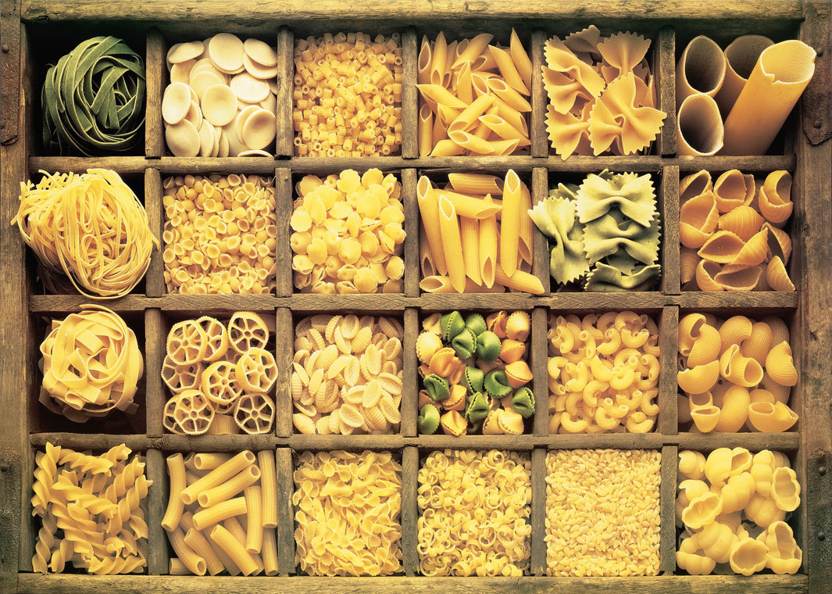

cannelloni []- трубочки
This fairly large tubular pasta is usually stuffed with meat or cheese, covered with tomato sauce and baked au gratin.
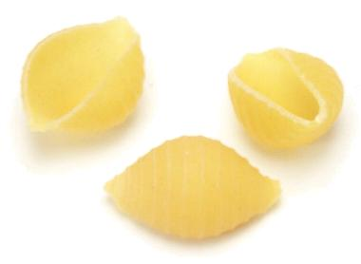 | conchiglie - мушлі  Small shell-shaped pasta that can be served with a sauce or added to soup or pasta salads.
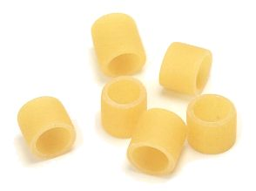 | ditali – ріжки деталі  Short tube-shaped pasta that resemble fat macaroni, used especially in broth and vegetable soups.
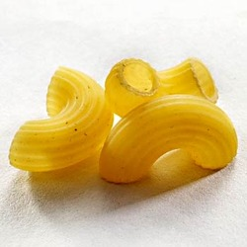 | elbows []– ріжки штопор  Sometimes used in a salad, this type of macaroni is also served with tomato or cheese sauce.
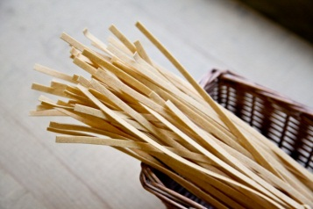 | fettucine - феттучини  Thicker but not as wide as tagliatelle, this pasta is often served with Alfredo sauce.
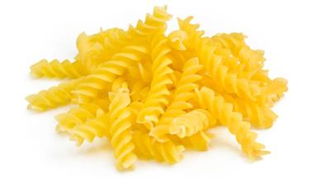 | fusilli - фузіллі  This spiral-shaped pasta is thinner and longer than rotini, but can replace it in most recipes.
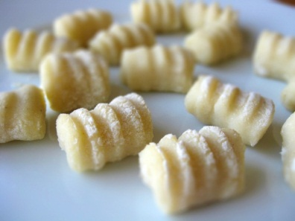 | gnocchi - ньокки  Often made from a potato or semolina dough with eggs and cheese; it is usually served au gratin, as an appetizer.
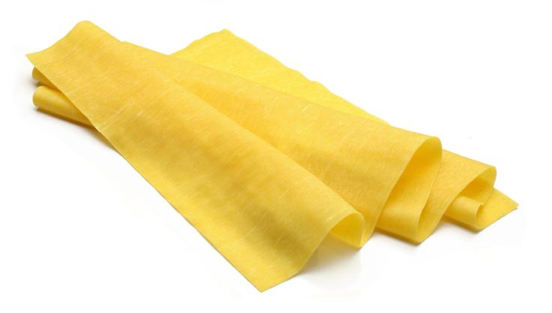 | lasagna - лазанья  These wide strips, green if spinach-flavored, are combined with a filling in alternate layers to create the eponymous dish.
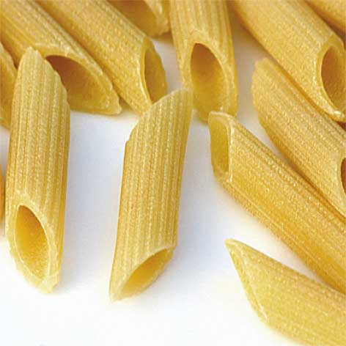 | penne - пенне  Tube-shaped pasta with diagonally cut ends, often served with a spicy tomato sauce in a dish called penne all’arrabiata.
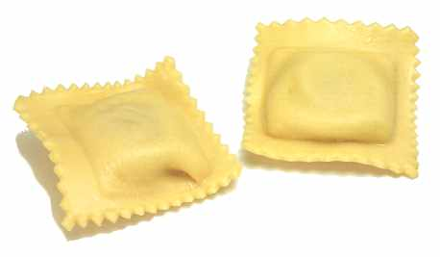 | ravioli [] - равіолі  Pasta stuffed with meat, cheese or vegetables; a classic way to serve it is with tomato sauce, sprinkled with grated Parmesan.
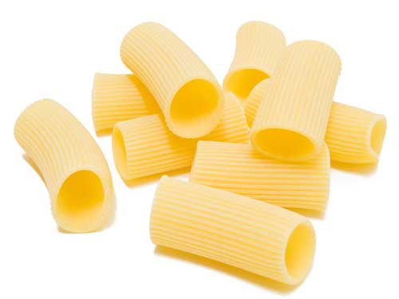 | rigatoni - ріжки  This fairly large tubular pasta is suitable for serving with all kinds of sauces because they cling to it readily.
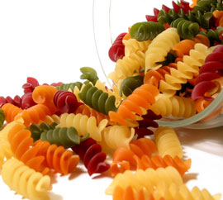 | rotini – ріжки рифлені  Because of its spiral grooves, it readily holds meat, cheese and vegetable sauces; it is also ideal for salads.
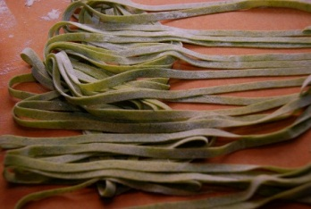 | spinach tagliatelle – шпинат тальятелле  Flat ribbonlike pasta made with spinach and eggs, traditionally served with meat sauce.
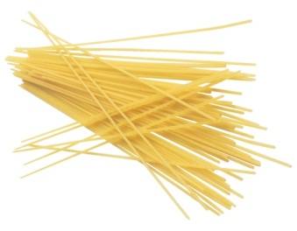 | spaghetti [] - спагетті  One of the best-known forms of pasta and the most extensively used; it is traditionally served with tomato or meat sauce.
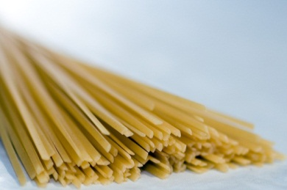 | spaghettini – шпагеттіні  Thinner than spaghetti but thicker than angel hair pasta or vermicelli noodles; it is particularly well suited to delicate sauces.
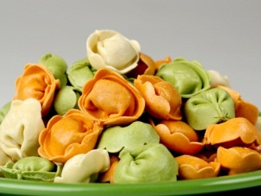 | tortellini []- пельмені  Pasta stuffed with meat or cheese and sometimes colored with tomato or spinach; it is delicious with tomato or cream sauce.
Asian noodles
Азіатськалокшина
This pasta is a staple of Asian cooking; generally classified according to its main ingredient: wheat, rice, buckwheat or mung beans.

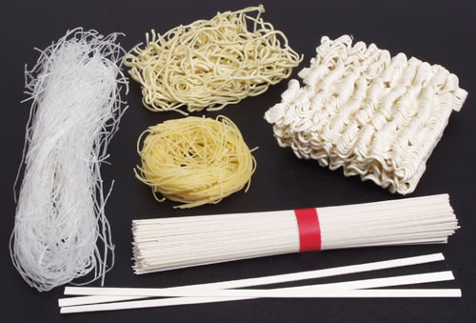

bean thread cellophane noodles []– бобова тонка локшина
Transparent noodles made with mung bean flour; before adding them to a recipe, they must be soaked in hot or warm water.
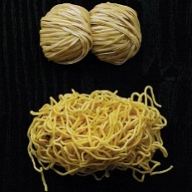 | egg noodles []– яєчна локшина  Wheat noodles made with eggs; they are boiled in water, then fried and used to make chow mein.
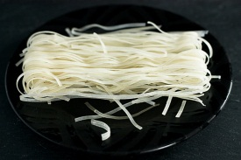 | rice noodles [] - рисова локшина  Wide ribbons made with rice flour and water; they are often added to soup.
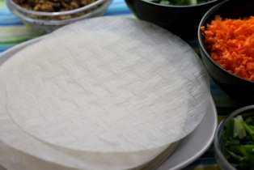 | rice papers [] – рисовий папір  Thin semitransparent sheets made with rice flour, used in Asia to prepare spring and imperial rolls.
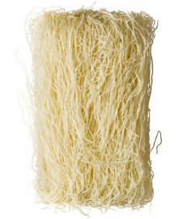 | rice vermicelli [] - рисова вермішель  Fine rice noodles that are fried in oil and shaped into a nest that is filled with various kinds of Asian food.
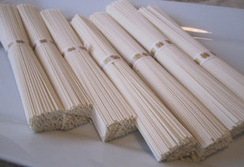 | somen noodles [] – локшина сомен  Fine whitish Japanese wheat noodles that go particularly well in salads and soups.
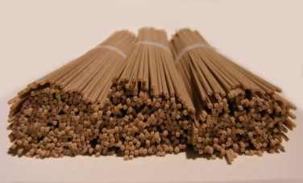 | soba noodles [] – локшина соба  Made with buckwheat flour, these noodles are used extensively in Japan, where they are mainly served cold, with soy sauce.
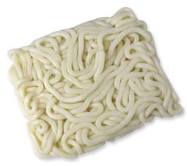 | udon noodles [] – локшина удон  These Japanese wheat noodles are thicker than somen noodles; among their various uses, they can be added to soup, salads and sautéed dishes.
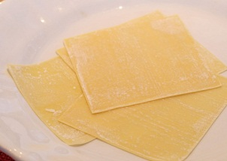 | won ton skins  Delicate sheets of wheat pasta that are stuffed with meat, seafood or vegetables; an essential ingredient in won ton soup.
Rice
Рис
Rice is commercially classified by the shape of the grain and the processing it has undergone before being packaged.

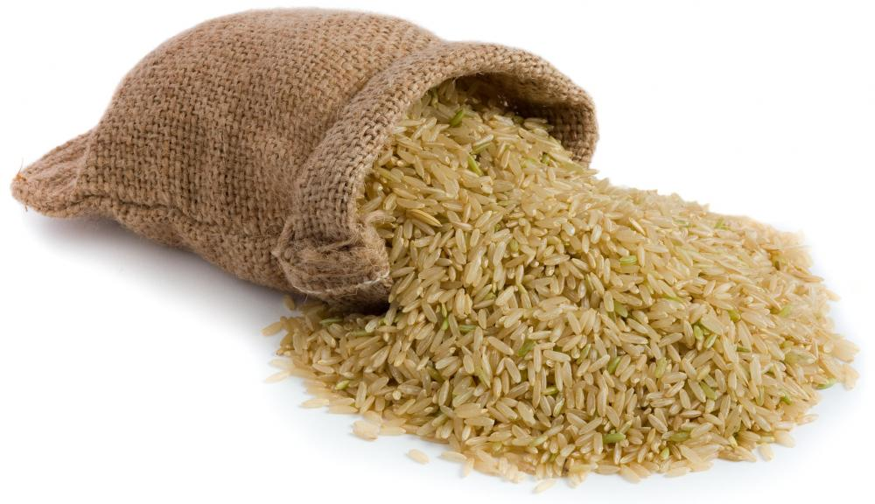

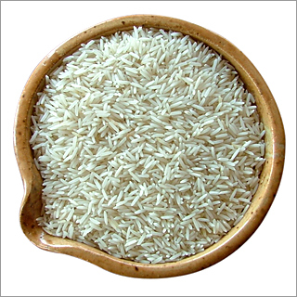 | basmati rice []– рис басматі  Variety of fine-grained rice native to India, it is known and prized for its aroma and light texture.
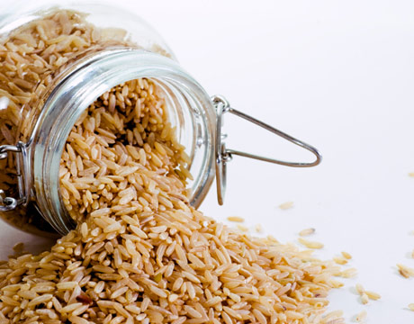 | brown rice []- лущений рис  Because it is not hulled, the grains retain the bran and germ; it is highly nutritious and has a stronger flavor than white rice.
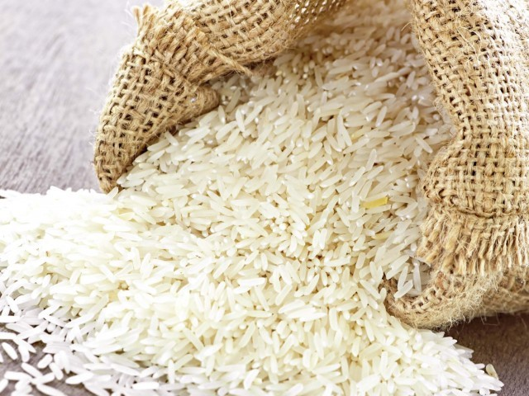 | parboiled rice []– пропарений рис  More nutritious than white rice, it has undergone a steam pressure process prior to milling, to preserve the grains’ vitamin and mineral content.
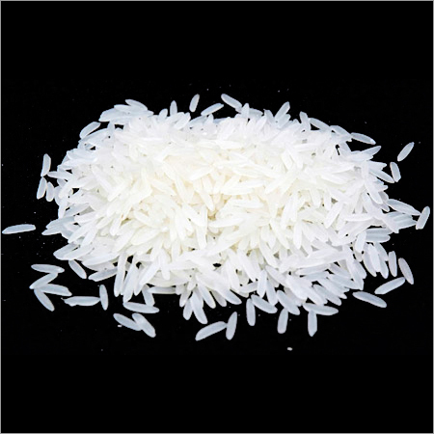 | white rice [] - шліфований рис  Milled rice from which the bran and germ have been removed; it is often enriched to compensate for the loss of nutrients.

Coffeeand tea
Кава та чай
Coffee - the seeds of the coffee tree can be used to prepare an extremely popular beverage, drunk hot or cold (iced coffee), and well known for its stimulant properties.
Tea - infusion made from the dried leaves of the tea tree; drunk hot or iced, it is the world’s most popular beverage after water; it is sold in bags or loose.

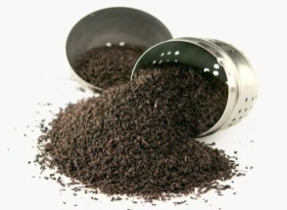 | black tea []– чорний чай  Made from tea leaves that are fermented and then dried, it represents more than 98% of the total worldwide production of tea.
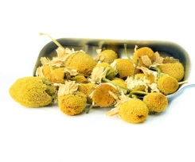 | chamomile [] - ромашка  Herbal teas made from the flowers and leaves of this plant are considered to have digestive and calming properties.
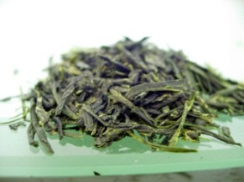 | green tea [] – зелений чай  This unfermented product is very popular in China, Japan and Muslim countries; it has a more bitter taste than black tea.
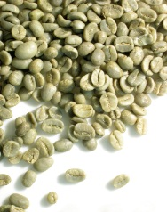 | greencoffeebeans[] - зелена кава в зернах  The green beans remain fresh for many years but the roasted beans quickly lose their flavor.
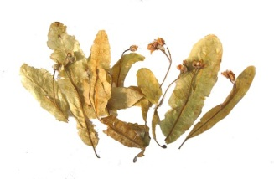 | linden [] - липа  Tree whose dried leaves and flowers can be made into herbal teas, considered to have calming, sedative and soothing properties.
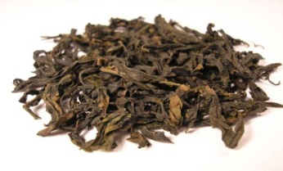 | oolong tea []– чай улунг  Semifermented tea; it has a stronger flavor than green tea but is more delicate-tasting than black tea.

roasted coffee beans []– смажені кавові зерна
Roasting beans by a dry method at high temperature enhances the coffee’s flavor and aroma.
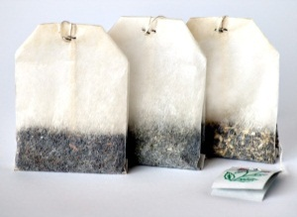 | tea bag []– чайний пакетик  Filled with ground leaves, it is often less flavorful than loose tea, which is composed of whole leaves.
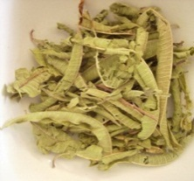 | verbena []- вербена  Herbal teas made from this native European plant are believed to have digestive and sedative properties.
Сhocolate
Шоколад
Smooth paste made with cocoa and sugar, extensively used in making candy and pastry and often eaten plain, as bars or squares.

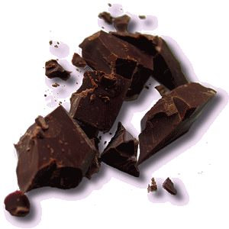 | dark chocolate []- чорний шоколад  Includes semisweet and bitter chocolate, which contain from 35% to 70% chocolate liquor; it is often used in cooking and is also eaten plain.
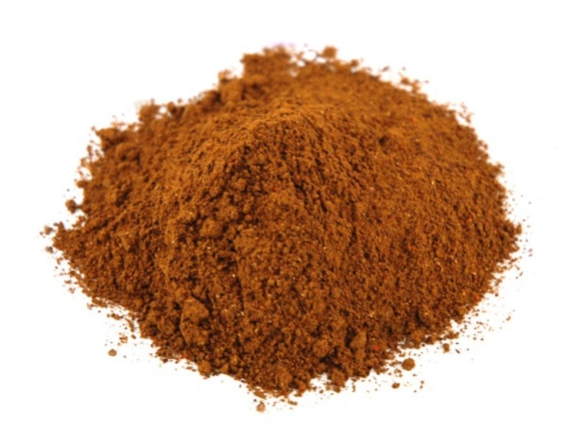 | cocoa [] - какао  The key ingredient in chocolate; grinding the beans of the cacao tree produces chocolate liquor, which yields cocoa butter and cocoa powder.
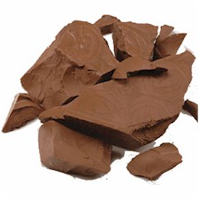 | milk chocolate [] - молочний шоколад  Made with chocolate liquor and cocoa butter mixed with powdered milk; it cannot be used in cooking because the milk solids it contains burn when heated.
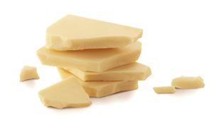 | white chocolate [] – білий шоколад  Sweet and creamy, it is made from cocoa butter, sugar and condensed or powdered milk.

Sugar
Цукор
Sweet-tasting foodstuff derived from certain plants; the most common varieties of sugar come from sugarcane and sugar beets.

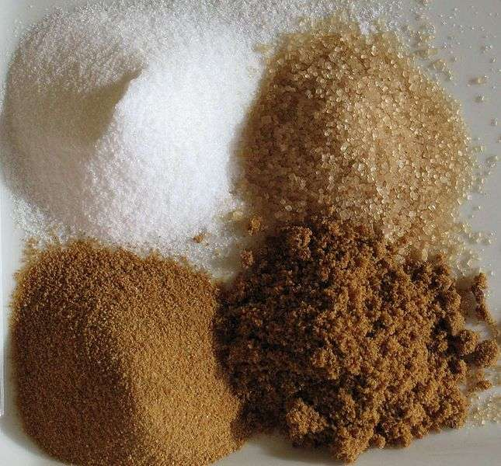

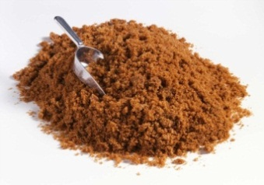 | brown sugar [] - коричневий цукор  Fine, only slightly refined sugar crystals that still contain molasses; it has a stronger taste than white sugar.

corn syrup[]– кукурудзяний сироп
Thick sweet syrup used extensively in making candy and pastry.
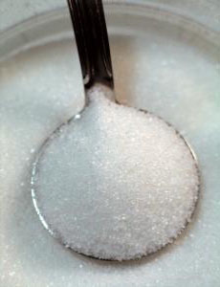 | granulated sugar []– гранульований цукор  The most commonly used sugar in cooking and baking; it is white, fully refined and composed of small crystals.
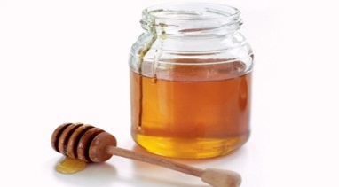 | honey[] - мед  Substance made by bees from flower nectar; its color and flavor vary depending on the nectar’s origin
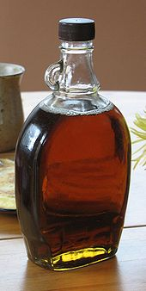 | maple syrup [] - кленовий сироп  Produced by reducing sugar maple sap; it is used to make various desserts and to accompany pancakes, poach eggs and glaze ham.

molasses []– меласа, чорна патока
Thick liquid residue from the process of converting sugarcane into sugar; it is used to make rum, candy, soft cookies and pies.
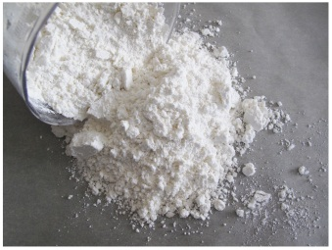 | powdered sugar []– цукрова пудра  White sugar in powdered form, containing about 3% corn or wheat starch, added to prevent caking; it is used mainly for icing and decorating.
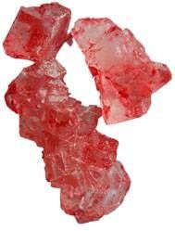 | rock candy []- льодяники  White or brown sugar in very large crystal form; it is used especially to sweeten fruits in brandy.
Fats and oils
Жири та олії
Animal or vegetable fatty acids in solid or liquid form generally used to cook, flavor, thicken or preserve foods.

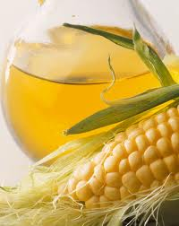 | corn oil []– кукурудзяна олія  Has relatively little flavor or odor; one of the most ubiquitous oils, used for cooking, frying and seasoning foods.
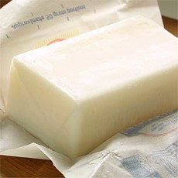 | lard [] – топлений свинячий жир  Pork fat; fatback is rendered into shortening whereas side pork (fat streaked with lean) provides lardons and bacon.
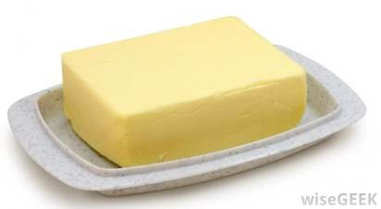 | margarine [] - маргарин  Fatty acid used as a substitute for butter; those made with vegetable oil contain no cholesterol.
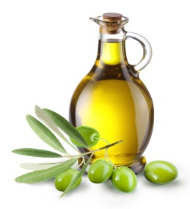 | oliveoil[] – маслинова або прованська олія  This extract derived from olive pulp is essential to Mediterranean cooking, both for preparing and seasoning recipes.

peanut oil [] - арахісове масло
Heat-resistant, mild-tasting oil equally well suited to frying and to dressing salads.
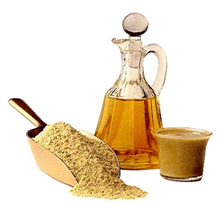 | sesame oil []– кунжутове масло  Very popular in Asian cooking and characterized by its rich delicate toasted-nut flavor; it is not well suited to high temperatures.
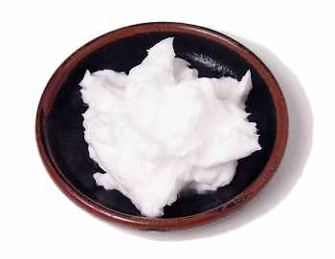 | shortening []- шортенинг  Substance produced by rendering pork fat; it is used for the lengthy cooking of certain ragouts, and for frying and for making pastry.

sunflower-seed oil []– соняшникова олія
This delicately flavored oil is the main ingredient in margarine and dressings; it is also used for frying sweet foods.
Dairy products
Молочні продукти
Foods produced by processing fresh milk; they are used daily in Western countries, where they are known for their high calcium content

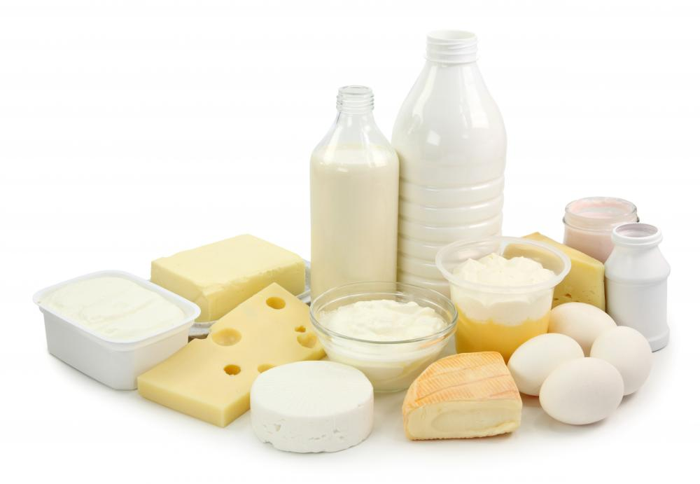

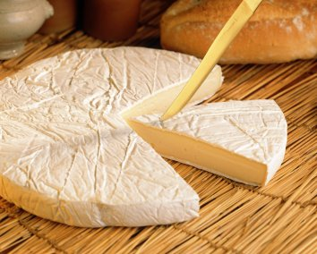 | Brie [] - брі  Native to Brie, near Paris, it is one of the best-known French cheeses; among its many varieties is the one from Meaux.
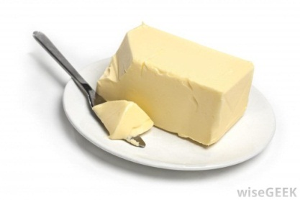 | butter [] - масло  Fatty rich substance produced by churning cream; it is used in cooking or is added to various recipes for sauces, pastries and creams.
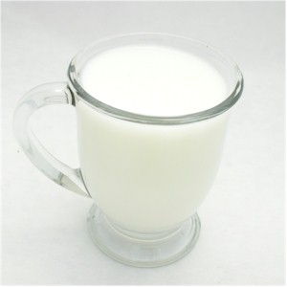 | buttermilk []– сколотини, маслянка  Tangy liquid that separates from cream during churning; today, commercial buttermilk is made by adding bacterial culture to milk.
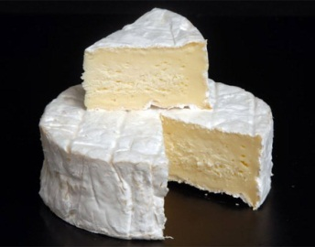 | Camembert[]– сир «камамбер»  Soft and easy to spread, France’s most famous cheese is smaller and slightly firmer than Brie.
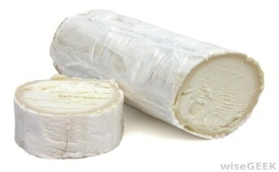 | Chèvre cheese [] - сир чевре  Fresh rindless cheese that has a tangy, mild taste; it is sometimes flavored with herbs.
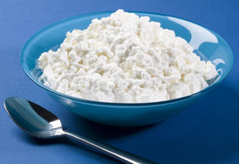 | cottagecheese[]– сир «котедж», домашній сир  Low in fat and grainy in texture; it works well as a spread or can be added to salads, desserts and sauces.
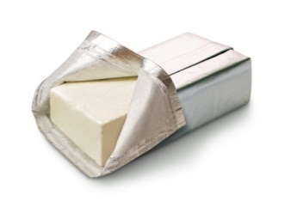 | cream cheese []– вершковий сир  Made with cream, which is sometimes mixed with milk; it is smooth and spreads easily, and is used as a spread or as a dessert ingredient (e.g., in cheesecake).
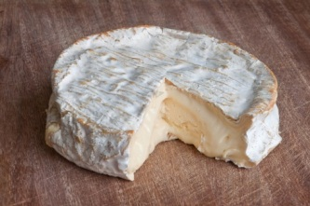 | Coulommiers - Куломьер  Native to the area around Paris, it is similar to Brie but smaller; it contains from 45% to 50% milk fat.
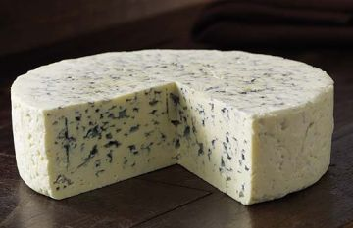 | Danish Blue []– датський голубий сир  Native to Denmark, it has a pungent flavor, a creamy texture and a milk fat content of up to 60%.
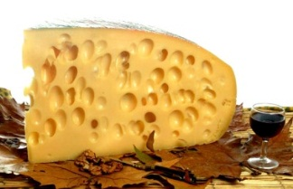 | Emmenthal - Емменталь  Characterized by large holes, this mild Swiss cheese is very popular in fondues and au gratin dishes.
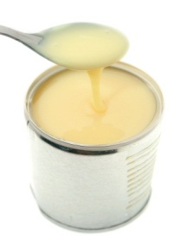 | evaporated milk []– згущене молоко  Milk from which a significant percentage of the water has been evaporated; it has a high milk fat content and is used primarily for making desserts.
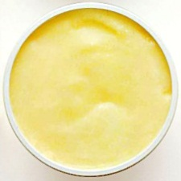 | ghee[]– перетоплене рідке масло  Clarified butter originating in Asia and traditionally made from buffalo milk; it is very popular in India and in Arab countries.

goat’s milk [] – козине молоко
Whiter and stronger-tasting than cow’s milk, it is also easier to digest.
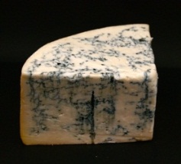 | Gorgonzola[]– сир горгонзола (сорт овечого сиру)  Native to Italy and recognizable by its textured gray rind, spotted with red.
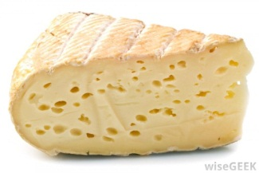 | Gruyère - грюйер  Swiss cheese with small holes called "eyes" and a medium-sweet taste; extensively used in cooking, either as is, grated or melted.

homogenized milk []– гомогенізоване молоко
Milk processed so the fat particles remain suspended instead of rising to the surface; varieties include whole, partially skimmed or skim.
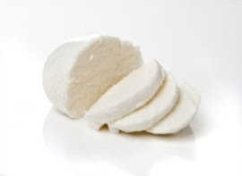 | mozzarella - моцарелла  This native Italian cheese has a rubbery texture and is firmer than other cheeses; it is the garnish of choice for pizza.
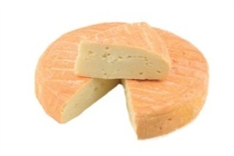 | Munster - Мюнстер  Cheese with a powerful penetrating odor, originally from the Alsace region; it has a creamy texture and a smooth moist rind.
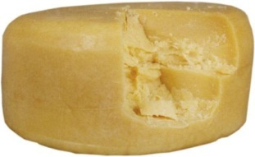 | Parmesan [] - сир пармезан  Strong-smelling Italian cheese with a grainy texture, sold in rounds or grated; it is a popular flavoring ingredient, especially for pasta dishes.
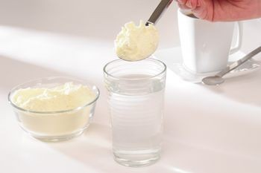 | powdered milk [] - сухе молоко  Dehydrated milk that can be stored for one year without refrigeration if the container remains unopened.
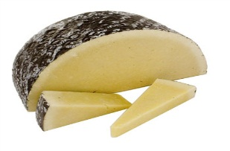 | Romano - Романо  Native to Rome, this dry granular cheese is made from cow, ewe or goat’s milk or a mixture of all three; it is mostly used in grated form.
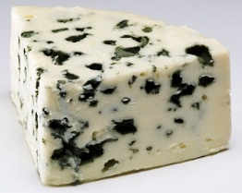 | Roquefort []- рокфор (сорт сиру)  The best-known blue cheese, originally from Roquefort, France; it is made from ewe’s milk and goes well with pears, cream and butter.
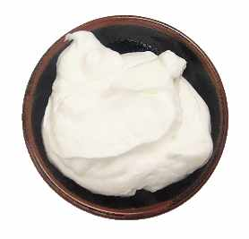 | sour cream []- сметана  Has a thick and creamy consistency and is obtained by fermentation and bacterial action; it can be used to flavor or garnish recipes.
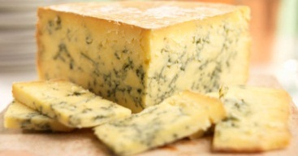 | Stilton []– стилтон (сорт, жирного сиру)  English cheese with a firm but creamy texture; it is often served with crackers and port.
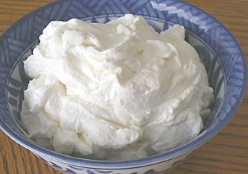 | whipping cream []– вершки для збивання  With a minimum 30% milk fat content, this is the richest cream; it is often whipped and used to make and decorate various desserts, such as cream puffs.
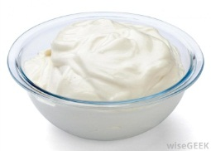 | yogurt [] - йогурт  Semisolid substance produced by milk fermentation and the action of bacterial cultures; it can be eaten as is or cooked.
Variety meat
Різновиди мяса
Edible parts of slaughter animals, apart from the meat.

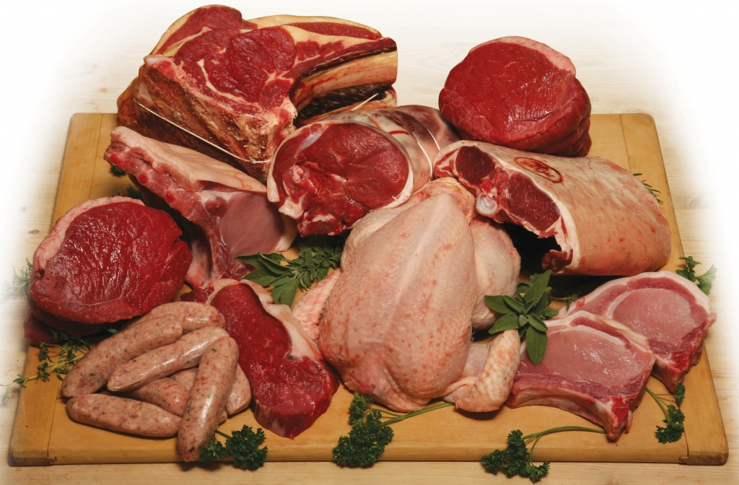

brains [] - мозок
Lamb, sheep and veal brains are the most prized, served in salads, au gratin, in croquettes, stuffings and sauces.
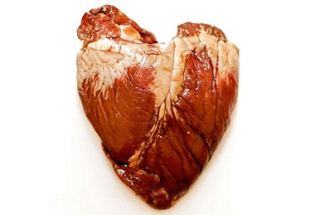 | heart [] - серце  Cooked in ragouts and casseroles, it can also be sautéed, roasted, braised or simmered; veal, lamb and chicken heart are the most popular.
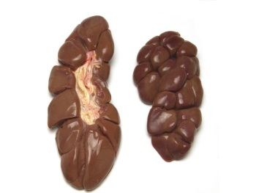 | kidney [] - нирка  Young slaughter animals such as calves tend to have more tender kidneys; there is an unpleasant aftertaste if they are not prepared carefully.
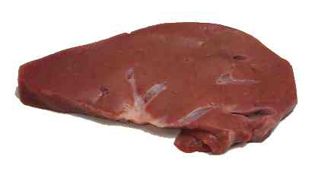 | liver [] – печінка, лівер  People eat the liver of slaughter animals, poultry, game and some fish (cod); it has a high iron content.
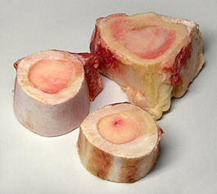 | marrow [] – кістковий мозок  Soft fatty tissue found in the centre of bones; it is served mainly with roast beef and cardons and can also be used to add flavor to soups.
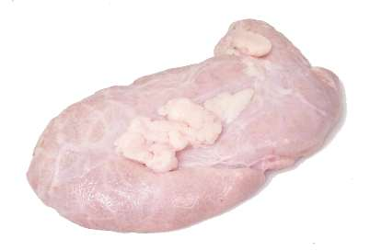 | sweetbreads []– «солодке м'ясо» (зобна е підшлункова залоза)  Designates the tender, delicately flavored thymus gland of calves, lambs and kids; veal sweetbreads are especially prized.
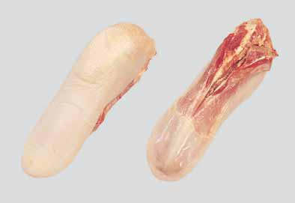 | tongue [] - язик  Covered with a thick skin that lifts off easily once cooked; calf tongue is the most tender.
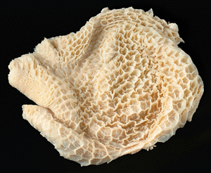 | tripe []– рубець (частина шлунку жуйної тварини)  Ruminants’ stomach lining, made ready for cooking; the main ingredient in many regional dishes, the best known being tripes à la mode de Caen.
Game
Дичина
Wild animals that can legally be hunted and eaten as food; includes large and small game animals and game birds.

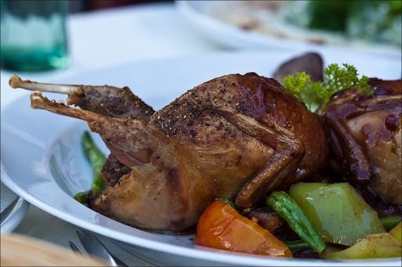

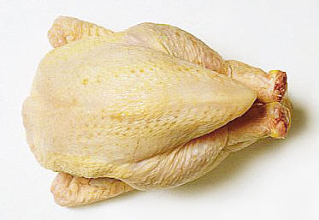 | guinea fowl []- цесарка  The same size as a small chicken, it is more flavorful when young and weighs less than 2 lbs; its flesh is slightly gamy.
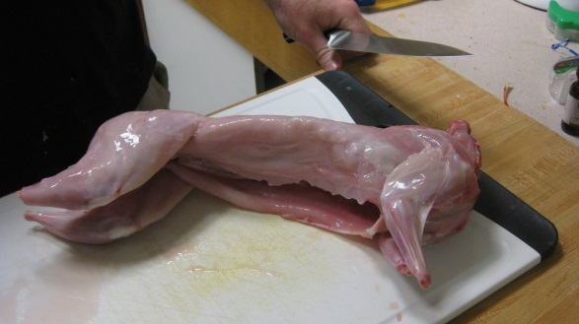 | hare [] - заєць  The dark meat has a stronger flavor than rabbit meat. Young hares can be roasted or sautéed; older ones are marinated, then jugged or made into terrine or pâté.
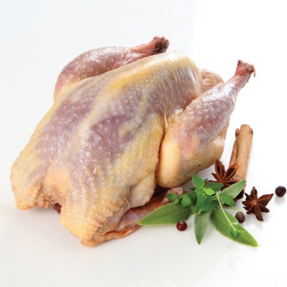 | pheasant [] - фазан  Young pheasant are often broiled and served with a moist stuffing; as they age, they become dry and less tender and so are usually made into terrine or pâté.
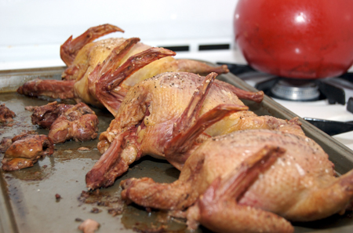 | pigeon [] - голуб  Eaten since ancient times, pigeon is broiled, sautéed or roasted, or braised when the bird is mature; it is traditionally served with green peas.
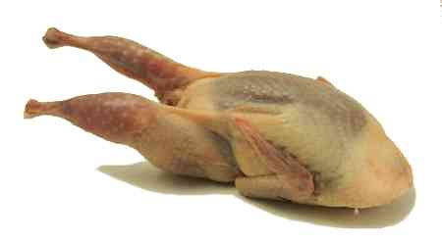 | quail [] - перепел  Roasted, braised, broiled or cooked in a casserole, this small bird is a prized delicacy; it is delicious cooked with grapes.
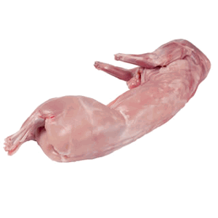 | rabbit [] - кролик  Wild rabbit has a more pronounced flavor than domesticated rabbit, which tastes like chicken; it is often prepared with a mustard sauce.

Poultry
М'ясо свійської птиці
Term that refers to barnyard fowl, most of which have been domesticated for centuries and are now mass-produced.

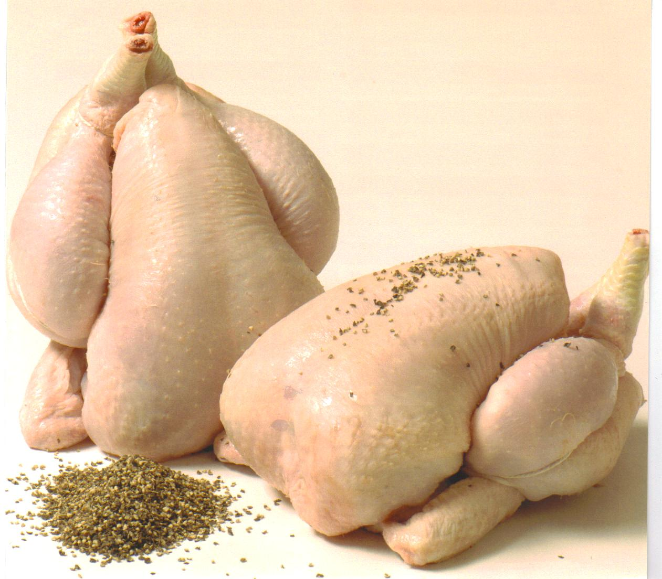

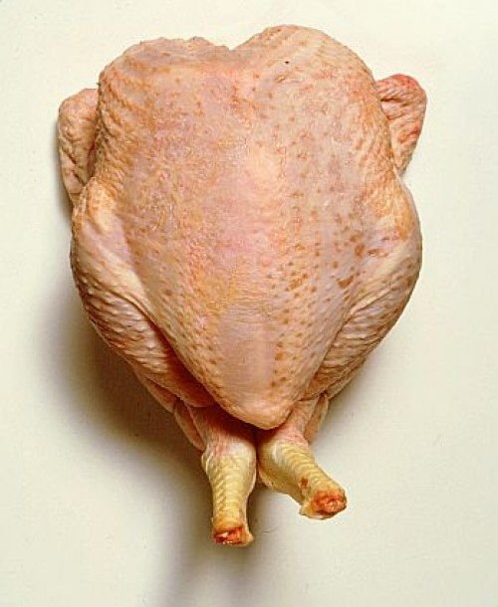 | capon []- каплун  Young rooster, castrated and fattened for slaughter; it grows to twice the size of a chicken yet has tender juicy meat.
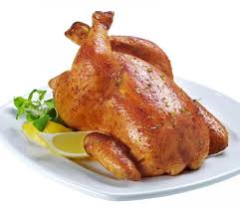 | chicken []- курча  The offspring of a hen, from 4 to 12 months old; it is cheap, tasty and can be prepared in numerous ways, thus it is the most popular type of poultry.
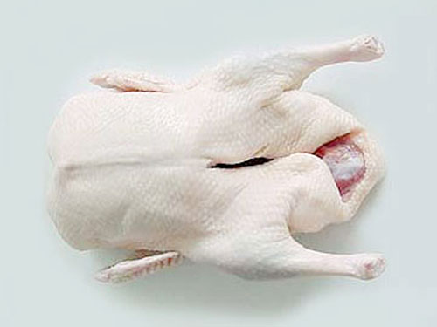 | duck [] - качка  The magret, or breast meat, can be roasted, fried or smoked; they are force-fed to produce foie gras.
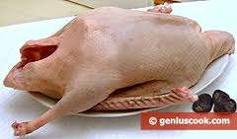 | goose [] - гуска  Often force-fed to produce foie gras, it is delicious stuffed or served with a fruit sauce; goose stuffed with chestnuts is a classic European dish.
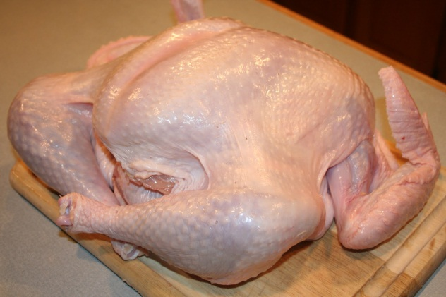 | turkey []- індичка  Prepared like chicken although its meat is drier; in North America, turkey with stuffing is the traditional Thanksgiving and Christmas meal.

Variety cuts of meet
Різновиди шматків м’яса
Flesh of slaughter animals, consumed as food; a distinction is usually made between red meat, such as beef and lamb, and white meat, such as veal and pork.

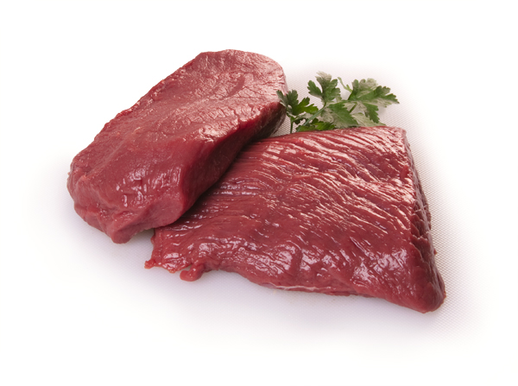

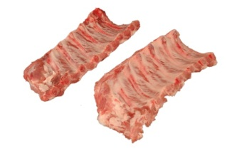 | back ribs []- ребра  They comprise sections of rib taken from the back and the attached muscles; they are delicious with a sweet-and-sour sauce.
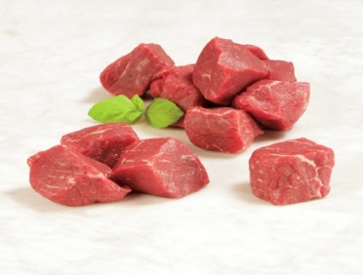 | beef cubes [] – яловичина шматками  Their tenderness varies, depending on the section from which they were cut; they are mainly used to make brochettes or ragouts, such as boeuf bourguignon.
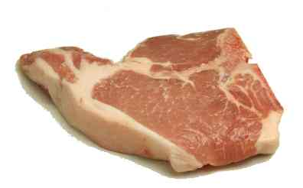 | chop [] – кусокм’яса  Piece composed of a bone from the rib section and the attached muscles, generally eaten grilled.
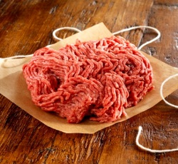 | ground beef []– фарш з яловичини  Made from various parts of the steer; when lean and taken from the tenderloin, it is the basis for steak tartare.
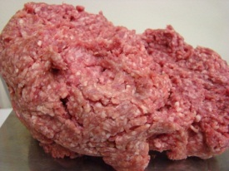 | ground lamb [] – фарш з баранини  Made from various parts of the lamb, it is used especially to make Greek moussaka.
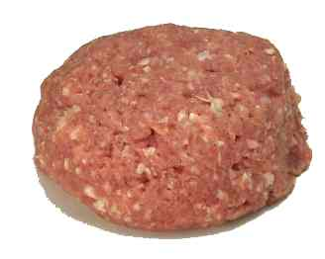 | ground veal []– фарш з телятини  Made from various parts of the calf, its flavor is less pronounced than that of ground beef.
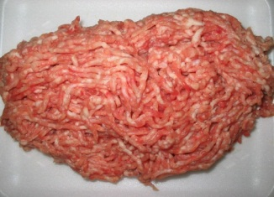 | ground pork []– фарш з свинини  It is made from various parts of the pig and is very tender; it is used especially to make stuffed vegetables and meat loaf.
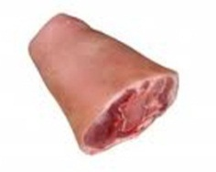 | hock []- окіст  Also called "shank end", it comes from the lower section of the pig’s front or hind leg; it is used to make the traditional pork hock stew.
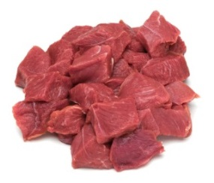 | lamb cubes []– шматки баранини  Their tenderness varies, depending on the section of the lamb they come from; they are used mainly to make brochettes or ragouts.
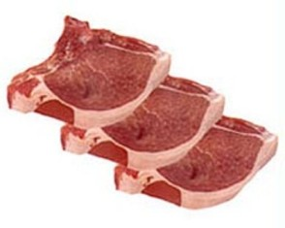 | loin chop [] – порціоний шматок м’яса  Piece composed of a bone from the rib section and the attached muscles; some, like the butterfly chop, are sold boned.
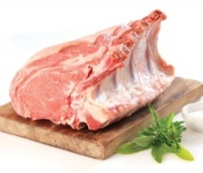 | rib roast[]- ребро  Piece of meat intended for roasting, taken from the animal’s rib section; this tender and tasty cut is one of the most popular kinds of roast beef.
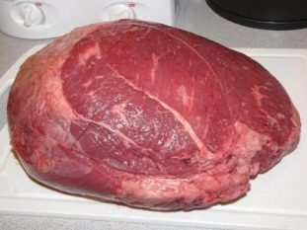 | roast[]– кусок м’яса для смаження  Piece of meat intended for roasting; the gigot, taken from the hind section of the carcass, is the best-known cut and is a traditional Easter dish in some countries.
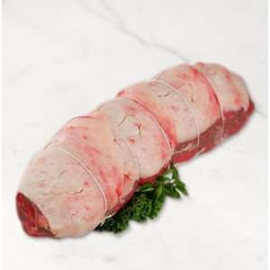 | roast[]– кусок м’яса для смаження  Piece of meat intended for roasting, of variable tenderness; since the meat is lean, it is advisable to bard the roast with fat before cooking it.
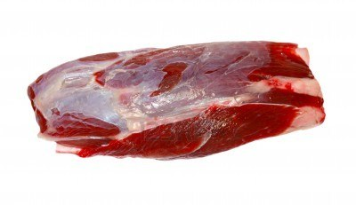 | shank [] - гомілка  Comes from a section of the front or hind leg of a calf; when sliced, it is primarily used to make the Italian dish called osso bucco.
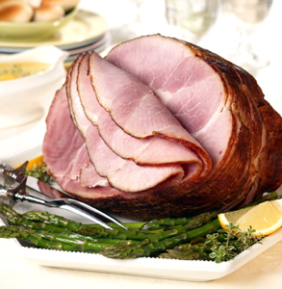 | smoked ham [] - капчена шинка  Taken from the pig’s legs, this cut is preserved by smoking; it is sold as is, boned or sliced and can be prepared in numerous ways.
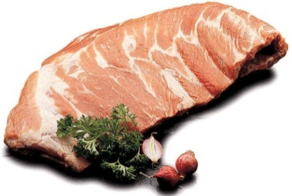 | spareribs []– свинячі порібнини  They comprise sections of rib taken from the back and the attached muscles; North American-style Chinese cooking usually serves them with sweet-and-sour sauce.
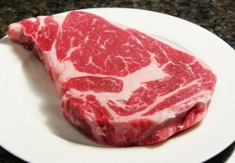 | steak [] - біфштекс  Strip of meat that can be grilled or sautéed; in general, the most tender steaks, loin, sirloin and rib, come from the central section of the carcass.
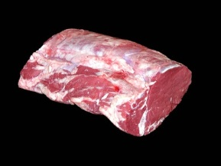 | tenderloin roast []- вирізка  Taken from the back, along the spine, it is prized for its tenderness and is excellent when grilled; tournedos and châteaubriand come from it.
Eggs
Яйця
Foodstuff that female fowl, especially hens, produce by laying; there are many ways of preparing them: e.g., soft-boiled, scrambled and in omelettes.

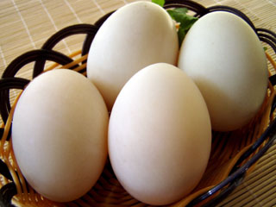 | duck egg [] – качине яйце  Prized in Asia for its taste, stronger than a chicken egg’s; it must be boiled for at least 15 minutes to destroy harmful bacteria.
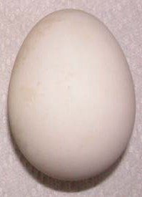 | goose egg []– гусине яйце  These relatively large eggs weigh approximately 0.5 lbs; they are rarely found for sale.
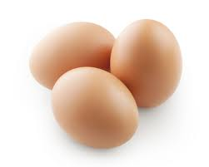 | hen egg []– курине яйце  By far the most commonly eaten, it is cooked as is or added to recipes; used alone, the word "egg" refers to a hen’s egg.

ostrich egg []– страусине яйце
The largest of all eggs, it can weigh up to 5 lbs; one ostrich egg makes an omelette large enough to feed 10 people.

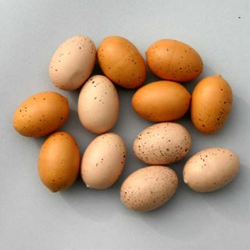 | pheasant egg []– фазанове яйце  Rounder and smaller than a chicken egg, it is not readily available; it is mostly eaten hard-boiled, in salads or aspics.
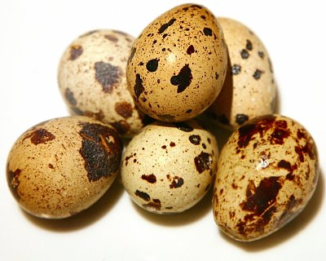 | quail egg []– перепилине яйце  Very popular in China and Japan, it is usually eaten hard-boiled, often as an appetizer; it also has decorative uses.

Delicatessen
Делікатеси
Foodstuff made from the meat (usually pork) or offal of various animals; among the many different varieties, some can be consumed as is, some are cooked.

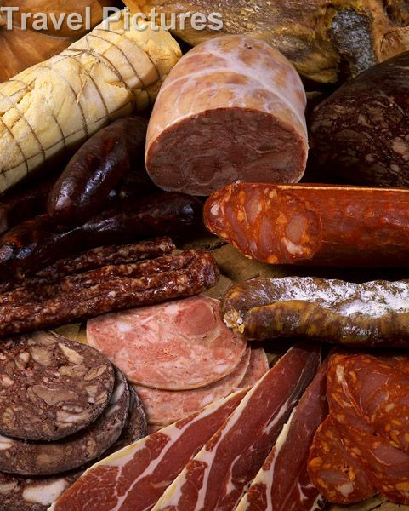

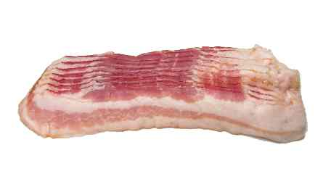 | American bacon []– американський бекон  Salted and smoked side pork, cut into thin slices; in North America, it is traditionally served with eggs, for breakfast.
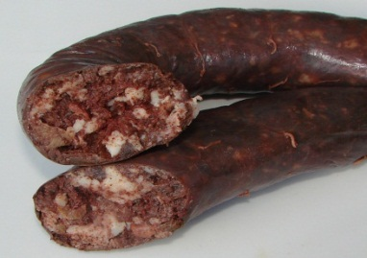 | blood sausage []– кров’яна ковбаса  The main ingredients in blood pudding are blood and suet (from pigs or other animals) packed into a casing; white pudding is made from white meat and milk.
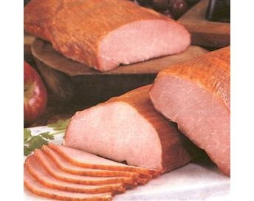 | Canadian bacon []– канадський бекон  Piece of salted, usually smoked, meat from the pork loin; it goes well with eggs and in dishes such as quiches and omelets.
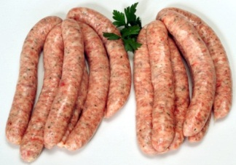 | chipolata sausage []– свинячі сардельки  Raw pork, or pork and beef, sausage characteristically flavored with cloves; it is often grilled or fried.
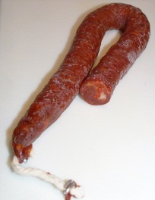 | chorizo [] – чорізо, іспанська сирокопчена ковбаса  Semidry Spanish sausage seasoned with red chiles, available in several versions that vary in spiciness; it is often added to paella.
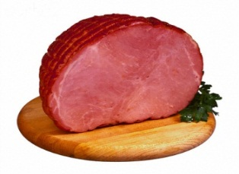 | cooked ham []- шинка  Salt-cured and cooked pork meat, usually served thinly sliced; it is eaten hot or cold, especially in sandwiches, and on croque-monsieurs and canapés.
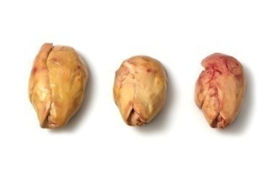 | foie gras – паштет з гусячої печінки  Goose or duck liver, abnormally enlarged by force-feeding; considered a gourmet item, it is sold raw or ready to eat.

frankfurter []- сосиска
Smoked precooked sausage that is native to Germany and made from a pastelike pork mixture; among its many versions is the American hot dog.
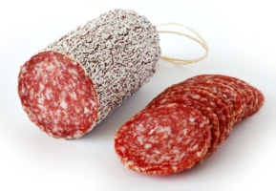 | Genoa salami [] - салямі  Dry Italian sausage made with a mixture of pork, veal and fat; the thin slices are often served as an hors d’oeuvre.
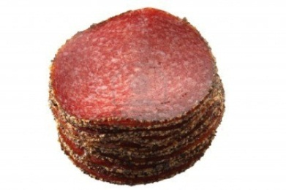 | German salami []– німецька салямі  Made with finely ground beef and pork, it is usually served sliced, as an hors d’oeuvre, but also on pizza and canapés and in sandwiches.

kielbasa sausage []– ковбаса
Native to Poland, it is made with coarsely ground pork and beef, seasoned with garlic and spices.
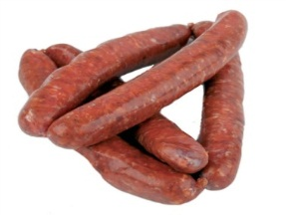 | merguez sausage [] – ковбаски мергуз  Small, highly spiced sausage made with lamb, beef or mutton; popular in North Africa and Spain, it is usually eaten fried or grilled.
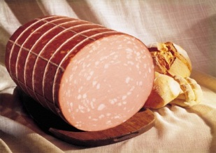 | mortadella - мортаделлу  Italian sausage made with meat and fat and flavored with peppercorns and pistachios.
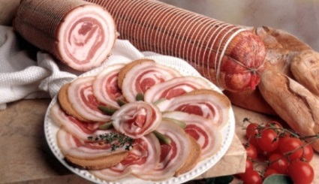 | pancetta - панчетта  Rolled Italian bacon, sometimes spiced; it is an essential ingredient in pasta alla carbonara and also flavors sauces, soups and meat dishes.
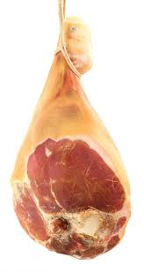 | prosciutto [] – гостра копчена шинка  Raw dried ham native to the Parma region of Italy; it is mostly eaten thinly sliced and served with melon or fresh figs.

Mollusks
Молюски
Usually marine-dwelling, soft-bodied invertebrates; some have shells and are sold live.

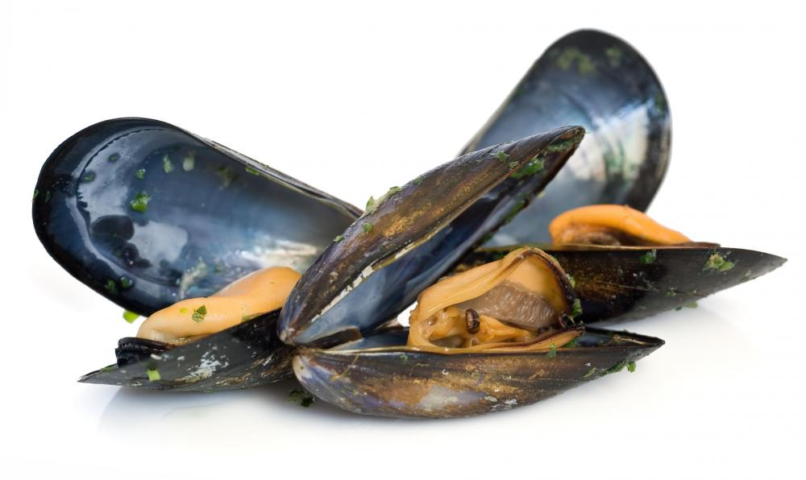

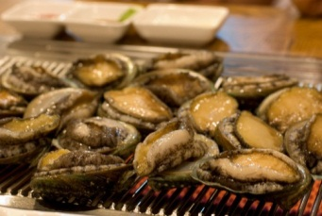 | abalone []– морське вушко  The muscle, also called the "foot", is delicious raw or cooked; it must be pounded before cooking.
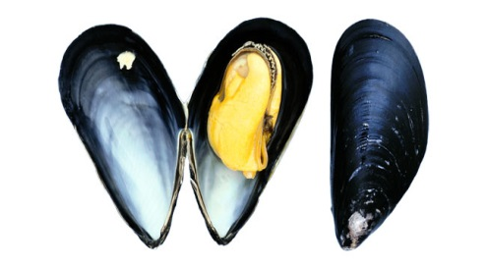 | blue mussel []– блакитна двостулкова молюска  Fresh mussels are usually poached in broth or steamed until they open; those that fail to open should be discarded.
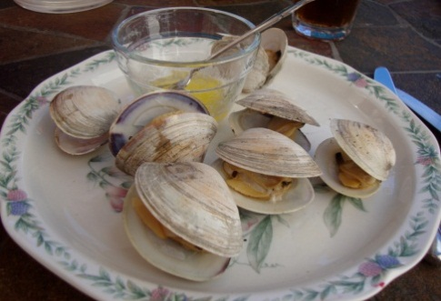 | clam []– клем, їстівний морський молюск  Related to the hard-shell clam, it is as tasty raw (with or without lemon juice) as it is cooked (in soups, or stuffed, like the blue mussel).
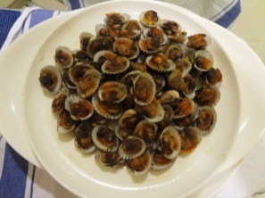 | cockle [] – черепашка молюска  Generally designates the European variety, although others exist; it has a firmer texture and a more pronounced flavor than oysters and mussels.
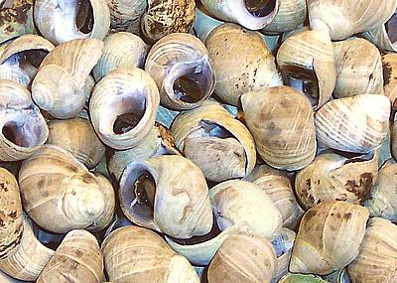 | common periwinkle []– береговий равлик  Its flesh resembles the snail’s, which it can replace in most recipes; whether eaten hot or cold, it is always cooked first.
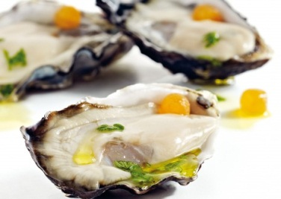 | cupped Pacific oyster []- чашоподібна тихоокеанська устриця  Juicy and meaty, with a well-developed lower shell; like all oysters, it is often eaten raw, either plain or with lemon juice.
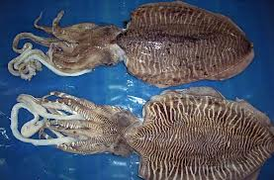 | cuttlefish []- каракатиця  The very firm flesh must be pounded before cooking and is delicious stuffed; the ink, or sepia, can also be used to color certain recipes.
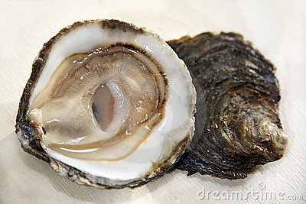 | flat oyster []– гладка устриця  Less common than the cupped oyster, with a completely flat lower shell; the belon variety is particularly prized.
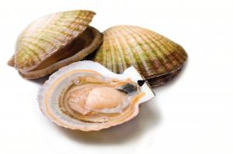 | great scallop [] - гребінець  Related to the scallop, the delicately flavored flesh is prized by Europeans; the shells are resistant to heat and are often used as cooking and serving dishes.
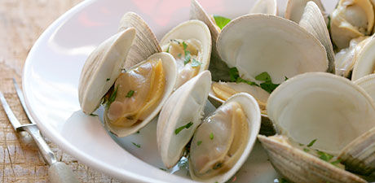 | hard-shell clam []– венерка (їстівний молюск)  Mollusk with a very hard shell whose flesh can be eaten raw or cooked; they are used to make chowder, a popular New England recipe.
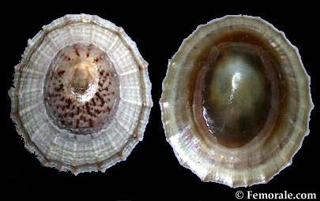 | limpet []- блюдечко  It has a single shell and is eaten raw with lemon juice or vinegar, or grilled, with butter.

octopus []– восьминіг, спрут
The tough flesh must be tenderized before cooking; it is delicious simmered, grilled or marinated.
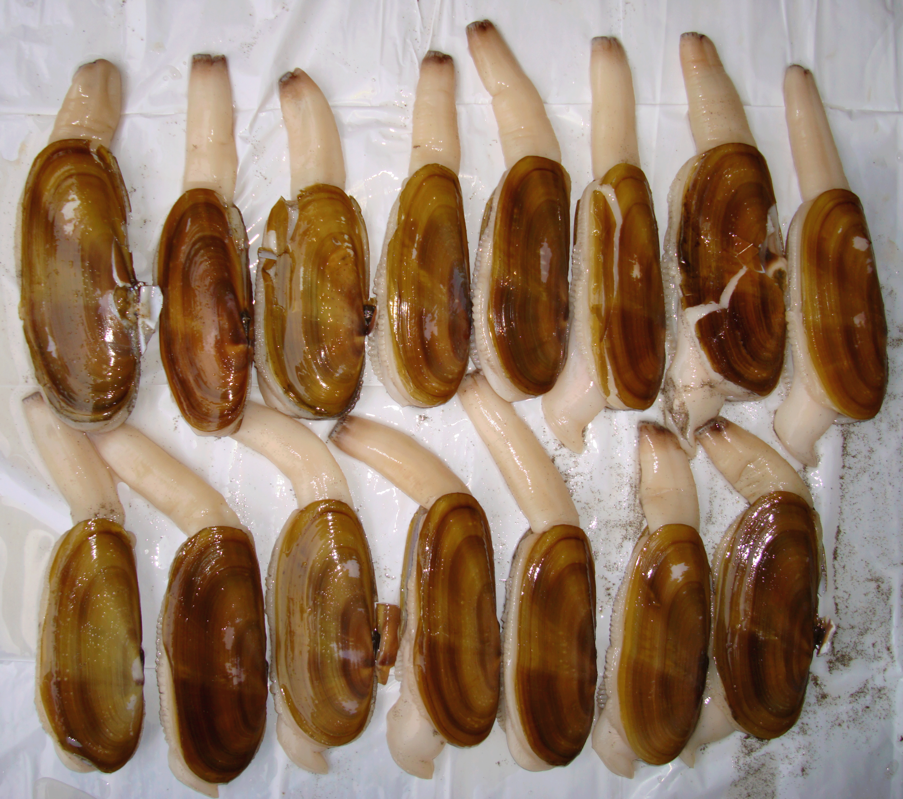 | razor clam []- бритва малюск  Elongated mollusk of the clam family, with a shell sharp enough to cut skin, hence its name.

snail []- равлик
Snails are often sold canned, frozen or ready-cooked; served with garlic butter, they constitute a classic appetizer.
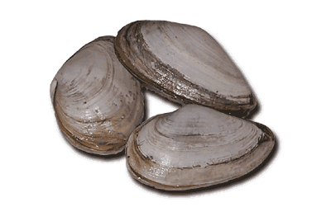 | soft-shell clam []– молюски з м’якю оболонкою  Primarily harvested in the Atlantic, this large soft mollusk of the clam family can replace the latter in recipes.

squid [] - кальмар
The edible parts are the tentacles, the body pouch and the ink; often grilled or fried, the lean flesh can occasionally be rubbery.
Crustaceans
Ракоподібні
Aquatic invertebrates having a carapace over their bodies; they are sold live, frozen (raw or cooked) or canned.

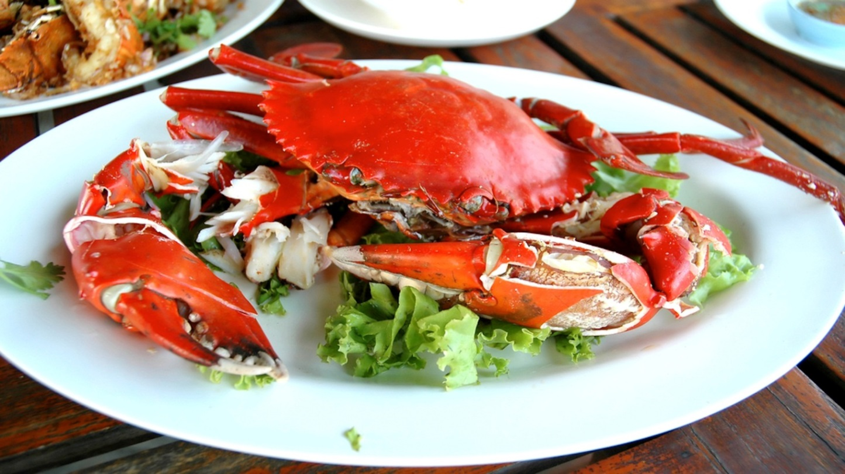

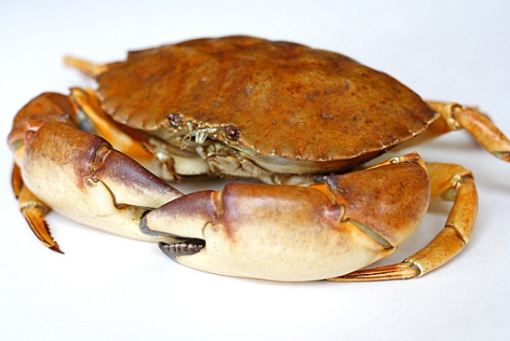 | crab [] - краб  Sometimes sold live and cooked like the lobster, its lean stringy flesh, its liver and the creamy substance under the shell can all be eaten.
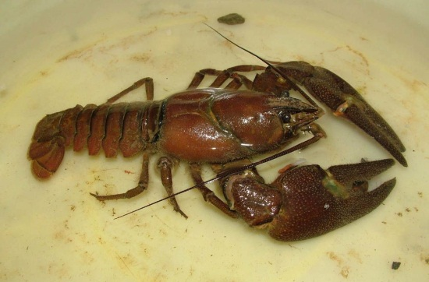 | crayfish []– річковий рак  Small freshwater crustacean usually prepared like lobster; only the tail is eaten and its pinkish-white flesh is lean and delicate.
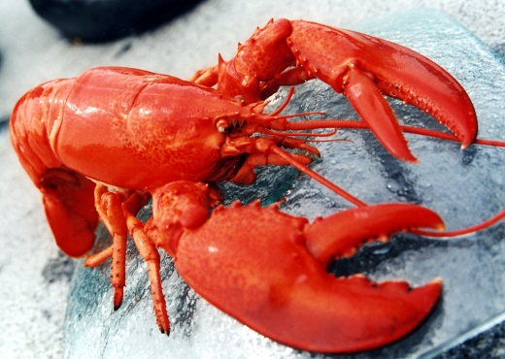 | lobster [] – омар  To ensure maximum freshness, the lobster should be cooked live, by plunging it into boiling liquid.
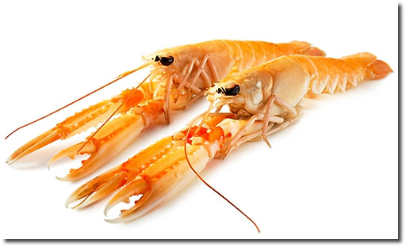 | scampi []- креветки  Rarely sold live, it resembles a small lobster but has more delicate flesh; it is often served with garlic butter.
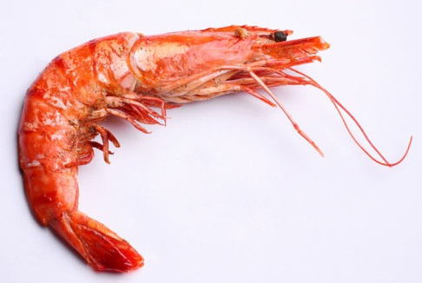 | shrimp [] – дрібна креветка  Delicious hot or cold; although many prefer them deveined, the intestine (the dark vein running along the back) is edible.
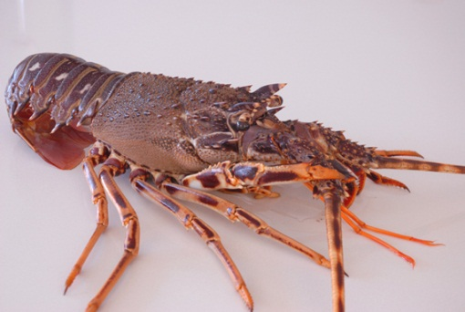 | spiny lobster []- лангуст  Spiny-shelled crustacean whose flesh is slightly less flavorful than the lobster’s; the tail is the only part that is commonly found for sale, either raw or cooked.
Cartilaginousfishes
Хрящові риби
Fish with skeletons made of cartilage rather than bones; their flesh usually contains no bones.

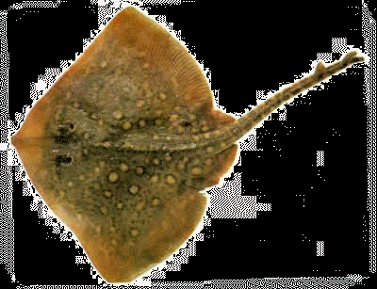

larger spotted dogfish [] – велика плямиста минь
Shark of the Mediterranean and Atlantic; it tastes best if cooked when very fresh and served with a flavorful sauce.

skate [] - скат
Its pinkish or whitish boneless flesh must be cooked until it is no longer viscous or gelatinous; the main edible parts are the wings (pectoral fins).

smooth hound []– щогловий бугель, чикс (щогли)
Shark of the Mediterranean, Atlantic and Pacific; its white flesh has a faint smell of ammonia that disappears with cooking.

sturgeon [] - осетер
This freshwater or saltwater fish of imposing size is prized for its firm flesh and its eggs, which constitute the true caviar.

Bonyfishes
Кісткові риби
Fish with smooth flat scales and a rigid skeleton; the various species make up the largest group of fish.

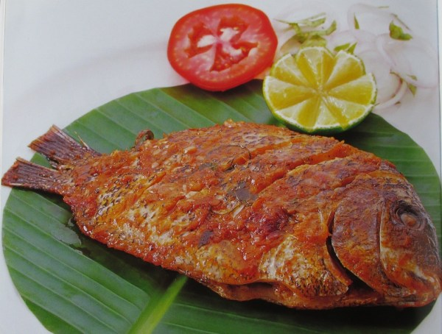

anchovy []– анчоус, хамса, кілька

Very popular in Mediterranean countries, this highly perishable fish is often preserved in brine, oil or salt and sold in cans or jars.

Atlantic cod [] – атлантична тріска
It is often dried or salted and its liver yields an oil that is rich in vitamin D; it is fished extensively off the Canadian and American coasts.
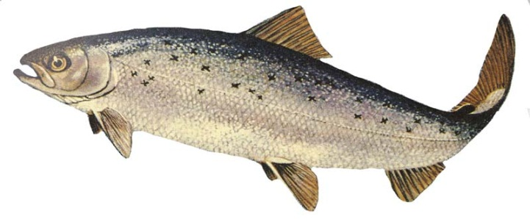 | Atlantic salmon []– атлантична сьомга  The only species of salmon inhabiting the Atlantic; it is prized for its pink, somewhat oily and fragrant flesh and is sold fresh, frozen and smoked.
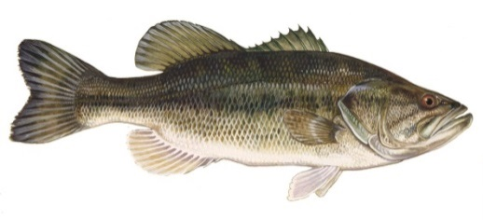 | bass [] - окунь  Rarely found for sale, this sport fishing species has lean flaky flesh that is well suited to all cooking methods.
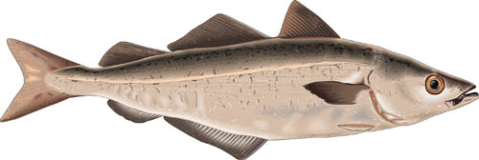 | black pollock []– чорна сайда  Especially popular in England, it is also used in Canada to make surimi, a paste from which imitation seafood is made.
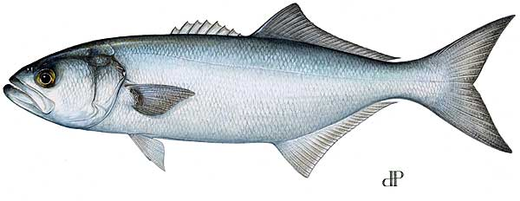 | bluefish [] – блакитна риба  Very popular in the U.S., this lean fish is often grilled, braised or poached; it is prepared like mackerel.

brook trout []- голець
Native to Canada, it resembles the trout and is greatly prized for its delicate flesh, which is best when simply prepared.

carp [] - короп
Soaking in vinegar water will make the sometimes muddy taste of the wild varieties disappear; it is especially prized for its tongue and lips.
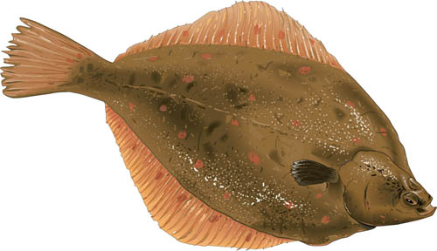 | common plaice []– камбала європейська  Because it has so many bones, it is often sold filleted and is one of the varieties used in fish-and-chips; it is found primarily off the European coast.

eel [] - вугор
Prized in Europe and Asia for its delicate firm oily flesh; its excess fat is removed when it is skinned.
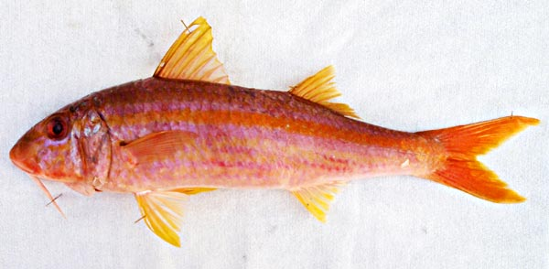 | goatfish - барабулька  In spite of its many bones, it is highly prized, especially in southern France, for its particularly delicate flavor.
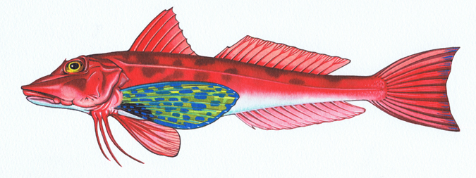 | gurnard []– морський півень  Somewhat lean, it is often used in soups such as bouillabaisse and in fish stews; it is also excellent baked, poached, fried or smoked.
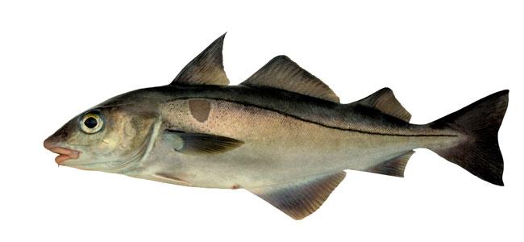 | haddock []– морський окунь  Related to cod but with flesh that is sweeter and more delicate; it is often smoked.
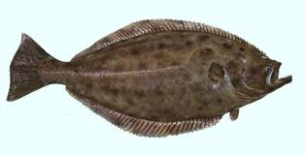 | halibut []- палтус  The largest of the flatfish family, it is commonly cooked in wine or served with anchovy butter; its lean flaky flesh has few bones.
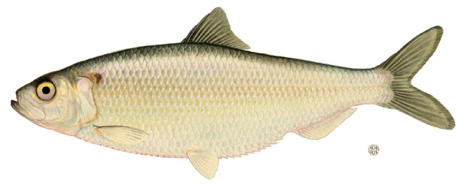 | herring [] - оселедець  One of the world’s most harvested species, it is sold fresh as well as canned, marinated, salted and smoked; it can replace mackerel in most recipes.
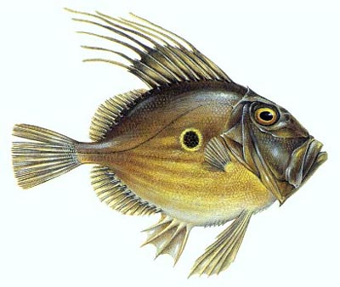 | John dory [] - сонцевик  Usually prepared like sole or turbot, its medium-firm flesh contains gelatinous bones that make an excellent fish stock.

lamprey []- мінога
The flavor of its oily boneless flesh is more delicate than the eel’s; lamproie à la bordelaise is a famous French gourmet recipe.
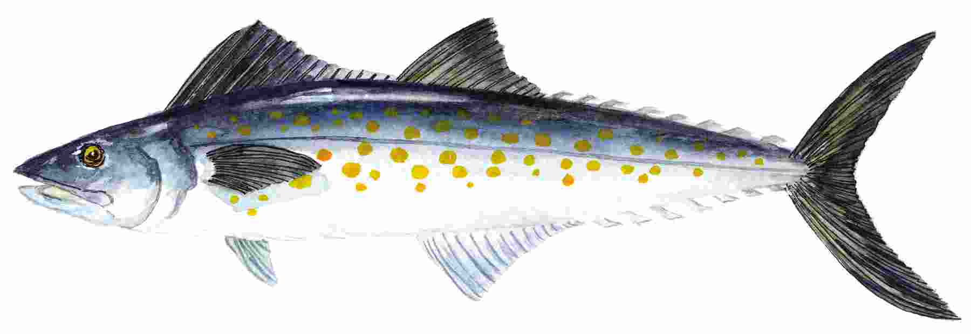 | mackerel [] - скумбрія  Traditionally served with gooseberry chutney, its somewhat oily flesh spoils rapidly if not eaten promptly.
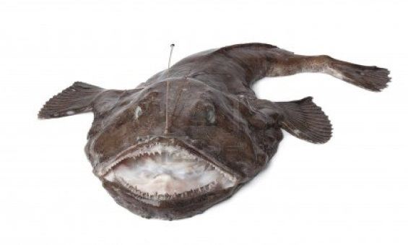 | monkfish []– морський ангел  Also called "angler fish", only its tail is eaten and the taste is said to be similar to lobster; it is delicious cold, served with a dressing.
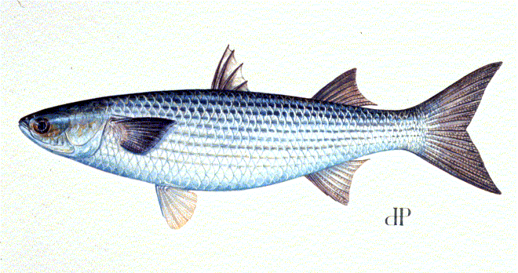 | mullet []- кефаль  Excellent hot or cold, it is well suited to all cooking methods; its eggs are used to make boutargue provençale and the Greek taramosalata (a creamy spread).

Pacific salmon [] – тихоокеанська лосось
King salmon (or chinook) has the oiliest flesh and is greatly prized; the leaner and less oily varieties are often canned.
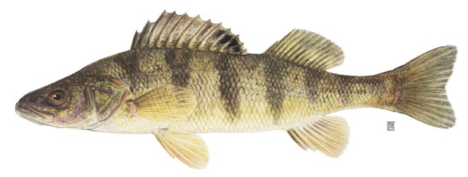 | perch []- окунь  Related to the pike perch, it is often poached, steamed or floured and fried in butter; its bony flesh has a delicate flavor.

pike [] - щука
The flesh sometimes has a slightly muddy taste that disappears with soaking; because it has many bones, it is often made into pâtés or quenelles.
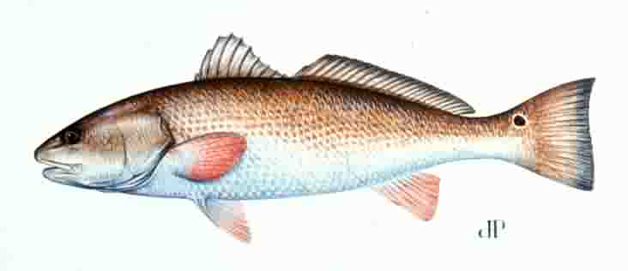 | redfish []– червона нерка; морський окунь  Excellent raw, cooked or smoked; if cooked in broth or grilled, it is best to leave the skin on to prevent its flaky flesh from falling apart.
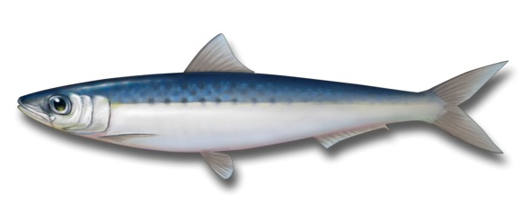 | sardine []- сардина  Related to the herring, it is often canned (in oil, tomato sauce or white wine) and is eaten with bread, as is or with lemon juice.
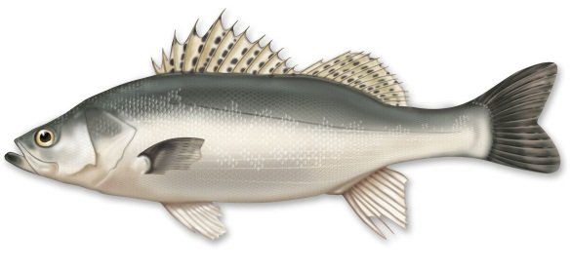 | sea bass []– морський окунь  Its firm lean flesh has few bones and withstands cooking well; it is best cooked simply, to avoid overpowering the delicate taste.
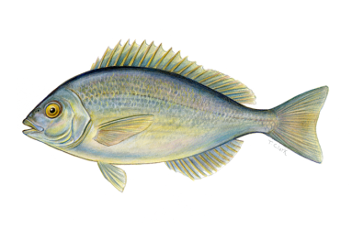 | sea bream []– морський лящ  Its delicate lean white flesh can be prepared in many ways although the simplest are the best; it is delicious smoked, in sashimi or in ceviche.
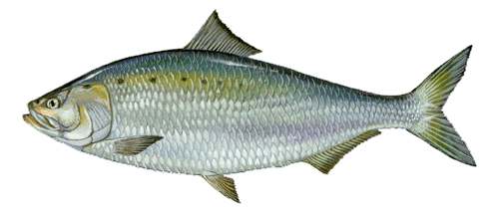 | shad []- алоза  Acidic ingredients such as sorrel and rhubarb are often used to prepare its somewhat oily, tender flesh; the bones of the female are more easily removed.

smelt [] -корюшка
The somewhat oily cucumber-scented flesh is the main part eaten, but the head, bones, tail and eggs are also considered edible; it is most often simply gutted and fried.
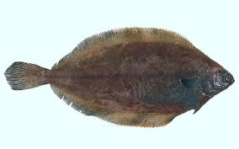 | sole [] - камбала  Often confused with plaice, it is only found in waters off the European coast; the most highly prized variety is the common or Dover sole.

swordfish [] – меч-риба
The highly prized flesh becomes easier to digest if it is poached before being prepared; the tail and fins are also edible.
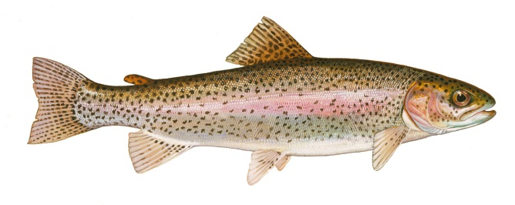 | trout []- форель  Freshwater fish with medium-oily delicate and fragrant flesh that is delicious smoked; rainbow trout is the species most often raised in captivity.
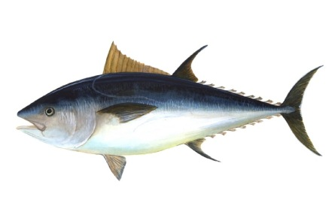 | tuna [] - тунець  Often canned in oil or water, it is one of the main ingredients in the Italian dish vitello tonnato; it is also used to make salads, sushi and sashimi.
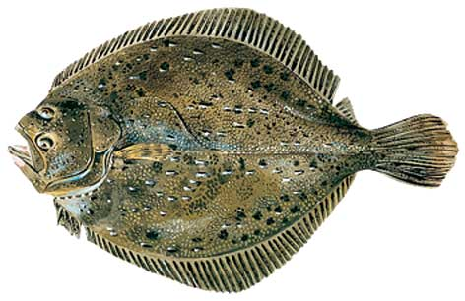 | turbot [] – білокорий палтус  One of the tenderest saltwater fish, with lean white flavorful flesh; sold whole or filleted, it is usually poached or grilled.
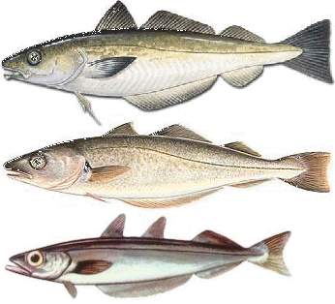 | whiting [] – хек, срібляста мерлуза, мерланг  Its delicate flaky flesh is similar to cod’s and is easy to digest; it is often wrapped in tinfoil or cooked in a flavored broth.
KITCHEN
КУХНЯ
Cooking, the main activity in a kitchen, includes anything to do with preserving, preparing or eating food.

Glassware
Вироби зі скла
Drinking receptacles; some are used to measure volume for cooking.

Alsace glass [] –келих Ельзас
Glass with a long stem, usually green, used to serve Alsatian white wines.

beer mug []– пивний кухоль
Large cylindrical vessel with a handle used to serve beer; it is usually made of thick glass, ceramic or stoneware.

bordeaux glass []–келих бордо
Tulip-shaped stemmed glass, mainly used for Bordeaux; tapering slightly at the top, it concentrates the aroma.

brandysnifter []-келих, звужений догори (для коньяку)
Short-stemmed glass whose pear shape allows the cognac to warm up, and whose narrow lip concentrates the aroma.

burgundyglass []–келих для червоного вина
Stemmed glass whose wide mouth ensures maximum oxygenation of the wine; it is used mainly for Burgundies.

champagne flute []–келих для шампанського
Tall and very thin stemmed glass used for champagne and sparkling wines; because the air bubbles break more slowly, the wine retains its effervescence longer.

cocktail glass [] - келихдля коктейлю
Conical stemmed glass used to serve certain cocktails; before serving, the rim of the glass can be frosted or decorated with fruit.

decanter []- графин
Glass or crystal carafe with a wide base and a narrow neck used to serve water or wine.

highball glass []- хайбол
Tall narrow straight glass used for serving liquor such as gin, often over ice or sometimes mixed with water, soda, etc.

liqueur glass [] - чарочка
Very small stemmed glass used for drinking liqueurs with a high alcohol content.

old-fashioned glass [] –«старомодний»
Wide short straight glass with a thick bottom primarily used for serving whiskey.

port glass [] –чарка для портвейну
Small rounded stemmed glass used to serve port and dessert wines.

small decanter []–маленький графин
Small carafe used in restaurants to serve wine.

sparkling wine glass [[]]–келих для ігристого вина
Stemmed glass, wider than it is tall, used to serve champagne and sparkling wines.

water goblet []–келих для води
Large stemmed glass used to serve water at the table; taller and wider than wine glasses.

white wine glass []–келих для білого вина
Somewhat narrow stemmed glass usually used for white wines.
Dinnerware
Посуд
Receptacles of various sizes, shapes and materials used to present food and for eating it.

bread and butter plate []–тарілка для хліба з маслом
Small flat plate used to serve desserts.
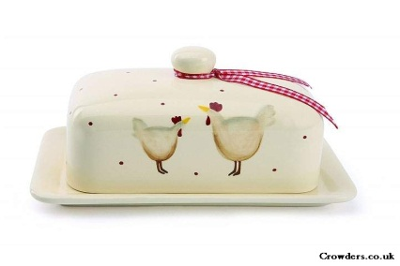 | butter dish []- маслянка  Flat covered receptacle from which guests serve themselves butter.

coffee mug []–чашка для кави
Large cup used to serve café au lait.

creamer [] – глечичок для вершків; сметаник
Small jug used to serve cream at the table.

cup [] - чашка
Cup, larger than the demitasse, used to serve tea.

demitasse [] – кавова чашечка
Small cup for serving coffee.

dinner plate []–тарілка для обіду
Large piece of flat or shallow dinnerware, usually containing individual portions of solid food.

fishplatter []–велике плоске блюдо під рибу
Large oval plate used to serve a whole cooked fish.
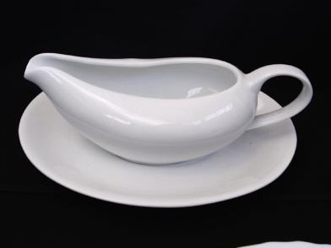 | gravy boat [] - соусник  Receptacle used to serve sauces at the table.
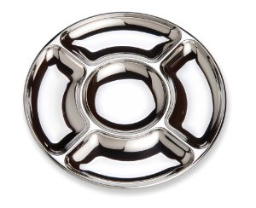 | hors d’oeuvre dish – блюдо під закуски  Serving platter divided into sections used to serve several complementary foods.
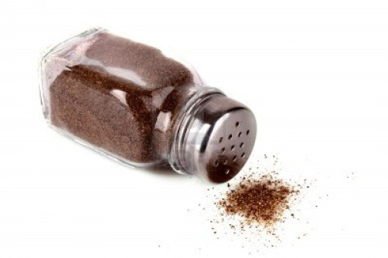 | pepper shaker[]- перечниця  Small receptacle used to serve pepper at the table, often paired with the salt shaker.

platter [] - блюдо
Large oval plate used to present and serve various solid foods, such as cuts of meat, roasts, grilled meat and omelettes.

ramekin []– порціонний горщичок або порціонна формочка
Small containers, suitable for oven and table, used to cook and serve individual portions.

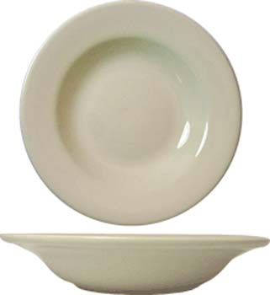 | rimsoupbowl[]–тарілка для супа  Shallower round container used to serve individual portions of soup.

saladplate []– тарілочка для салату
Flat plate commonly used to serve salads or appetizers.

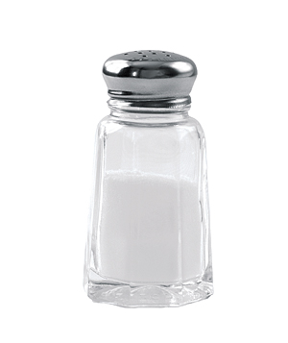 | salt shaker [] - сільниця  Small receptacle used to serve salt at the table, often paired with the pepper shaker.
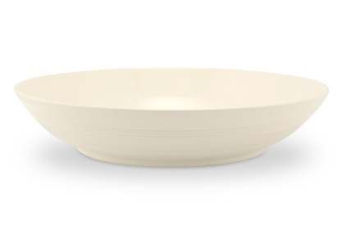 | soup bowl[] - миска  Deep round container used to serve individual portions of soup.
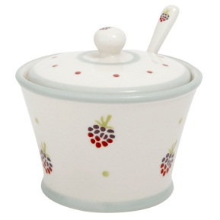 | sugar bowl [] - цукорниця  Small pot used to serve sugar at the table.
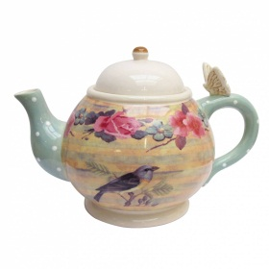 | teapot []– чайник (для заварки)  Receptacle used for steeping and serving tea.
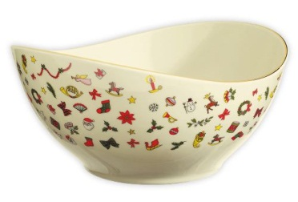 | vegetable bowl []–миска для овочів  Large receptacle used to bring side vegetables to the table.
Silverware
Столове срібло
Utensils used at the table, generally knives, forks and spoons, to which other utensils may be added, depending on the menu.

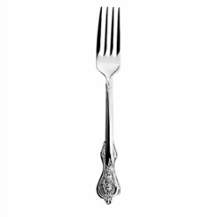 | dinner fork[]–обідня виделка  Large all-purpose fork that is part of a basic place setting.

dessert fork []–десертна виделка
Fork used to cut desserts into bite-sized pieces.

fish fork []–виделка для риби
Large fork, usually used for eating fish dishes.

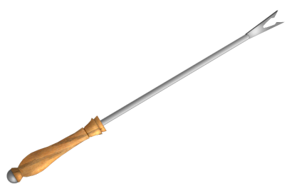 | fondue fork []–вилка фондю  Fork used to spear the bread served with a cheese fondue, or the meat served as part of Chinese fondue or fondue bourguignonne.
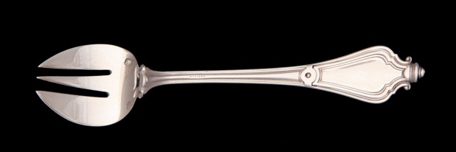 | oyster fork []–виделка для устриці  Fork used mainly to separate the flesh of a mollusk from its shell.
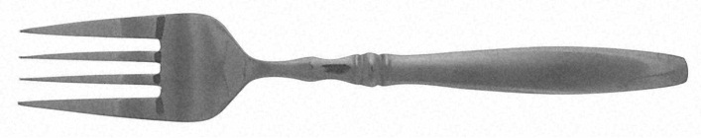 | salad fork []–виделка для салату  Fork used mainly for eating salad.
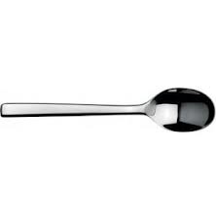 | coffee spoon [] – кавова ложка  The smallest utensil in this category, hence sometimes called a small spoon.

dessert spoon []– десертна ложка
Spoon used for eating liquid or semiliquid desserts.
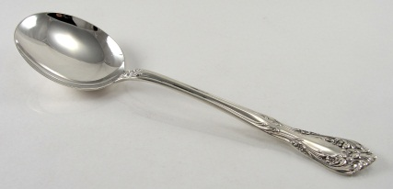 | soup spoon []– столова ложка  Spoon used for eating liquid or semiliquid foods; it is part of a basic place setting.

sundae spoon []- ложка для морозива
Long-handled spoon used for mixing drinks or eating desserts served in a sundae glass.
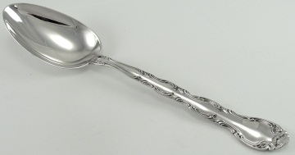 | tablespoon [ˈteɪblspuːn] - столова ложка; салатна ложка; мірна ложка  Largest spoon, with a capacity of .5 oz.

teaspoon []– чайна ложка
Somewhat larger spoon, with a capacity of 1/6 oz or 1/3 tablespoon.
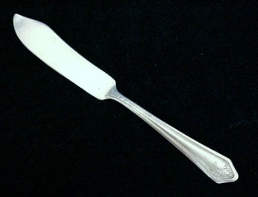 | butter knife []– ніж для масла  Blunt knife set out when bread is served and used for buttering it.

cheese knife [] – ніж для сиру
Its curved, double-pointed tip makes it easier to spear individual pieces of cheese.
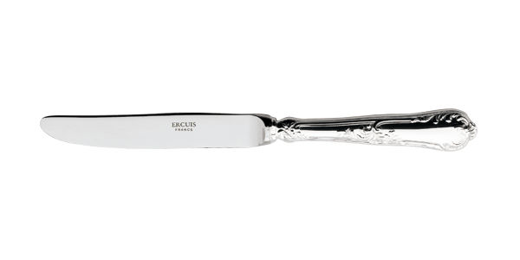 | dessert knife []– ніж для десерту  Small knife used to cut desserts into bite-sized pieces.
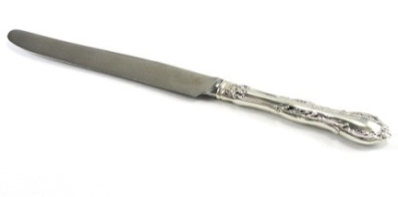 | dinner knife[]–столовий ніж  Large all-purpose knife that is part of a basic place setting.
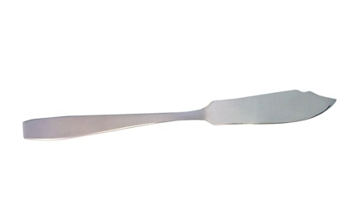 | fishknife []– столовий ніж для риби  Wide-bladed knife used to remove bones from a fish served whole.

steakknife[]– гострий столовий ніж, часто з зубчиками
Very sharp knife, often serrated, used to cut firm, often fried, pieces of meat.
Kitchen utensils
Кухонний посуд
Accessories or simple mechanical devices used for preparing food.

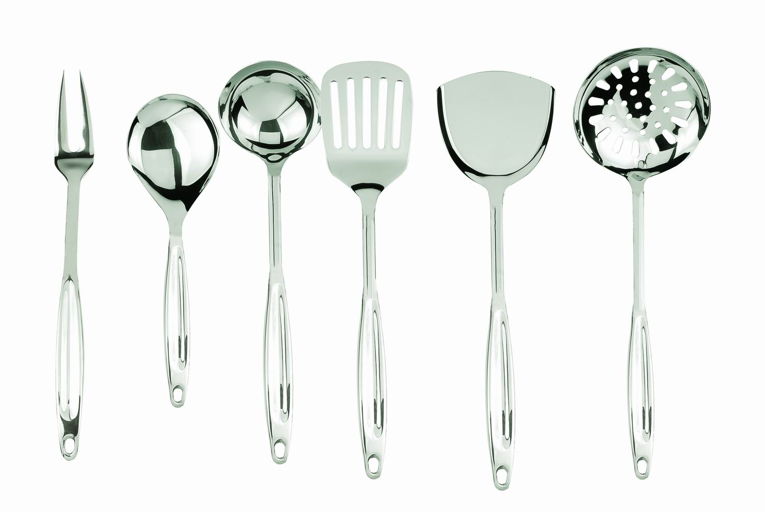

Examples of kitchen knives
Різновиди кухонних ножів
The shape and size of kitchen knives vary depending on their use and the type of food for which they are intended.

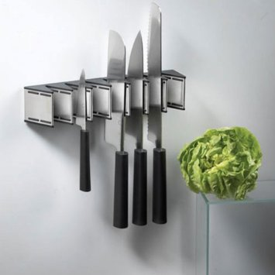

boning knife[]–ніж для кісток
Small pointed knife with a tapered blade used to separate the meat from the bones.

bread knife []– ніж для хліба
Serrated knife used for cutting fresh bread.

butter curler []–ніж для масла
Utensil with a serrated hook that creates butter curls when scraped across cold butter.
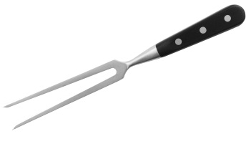 | carving fork []–виделка для різьби  Fork used to hold a piece of meat in place when it is being cut into portions.

carving knife [] – ніж для нарізування м’яса
Knife with a narrow blade used to slice pieces of cooked meat into portions.

cleaver []– сокира м’ясника
Knife with a wide rigid blade heavy enough to break bones.

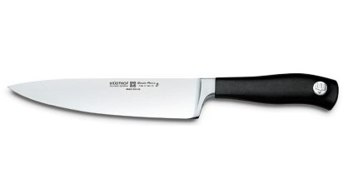 | cook’s knife []–ніж кухаря  Knife with a wide range of uses, from cutting large pieces of meat to chopping fresh herbs.
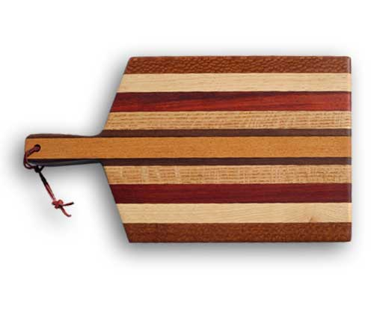 | cutting board []– обробна дошка  Made of plastic or wood and used for cutting up foods.
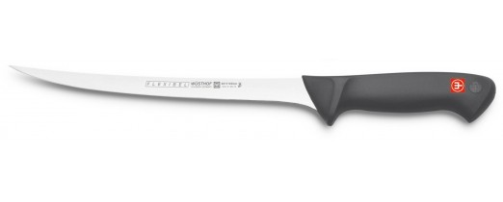 | filleting knife []–ніж для філе  Knife with a long pointed blade used for separating fish into fillets.
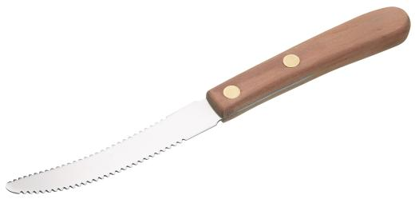 | grapefruit knife – ніж для грейфрукта  Knife used to detach citrus fruit pulp.
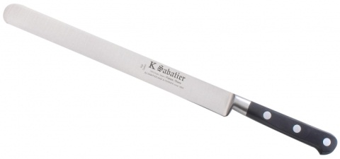 | ham knife []–ніж для шинки  Knife with a ridged blade used to cut whole cooked ham.
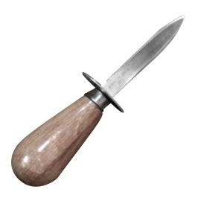 | oysterknife []– ніж для розкриття устричних черепашок  Double-edged knife with a guard used to open oyster shells by severing the muscle that holds them closed.

paring knife []– ніж для очищення овочів
Miniature version of the cook’s knife, it is used to clean, scrape and slice small pieces of food.
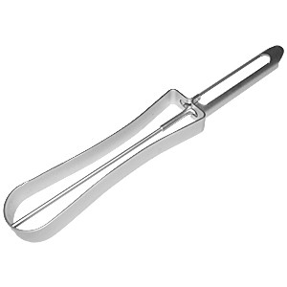 | peeler[] – машина для очищення від шкурки або шкірочки  Its pivoting blade follows the contours of the fruits and vegetables it is used to peel.

sharpening steel [] - мусат
Cylindrical steel rod with narrow grooves used for honing a knife edge.

sharpening stone [] - абразивний брусок
Abrasive stone used to sharpen knife edges.

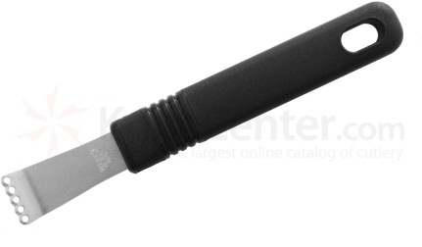 | zester - зестер  Knife whose blade curves at the end and has five small cutting holes; it is used to remove thin strips of rind from citrus fruits.

Foropening
Інструменти для відкриття
Instruments that remove lids, caps or corks from containers in order to provide access to their contents.

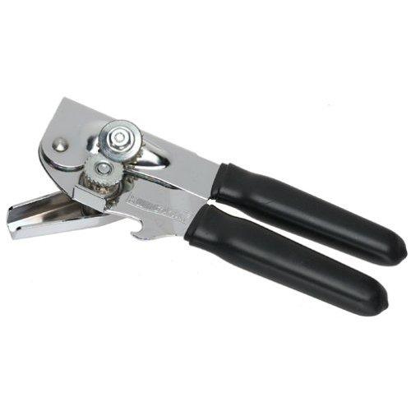 | can opener []– консервний ніж  Tool used to open cans by cutting along the inside edge of the lid.
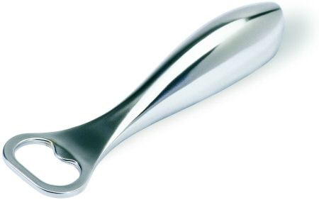 | bottle opener [] - відкривачка для пляшок  Instrument used to remove caps from bottles.
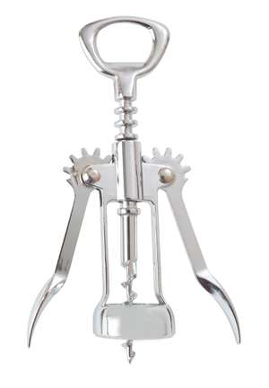 | lever corkscrew []- штопор  Instrument with a screw and two wings that rise as the screw penetrates the cork; they then act as levers to open the bottle.

wine waiter corkscrew[]– штопор сомельє
Instrument with a screw and a lever that open wine bottles by leverage, a blade for cutting the hood around the top, and a bottle opener.

Forgrindingandgrating
Посуд для шліфування і натирання
Instruments that can reduce food to fine particles, shavings, powder, purées, etc.

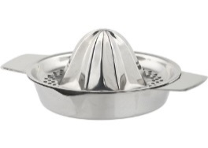 | citrusjuicer[] - соковижималка для цитрусових  Instrument used to extract juice from citrus fruits, usually lemons or oranges.

garlic press []–прес для часнику
Utensil used to finely crush garlic cloves.

grater [] - терка
Instrument used to reduce food such as vegetables, cheese and nuts into fine particles or a powder.

mandoline [] - мандоліна
Instrument comprising interchangeable cutting blades inserted in a frame; it slices vegetables in different ways, depending on the blade used.
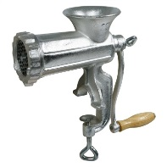 | meat grinder [] - м’ясорубка  Instrument with a knife and interchangeable disks used to grind meat; the perforations in the disks determine the size of the grind.
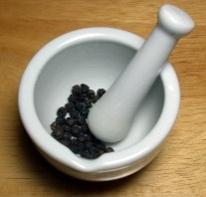 | mortar [] – ступка, ступа  Hemispheric receptacle made of marble, porcelain or hardwood in which certain foods can be ground with a pestle.
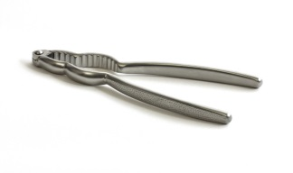 | nutcracker []– щипці для горіхів  Tongs used to break nutshells and release the kernel inside.

nutmeggrater[] – терка для мускатних горіхів
Small conical grater used to reduce nutmeg seeds to a powder.

pastamaker[]– машина для вироблення макаронних виробів
Instrument that can roll out and cut pasta dough into different shapes with its removable blades.
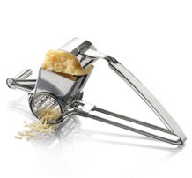 | rotary cheese grater []– терка для сиру  Instrument used to grate cheese by scraping it against the teeth of a rotating drum.
For measuring
Посуд для вимірювання
Instruments designed to measure the volume or weight of ingredients, food temperature, and cooking or preparation time.

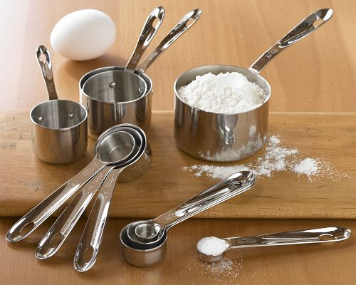

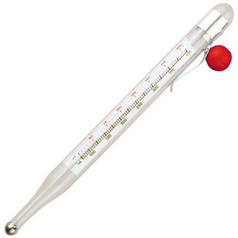 | candy thermometer [] – термометр для варіння льодяників  Thermometer that is placed in hot liquid sugar mixtures to measure their exact temperature.

eggtimer[] - трихвилиннийпісочний годинник
Device with two glass vials, one of which is filled with sand; the flow of the sand between the vials measures a precise time period.

instant-read thermometer []– миттєвий термометр
Digital thermometer that, when inserted into a roast, instantly indicates the meat’s internal temperature.

kitchen scale []– кухонні ваги
Instruments used to weigh dry ingredients (e.g., flour, sugar, rice).

kitchen timer []– кухонний таймер
Device used to measure a period of time; once that time has elapsed, the timer rings.

measuring beaker [] - вимірювальнний стакан
Graduated container used to measure dry and liquid ingredients.

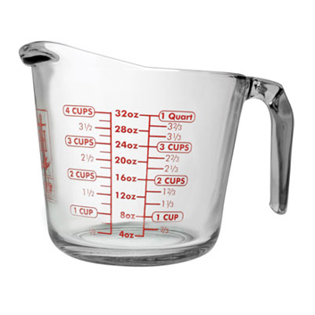 | measuring cup []– мірний стаканчик  Graduated container with a pouring spout used for measuring liquids.
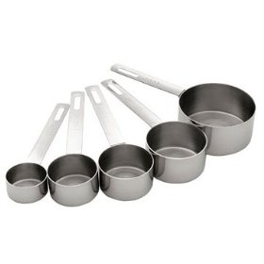 | measuring cups []– мірні стаканчики  Receptacles used to measure the exact quantity of an ingredient.
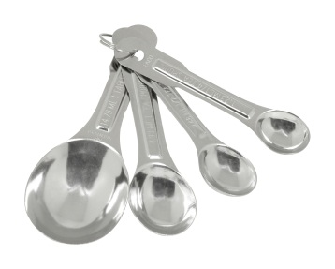 | measuring spoons [] – мірні ложки  The bowls on these spoons correspond to an exact quantity of an ingredient, and are used to measure it.
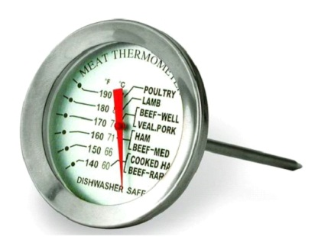 | meat thermometer []– термометр для м’яса  Thermometer inserted into a roast to check its degree of doneness.

oven thermometer [] - термометр печі
Thermometer that is placed inside an oven to check the exact temperature.

For straining and draining
Посуд для проціджування та сушіння
Instruments used to filter dry or liquid foods, or to remove the liquid used to wash, blanch, cook or fry certain foods.

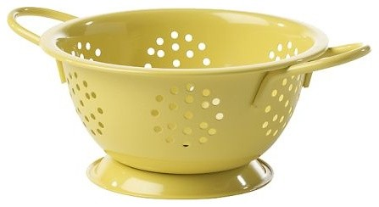

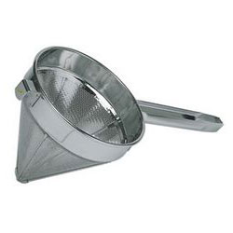 | chinois – сито конічне  Finely meshed cone-shaped strainer used to filter broth and sauces, and to reduce food to a purée.

colander [] - друшляк
Instrument used to drain food.

frybasket[] - корзина для смаження
Metal mesh receptacle designed to hold foods during frying and drain them afterward.

funnel [] - лійка
Cone-shaped instrument ending in a tube used to pour liquid into a narrow-necked container.
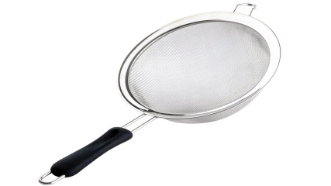 | mesh strainer [] - сітчастий фільтр  Instrument used to sift dry ingredients or filter liquid ones.
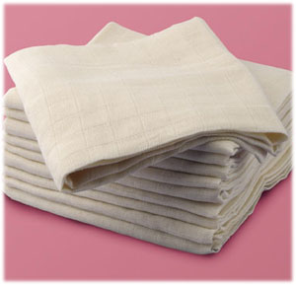 | muslin []- муслін  Cloth woven into a fine loose mesh and used to strain creamed soups and sauces so they become finer and smoother.

salad spinner []–друшляк для миття листів салату
Apparatus that uses centrifugal force to remove water from freshly washed lettuce leaves.
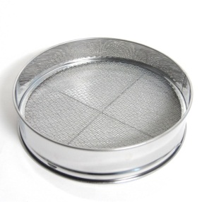 | sieve []– решето, сито  Strainer made of woven nylon, metal or silk strands and attached to a wooden frame; it is used to strain dry and liquid ingredients.
Baking untensils
Посуд для випічки
Baking: refers to the production of cakes, cookies and other usually sweet comestibles made from cooked dough, pastry or batter.

baking sheet [] - протвінь, лист для випікання
Rectangular pan with low sides, usually made of aluminum, used for baking cookies, cakes and other pastries that do not require molding.
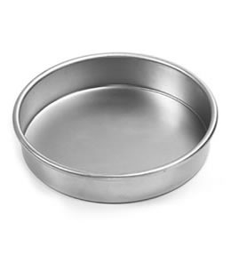 | cake pan []–сковорода чавунна  Relatively deep metal baking pan with enough room to allow the cake to rise.
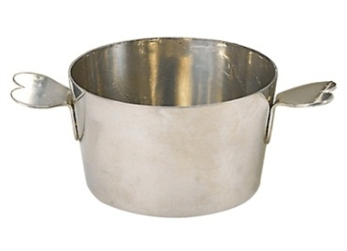 | charlottemold [] - форма для шарлотки  Deep metal pan shaped like a pail and used to cook a cream-based sweet dessert surrounded by biscuits.
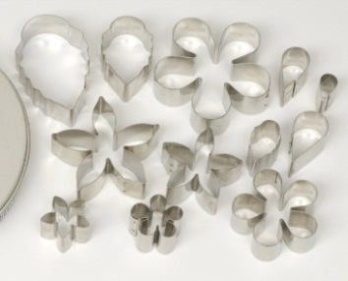 | cookie cutters []- формочки  Hollow metal molds used to cut dough into soft shapes that will be retained after baking.

dredger[] - посудина з маленькими дірочками в кришці
Container with a perforated lid used for sprinkling food with flour, sugar or grated cheese.
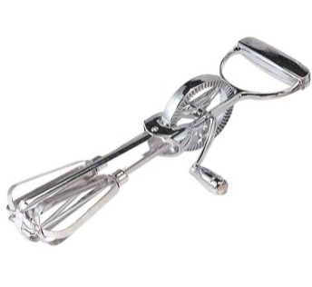 | egg beater []– міксер для збиття яєць  Mechanical device with two whisks activated by a crank handle; it is used to beat liquid and semiliquid ingredients.
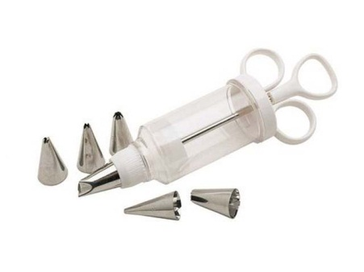 | icing syringe [] - кулінарний шприц  Fitted with interchangeable nozzles that are filled with icing, it is used to decorate baked goods and molded desserts.
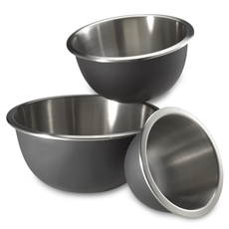 | mixing bowls [] - миски  Round containers of various sizes used to prepare or mix food and ingredients.

muffinpan [] - лист для випікання здоби
Baking pan with indentations used to give muffins their distinctive shape.

pastry bag and nozzles []– шприцювальний мішок та насадки
Leakproof bag into which interchangeable nozzles are inserted; it is used to decorate dishes, baked goods and molded desserts, or to make pastries.
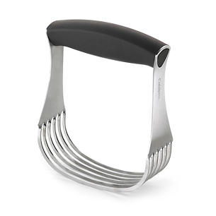 | pastryblender[]– блендер для печива  Utensil used to blend fatty ingredients with flour.

pastry brush []–щітка для смазування випечки
Device with silk or nylon bristles at one end, used to coat, brush or glaze pastries, or to grease baking pans.

pastry cutting wheel [] – колесо для різання тіста
Device used for cutting dough; the indented wheel gives it a fluted edge.

piepan[]–форма для випікання пирога
Metal pan used to make a pie crust and to bake a pie in the oven.

quicheplate[]– форма для пирога із заварним кремом, різною начинкою
Metal baking pan with a scalloped edge that makes the crust of the quiche more attractive.

removable-bottomed pan []– каструлі зі знімним дном
Metal baking pan whose bottom, and sometimes its side, come apart so the contents can be removed more easily.

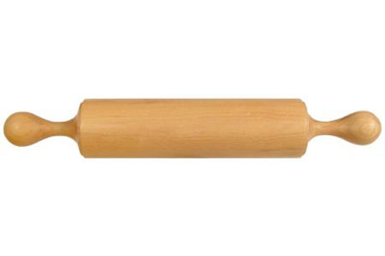 | rolling pin - качалка  Wooden cylinder that rolls freely between two lateral handles; it is used to roll out pastry.
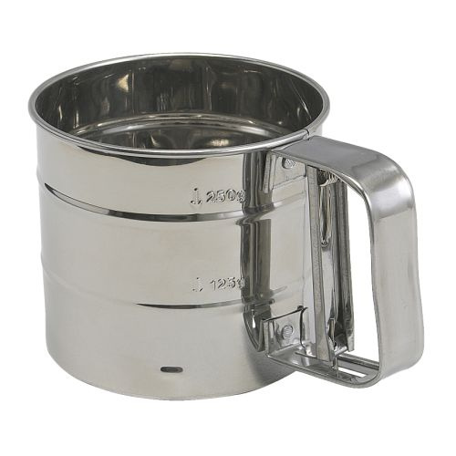 | sifter [] - сито  Device used to sieve flour; it has a spring-loaded handle that moves the flour about and makes it lighter.

soufflé dish[]– форма для суфле
Deep porcelain dish that prevents the rising soufflé from overflowing as it cooks.

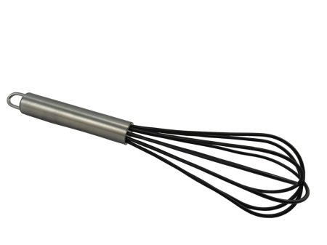 | whisk []- збивачка  Utensil made of several curved and intersecting steel wires used to blend, beat or whip liquid and semiliquid ingredients.
Miscellaneous utensils
Різний посуд

applecorer[] – машинка або ніж для видалення серцевини з плодів
Utensil used to remove the core from apples and pears.
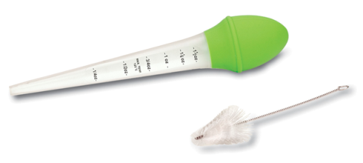 | baster [] - зметування  Utensil with a graduated tube and a rubber bulb; it is used to suck up cooking liquid and drizzle it over the meat.
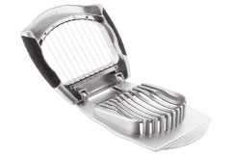 | egg slicer [] - яйцерізка  Device that uses taut steel wires to slice a hard-boiled egg.
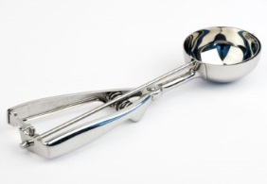 | icecreamscoop[] - совок для морозива  Spoon used to remove a serving of ice milk or ice cream from a container.

kitchen shears [] - кухонні ножиці
Multipurpose utensil used for cutting fresh herbs, trimming meat and vegetables.
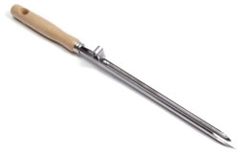 | larding needle []– шпигувальна голка  Tool used to insert strips of lard, ham or truffles into cuts of meat.
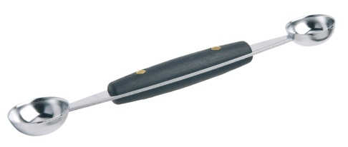 | melonballer - ложка для вирізання маленьких кругленьких частин з овочів та фруктів  Spoon used to cut small round pieces from the flesh of fruits or vegetables.
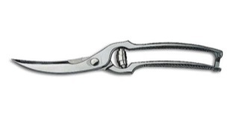 | poultry shears [] - ножицідлярозробки птаха  Utensil used to cut poultry into pieces.
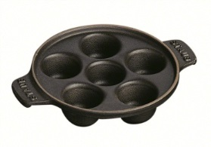 | snaildish[]–сковороди із заглибленням для жовтка  Has several indentations for holding snails when they are served.

snail tongs [] - кліщі для уліток
Utensil used to hold snail shells so the snail can be extracted.
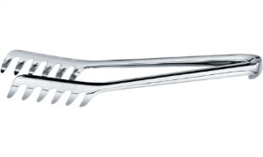 | spaghetti tongs [] - кліщі для спагетті  Two-armed utensil with teeth at the end that facilitate serving long strips of pasta.
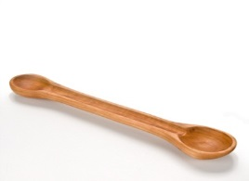 | tasting spoon []– дегустаційна ложка  Wooden spoon consisting of two bowls joined by a shallow groove used to take and taste liquids.

tea ball [] – заварювальна кулька
Hollow sphere that holds dried tea leaves during steeping.
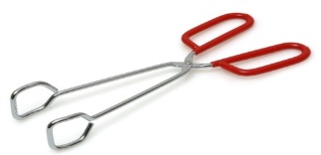 | tongs - щипці  Utensil used for holding, turning and serving food.

trussing needle[] – кухонна голка
Tool used to thread pieces of string through poultry or to tie a roast.

vegetable brush [] – щітка для овочів
Utensil used to clean certain vegetables, such as potatoes.
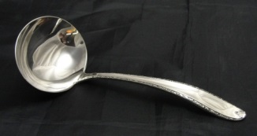 | ladle [] - черпак  Spoon with a deep bowl and a long handle; it is used to decant liquid or semiliquid food.
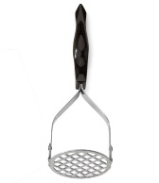 | potato masher [] - картофелемялка  Utensil used to manually purée cooked fruits and vegetables.
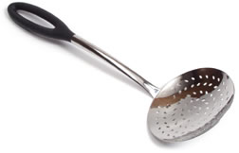 | skimmer [] – шумівка  Large round slightly concave spoon with perforations; it is used to skim broth and sauce, or to remove food from its cooking liquid.
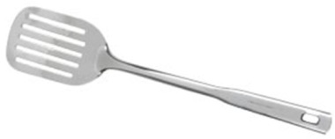 | spatula [] - лопатка  Long blade of variable width used to turn food over during cooking.

Cooking utensils
Кухонне приладдя
Utensils used for cooking food, especially in the oven or on the stove.

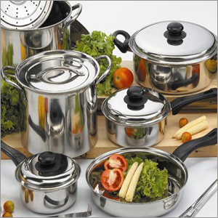

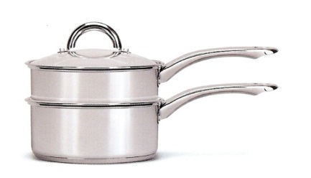 | double boiler [] - пароварка  Utensil comprising two saucepans; the bottom one contains boiling water, which cooks or heats the food in the top one.

dripping pan [] - деко
Slightly concave rectangular pan used to roast meat or to catch the meat’s cooking juices.
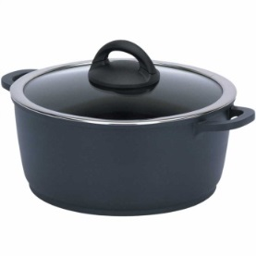 | Dutch oven [] - невелика жаровня  Somewhat deep stock pot used for cooking food in a liquid.
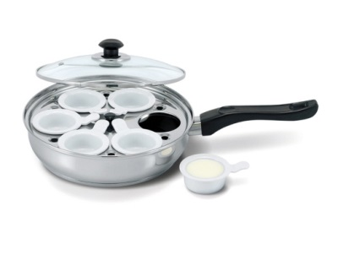 | eggpoacher []– посудина для варіння яєць-пашот  Device used to poach eggs by placing them in indentations in a tray suspended over a hot liquid.
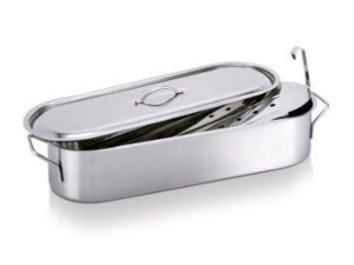 | fishpoacher[] - посудина для варіння риби в окропі  Oblong receptacle that has a rack and a cover; it is used to cook whole fish.
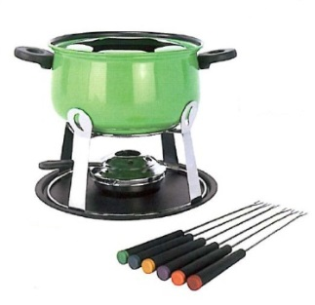 | fondueset[] - фондюшниця, каструля для приготування фондю  Utensil designed to prepare and serve various kinds of fondue, such as meat, cheese or chocolate.
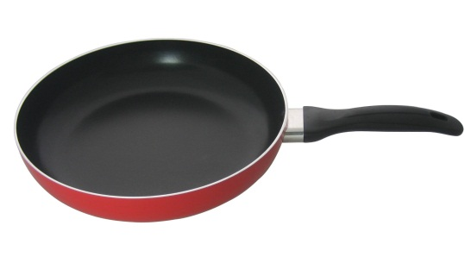 | fryingpan []– сковорода з ручкою  Utensil used to fry, sauté or brown food.
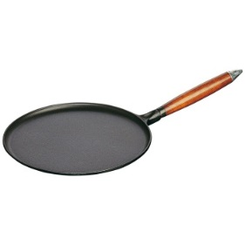 | pancakepan [] - сковорода для млинців  Round thick-bottomed skillet with a shallow edge that allows a spatula to loosen and flip the pancake.
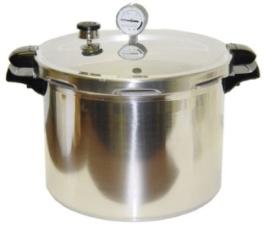 | pressurecooker[] – скороварка; варильний автоклав  Stock pot with a screw-on, airtight lid designed to cook food rapidly using pressurized steam.
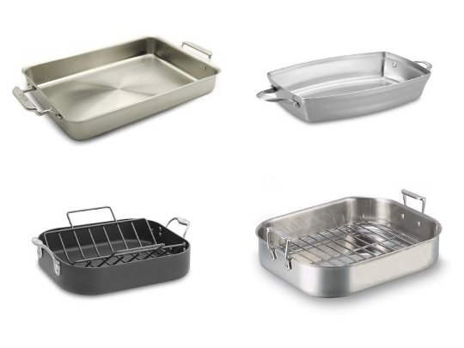 | roasting pans [] - каструлі для смаження  Somewhat deep large-capacity utensils used to roast meat in the oven.
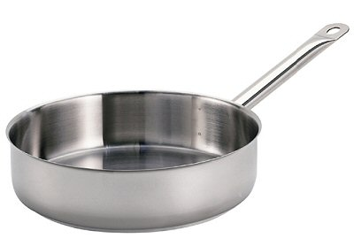 | sauté pan []- сотейник  Similar to a frying pan but with a straight edge, used to cook food in fat, over high heat.
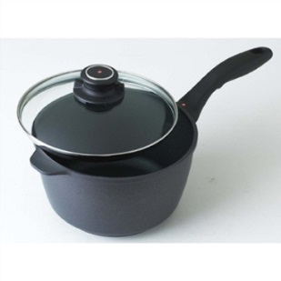 | small saucepan []– невеличка каструлька  Deeper than a frying pan, this utensil is used to simmer or braise dishes.
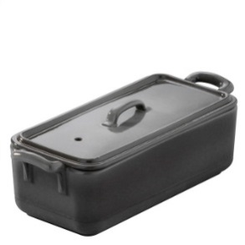 | Terrine[] - террін  Container with a perforated lid that allows steam to escape; it is designed for cooking recipes with or without jelly.
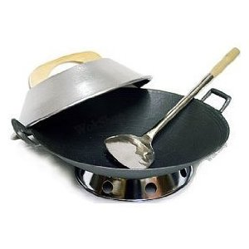 | wokset [] - казанок з опуклим дном (для блюд китайської кухні)  Cooking utensil native to Asia used for rapidly cooking food in very little fat.
Domesticappliances
Предмети домашнього вжитку
Domestic appliances operating on electricity

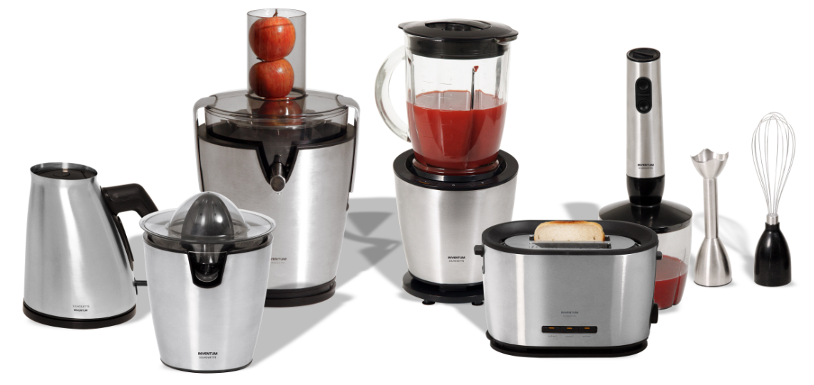

automatic drip coffee maker – автоматична кавоварка
Electric coffee maker that allows hot water to drain into a paper filter containing the ground beans, and coffee to drip into the carafe below.

blender [] - змішувач, міксер
Electric appliance comprising a motor unit with a container on top, in which raw or cooked food is mixed, crushed or puréed.

coffee mill [m] - кавомолка
Appliance that uses a rotating blade to finely grind coffee beans or other items, such as spices.

citrus juicer[] - соковижималка для цитрусових
Electric appliance designed to extract the juice from citrus fruit.

deep fryer [] - фритюрниця
Container with a heating element that raises the temperature of fat high enough to deep-fry food.

electric knife []– електричний ніж
Electric appliance with a blade that has a back-and-forth motion used to facilitate cutting a piece of meat.

electric steamer []– електрична пароварка
Electric appliance comprising two dishes resting on a water-filled base; it is used to steam food separately.

espresso coffee maker [] – кавоварка еспресо
Coffee maker that allows boiling water from the lower compartment to be forced through the ground beans into the upper compartment.

espresso machine[] – еспресо-машина
Electric coffee maker that allows hot water to be forced under pressure through the ground beans.

griddle []– електрична сковорідка
Electric appliance comprising a cooking surface and used for grilling food.

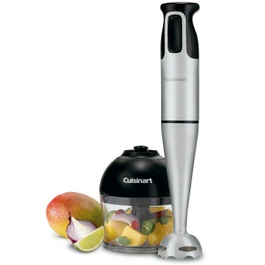 | hand blender [] - ручний блендер  Electric appliance with a handheld motor unit; less powerful than the blender, it is used for mixing liquids and grinding soft foods.

hand mixer []– ручний міксер
Electric appliance comprising two beaters and a motor unit used to beat or mix liquid or semiliquid food.

icecreamfreezer [] – морозильна камера для морозива
Appliance comprising a freezer bucket in which revolving paddles make sherbet and ice cream.

indoor electric grill []– домашній електричний рашпер
Electric appliance comprising a metal grill and a heating element used to cook food.

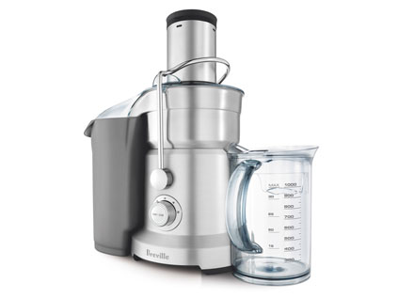 | juicer [] - соковижималка  Appliance that uses centrifugal force to extract the juice from vegetables and fruit, except citrus fruits, which must be reamed.

kettle [] - чайник

Container with a heating element used to boil water.

microwave oven ]]– мікрохвильова піч
Appliance that generates high-frequency waves to quickly heat or cook food.

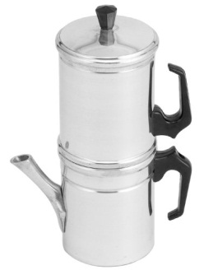 | Neapolitan coffee maker – неаполітанська кавоварка  Coffee maker that is placed on a heat source to boil the water; it is then turned over so the boiling water filters through the ground beans into the serving compartment.
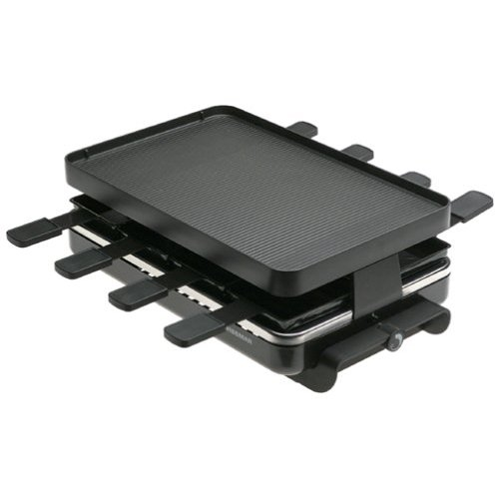 | raclette with grill – раклет з грилем  Appliance with covered heating elements used to melt cheese or grill meat and side vegetables.
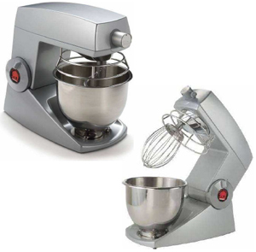 | table mixer []– настільний міксер  Electric appliance comprising a powerful motor unit, two beaters and a stand used to beat or mix liquid or semiliquid foods.

toaster []- тостер
Appliance with heating elements that toast slices of bread.

vacuum coffee maker[] – електрична кавоварка
Coffee maker that brews coffee by causing the water to pass through the ground beans twice.
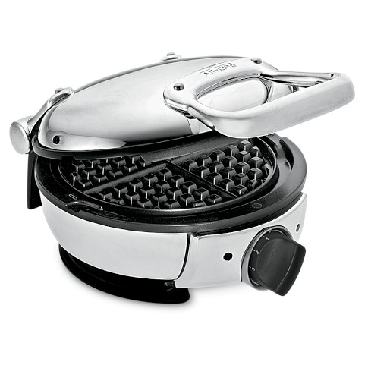 | waffle iron []- вафельниця  Appliance comprising two indented plates, each one covering a heating element; it is used to cook waffles or grill food.

Алфавітний покажчик

A

abalone [] – морське вушко

acorn squash [] - гарбуз великий столовий

adzuki bean [] - квасоля адзукі

Alfalfa [] - люцерна

all-purpose flour [] - борошно

allspice [] - перець гвоздичний

almond [] - мигдаль

Alsace glass [] – келих Ельзас

amaranth [] - щириця

American bacon [] – американський бекон

American corn bread [] – американський кукурудзяний хліб

American mustard []– американська гірчиця

anchovy []– анчоус, хамса, кілька

anise [] - аганус

apple [] - яблуко

apple cider vinegar []– яблучний оцет

apple corer [] – машинка або ніж для видалення серцевини з плодів

apricot [] - абрикос

Asian pear [] - Азіатська груша

asparagus [] – спаржа

Atlantic cod [] – атлантична тріска

Atlantic salmon [] – атлантична сьомга

autumn squash []- гарбуз

avocado [] - авакадо

automatic drip coffee maker – автоматична кавоварка

B

back ribs []- ребра

bagel - бублик

baguette [] – довгий французький хліб

baking sheet [] - протвінь, лист для випікання

balsamic vinegar [] – бальзамічний оцет

bamboo shoot [] – бамбук

banana [] - банан

barley [] - ячмінь

basil []- волошка

bass [] - окунь

basmati rice [] – рис басматі

baster [] - зметування

bean thread cellophane noodles [] – бобова тонка локшина

beechnut [] - буковий горіх

beef cubes [] – яловичина шматками

beer mug [] – пивний кухоль

bergamot [] - бергамот

black bean [] - квасоля чорна

blackberry [] - ожина

black currant [] - чорна смородина

black gram [] – чорний дрібний турецький горошок

black-eyed pea [] - чорноокий горох

black mustard [] - чорна гірчиця

black pepper [] - чорний перець

black rye bread [] – чорний житній хліб

black pollock [] – чорна сайда

black tea [] – чорний чай

blender [] - змішувач, міксер

blood sausage [] – кров’яна ковбаса

blue mussel []– блакитна двостулкова молюска

borage []- огірочник

bordeaux glass [] – келих бордо

blueberry [] - чорниця

bluefish [] – блакитна риба

bok choy - китайська капуста

boning knife [] – ніж для кісток

brains [] - мозок

brandysnifter []-келих, звужений догори (для коньяку)

Brazil nut [] - бразильський горіх

bread and butter plate []– тарілка для хліба з маслом

bread knife [] – ніж для хліба

Brie [] - брі

broad beans [] – кормові боби

brook trout []- голець

brown rice []- лущений рис

brown sugar [] - коричневий цукор

Brussels sprouts [] - Брюссельська капуста

buckwheat [] - гречка

burdock [] - лопух

burgundyglass []– келих для червоного вина

butter [] - масло

butter curler [] – ніж для масла

butter dish [] - маслянка

buttermilk [] – сколотини, маслянка

C
cake pan [] – сковорода чавунна
Canadian bacon []– канадський бекон

canary melon []–диня кенери

can opener [] – консервний ніж

Camembert []– сир «камамбер»

candy thermometer [] – термометр для варіння льодяників

cannelloni []- трубочки

cantaloupe [] - мускусна диня

capon [] - каплун

carambola - карамбола

caraway [] - кмин

cardamom [] –кардамон

carp [] - короп

carrot []– морква

carving fork [] – виделка для різьби

carving knife [] – ніж для нарізування м’яса

casaba melon [] – зимова диня

сashew [] - горіх кеш'ю cassava [] – маніока

cuttlefish [] - каракатиця

cayenne chile [] - перець стручковий кайєнський

celeriac [] - корінь селери

celery [] - селера

celery cabbage [] - пекінська капуста

celtuce - гібридселерита салату

chamomile [] – ромашка

champagne flute [] – келих для шампанського

chanterelle [] – лисичка справжня

charlotte mold [] - форма для шарлотки

chayote - чаоте

cherimoya - черімойя

cherry [] - вишня

chervil []- кервель

chestnut [] – каштан

chicken [] - курча

chick peas [s] - горох

chili powder [] - мелений перець

chinois – сито конічне

chipolata sausage [] – свинячі сардельки

chive [] - шніт-цибуля

chop [] – кусок м’яса

chorizo [] – чорізо, іспанська сирокопчена ковбаса

cinnamon [] – кориця

citron [] – цитрон

citrus juicer [] - соковижималка для цитрусових

clam [] – клем, їстівний морський молюск

cleaver [] – сокира м’ясника

coarse salt [] – сіль

cockle [] – черепашка молюска

cocoa [] - какао

coconut [] – кокос

cocktail glass [] - келих для коктейлю

coffee mill [m] - кавомолка

coffee mug [] – чашка для кави

cola nut [] - горіх кола

colander [] - друшляк

collards - капуста

common periwinkle [] – береговий равлик

common plaice [] – камбала європейська

conchiglie – мушлі

cooked ham []- шинка

cookie cutters [] - формочки

cook’s knife [] – ніж кухаря

coriander []- коріандр

corn [] - кукурудза

corn flour []– кукурудзяне борошно

corn oil []– кукурудзяна олія

corn syrup []– кукурудзяний сироп

cottage cheese []– сир «котедж», домашній сир

Coulommiers - Куломьер

couscous [] – кускус

crab [] - краб

cracked rye bread []– тріснутий житній хліб

crayfish [] – річковий рак

cream cheese [] – вершковий сир

creamer [] – глечичок для вершків; сметаник

croissant []- рогалик

crookneck squash []- неправильний гарбуз

crosne –кросне

crushed chiles []- мелиний чілі

cucumber [] - огірок

cultivated mushroom[] - печериці

cumin []- кмин

cup [] - чашка

cupped Pacific oyster [] - чашоподібна тихоокеанська устриця

curled kale [] – капуста кормова

currant [] - смородина

currant tomato [] – смородинові помідори

сurry [] – каррі

cutting board [] – обробна дошка

D
daikon – дайкон
Danish Blue [] – датський голубий сир
Danish rye bread [] – датський житній хліб
dark chocolate [] - чорний шоколад
date [] – фінік
decanter [] – графин
deep fryer [] - фритюрниця
delicious lactarius [] - смачні груздіdessert fork [] – десертна виделка dessert knife [] – ніж для десерту
dessert spoon [] – десертна ложка
Dijon mustard [] – гірчиця піжонська
dill []- кріп
dinner fork [] – обіднявиделка
dinner knife [] – столовий ніжdinner plate [] – тарілка для обідуditali – ріжки деталі
double boiler [] - пароваркаdredger[] - посудина з маленькими дірочками в кришці
dried chiles []– сушений чілі
dripping pan [] – деко
duck [] – качка
duck egg [] – качине яйцеdurian – дурман
Dutch oven [] - невелика жаровня

E
ear loaf []– колосиста буханка хліба
edible boletus [] - білий гриб
eel [] – вугор
egg beater [] – міксер для збиття яєць
egg noodles []– яєчна локшина egg timer [] - трихвилинний пісочний годинник
eggplant []–баклажан
egg poacher [] – посудина для варіння яєць-пашот
electric knife [] – електричний ніж
electric steamer []– електрична пароварка
elbows [] – ріжки штопорEmmenthal - Емментальenoki mushroom []- гриб енокі
English loaf [] – англійська буханка хліба
English mustard [] – англійська гірчиця
escarole [] –ескаріоль
espresso coffee maker [] – кавоварка еспресо
espresso machine [] – еспресо-машина
evaporated milk [] – згущене молоко

F
farmhouse bread [] – фермовий хліб, домашній хліб
feijoa - фейхоа

fennel[] - кріп

fenugreek [] – гуньба

fettucine - феттучини

fiddlehead fern [] – паростки папороті

fig [] – інжир

filleting knife [] – ніж для філе

fish fork [] – виделка для риби

fishknife []– столовий ніж для риби

fishplatter []– велике плоске блюдо під рибу

fish poacher [] - посудина для варіння риби в окропі

five spice powder [] – п’ять мелених спецій

flageolet []– флажолет

flat oyster []– гладка устриця

foie gras – паштет з гусячої печінки

fondue fork [] – вилка фондю

fondueset[] - фондюшниця, каструля для приготування фондю

frankfurter [] - сосиска

French bread [] - батон

frybasket [] - корзина для смаження

fryingpan []– сковорода з ручкою

funnel [] – лійка

fusilli - фузіллі

G
garlic []–часник
garlic press [] – прес для часнику
Genoa salami [] - салямі
German mustard [] - німецька гірчиця
German rye bread [] – німецький житній хліб
German salami [] – німецька салямі
ghee []– перетоплене рідке масло
gherkin [] – корнішон
ginger [] - імбир
ginkgo nut [] - гінкго гайки
gnocchi – ньокки
goatfish - барабулька
goat’s milk [] – козине молоко
goose [] – гуска
goose egg []– гусине яйце
Gorgonzola []– сир горгонзола (сорт овечого сиру)
granulated sugar [] – гранульований цукор
grape [] – виноград
grapefruit [] – грейпфрут
grapefruit knife – ніж для грейфрукта
grater [] - терка
gravy boat [] - соусник
great scallop [] - гребінець
Greek bread []- грецький хліб
green bean [] - зелена квасоля
green cabbage [] – капустабілокачанна
green coffee beans [] - зелена кава в зернах
green onion [] - зелена цибуля
green peas [s] - зелений горох
green pepper [] – зелений перець green sweet pepper [] - зелений солодкий перець
green tea [] – зелений чай
griddle [] – електрична сковорідка
ground beef [] – фарш з яловичини
ground lamb [] – фарш з баранини
ground pepper [] – мелений перець
ground pork [] – фарш з свинини
ground veal [] – фарш з телятини
Gruyère - грюйер
guava [] –гунява
guinea fowl []- цесарка
gurnard [] – морський півень

H
haddock [] – морський окунь
halibut [] – палтус
ham knife [] – ніж для шинки
hand blender [] - ручний блендер
hand mixer []– ручний міксер
hard-shell clam []– венерка (їстівний молюск)
hare [] - заєць
hazelnut [] - лісовий горіх
heart [] – серце
hen egg []– курине яйце
herring [] – оселедець
highball glass [] - хайбол
hock []- окіст
homogenized milk [] – гомогенізоване молоко
honey [] - мед
honeydew melon [] - нектарна диня
horned melon [] - рогата диня
hors d’oeuvre dish – блюдо під закуски
horseradish [] - хрін

hot pepper [] - гострий перець

hummus [] – пюре з нуту

hyssop []- гісоп

I

iceberg lettuce [] – качанний салат

icecreamfreezer [] – морозильна камера для морозива

ice cream scoop [] - совок для морозива

icing syringe [] - кулінарний шприц

Indian chapati bread [] – індійський хліб

Indian naan bread [[]]- маїсовий хліб

indoor electric grill [] – домашній електричний рашпер

instant-read thermometer [] – миттєвий термометр

Irish bread [] – ірландський хліб

J
jackfruit []– джекфрут
jalapeño chile [] – японський чілі
Japanese persimmon [] - Японська хурма
Japanese plum [] - японська слива

Jerusalem artichoke []– топінамбур

Jewish challah [] – єврейська хала

John dory [] - сонцевик

jicama – хікама

juicer []– соковижималка

juniper berry [] - яловець

K
ketchup []– кетчуп
kettle [] - чайник
kielbasa sausage [] – ковбаса
kidney [] - нирка
kitchen scale [] – кухонні ваги
kitchen shears [] - кухонні ножиці
kitchen timer [] – кухонний таймер
kiwi [] - ківі

kohlrabi [] – кольрабі

kumquat [] - кумкват

L
lablab bean [] – індійський біб
lamb cubes [] – шматки баранини
lamprey [] - мінога
lard [] – топлений свинячий жир
larding needle [] – шпигувальна голка
larger spotted dogfish [] – велика плямиста минь
lasagna - лазанья
leek [] - цибуля-порей
lemon [] - лимон
lentils [s] - сочевиця
lettuce [] – салат-латук
lever corkscrew [] - штопор

Lima bean [] - квасоля ліма

lime []– лайм

limpet []- блюдечко

linden [] – липа

liqueur glass [] - чарочка

litchi [] – лічі, нефеліум

liver [] – печінка, лівер

lobster [] – омар

loin chop [] – порціоний шматок м’яса

longan - лонган

lovage [] - любисток лікарський

M
macadamia nut [] - горіх макадамі
mackerel [] - скумбрія

malanga – маланга

malt vinegar [] – солодовий оцет

mandarin [] – мандарин

mandoline [] - мандоліна

mango [] – манго

mango chutney []– чатні мангове

mangosteen [] – мангостан

maple syrup [] - кленовий сироп

margarine [] - маргарин

marinade spices [] – спеції для маринаду

marrow [] – кістковий мозок

measuring cup [] – мірний стаканчик

measuring cups [] – мірні стаканчики

measuring beaker [] - вимірювальнний стакан

measuring spoons [] – мірні ложки

meat grinder [] - м’ясорубка

meat thermometer [] – термометр для м’яса

melonballer - ложка для вирізання маленьких кругленьких частин з овочів та фруктів

merguez sausage [] – ковбаски мерлуз

mesh strainer [] - сітчастий фільтр

microwave oven ]]– мікрохвильова піч

mint – м’ята

milk chocolate [] - молочний шоколад

millet – просо

mixing bowls [] - миски

molasses [] – меласа, чорна патока

monkfish [] – морський ангел

morel []– зморшки

mortadella - мортаделлу

mortar [] – ступка, ступа

mozzarella – моцарелла

muffin pan [] - лист для випікання здоби

mullet []- кефаль

multigrain bread [] – багато зерновий хліб

mung bean [] – квасоля маша

Munster - Мюнсте

muslin [] - муслін

N
Neapolitan coffee maker – неаполітанська кавоварка

nectarine []– нектарин

nutcracker [] – щипці для горіхів

nutmeg [] – мускатний горіх

nutmeggrater[] – терка для мускатних горіхів

O
oat flour [] - вівсяне борошно
oats [] – овес
octopus [] – восьминіг, спрут

Ogen melon [] – диня Оген

okra [] – окра

old-fashioned glass [] – «старомодний»

olive [] – оливка

oolong tea [] – чай улунг

oregano []- ореган

ornamental kale [] - декоративна капуста
ostrich egg [] – страусине яйце
oven thermometer [] - термометр печі
oyster fork [] – виделка для устриці
oyster knife [] – ніж для розкриття устричних черепашок

oyster mushroom []– гливи

P

Pacific salmon [] – тихоокеанська лосось

pancakepan [] - сковорода для млинців

pancetta - панчетта
papaya []– папайя
рaprika [] – перець стручковий або червоний
parboiled rice [] – пропарений рис

paring knife []– ніж для очищення овочів

Parmesan [] - сир пармезан

parsley []- петрушка
parsnip []– пастернак
passion fruit [[]] - маракуя

pastamaker[]– машина для вироблення макаронних виробів

pastry bag and nozzles [] – шприцювальний мішок та насадки

pastry blender []– блендер для печива

pastry brush [] – щітка для смазування випечки

pastry cutting wheel [] – колесо для різання тіста
pattypan squash []– патисон
peach [] - персик
рeanut [] – арахіс

peanut oil [] - арахісове масло
pear [] - груша
pearl onion [] – біла цибуля
pecan nut [] – горіх-пекан

peeler[] – машина для очищення від шкурки або шкірочки

penne - пенне

pepper shaker [] - перечниця
pepino [] –пепіно
perch [] - окунь

pheasant [] - фазан

pheasant egg []– фазанове яйце phyllo dough [] - тісто філо

piepan[] – форма для випікання пирога

pigeon [] - голуб

pike [] - щука
pineapple [] – ананас
pink pepper [] – рожевий перець
pinto bean [] - квасоля пінто
pistachio nut [] - фісташковий горіх

pita bread [] - лаваш

platter [] - блюдо
plum []– слива

plum sauce []– сливовий соус
pomegranate [] - гранат
pomelo [] – помело
poppy seeds []- мак

port glass [] – чарка для портвейну

potato [] –картопля

poultry shears [] - ножицідлярозробки птаха

powdered milk [] - сухе молоко

powdered mustard []– гірчичний порошок

powdered sugar []– цукрова пудра

pressurecooker[] – скороварка; варильний автоклав

prickly pear [] - опунція

prosciutto [] – гостра копчена шинка

pumpkin [] - гарбуз

Q

quail [] - перепел

quail egg []– перепилине яйце

quicheplate []– форма для пирога із заварним кремом, різною начинкою

quince [] - айва

quinoa [] - лобода, квінова

R

rabbit [] - кролик

raclette with grill – раклет з грилем

radicchio - радіккіо

radish [] - редіс

rambutan [] - нефеліум

ramekin []– порціонний горщичок або порціонна формочка

raspberry [] - малина

ravioli [] - равіолі

razor clam []- бритва малюск

red cabbage [] - капуста червонокачанна

red kidney bean [] - червона квасоля

red onion []- червона цибуля

red sweet pepper [] - червоний солодкий перець

red whortleberry [] - брусниця

redfish [] – червона нерка; морський окунь

removable-bottomed pan []– каструлі зі знімним дном

rhubarb [] - ревінь

rib roast [] - ребро

rice [] - рис

rice noodles [] - рисова локшина

rice papers [] – рисовий папір

rice vinegar []– рисовий оцет

rice vermicelli [] - рисова вермішель

rigatoni - ріжки

rimsoupbowl []– тарілка для супа

roast []– кусок м’яса для смаження

roasted coffee beans [] – смажені кавові зерна

rock candy [] - льодяники

roasting pans [] - каструлі для смаження

rolling pin - качалка

roman bean [] – квасоля римська

Romano - Романо

romaine lettuce [] – салат ромен

Roquefort []- рокфор (сорт сиру)

rosemary [] - розмарин

rotary cheese grater [] – терка для сиру

rotini – ріжки рифлені

royal agaric [] - королевський гриб

Russian pumpernickel [] - російський хліб з грубого не просіяного житнього борошна

rutabaga []– бруква

rye [] - жито

S

sage []- шавлія

salad plate [] – тарілочка для салату

salad spinner [] – друшляк для миття листів салату

salsify [] - козельці

salt shaker [] - сільниця

saffron []- шафран

sapodilla - саподілла

sardine [] - сардина

sauté pan [] - сотейник

savory [] - чабер

savoy cabbage [] - савойська капуста

scallion[]- цибуля-шалот

scampi [] - креветки

Scandinavian cracked bread [

] – скандинавський тріснутий хліб

scarlet runner bean [] – квасоля вогненна

sea bass []– морський окунь

sea bream [] – морський лящ

sea salt [] – морська сіль

seedless cucumber [] - огірки без насіння

semolina [] – манна крупа

sesame oil []– кунжутове масло

shad [] - алоза

shallot []- цибуля-шалот

shank [] - гомілка

sharpening steel [] - мусат

sharpening stone [] - абразивний брусок

shortening [] - шортенинг

shiitake mushroom [] - шиитаке

shrimp [] – дрібна креветка

sieve [] – решето, сито

sifter [] - сито skate [] - скат

small decanter [] – маленький графин

small saucepan []– невеличка каструлька

smelt [] - корюшка

smoked ham [] - капчена шинка smooth hound [] – щогловий бугель, чикс (щогли)

snail [] - равлик

snaildish []– сковороди із заглибленням для жовтка

snail tongs [] - кліщі для уліток

soba noodles [] – локшина соба

soft-shell clam [] – молюски з м’якю оболонкою

sole [] - камбала

somen noodles [] – локшина сомен

soufflé dish []– форма для суфле

soup bowl [] - миска

soup spoon [] – столова ложка

sour cream []- сметана

soybeans [] - соя

soybean sprouts [] - соєві паростки

soy sauce []– соєвий соус

spaghetti [] - спагетті

spaghettini – шпагеттіні

spaghetti squash [] – спагеті гарбуз

spaghetti tongs [] - кліщі для спагетті spareribs [] – свинячі порібнини

sparkling wine glass [[]] – келих для ігристого вина

spelt wheat [] - пшениця спельта

spinach tagliatelle – шпинат тальятелле

spiny lobster [] - лангуст

split peas [s] – лущений горох

squid [] - кальмар

steak [] - біфштекс

Stilton [] – стилтон (сорт, жирного сиру)

straightneck squash [] – прямий гарбуз

strawberry [] - полуниця

sturgeon [] - осетер

sugar bowl [] - цукорниця

sumac []- сумах

summer squash []- літній гарбуз

sundae spoon []- ложка для морозива

sunflower-seed oil []– соняшникова олія

sweet bay [[] – лавр благородний

sweetbreads []– «солодке м'ясо» (зобна е підшлункова залоза)

sweet potato [] - солодка картопля

Swiss chard [] – Мангольд, листовий буряк

swordfish [] – меч-риба

T

Tabasco® sauce [] - гостра перцева приправа

table mixer [] – настільний міксер

table salt [] - столова сіль

tablespoon [ˈteɪblspuːn] - столова ложка; салатна ложка; мірна ложка

tahini - тахині

tamarillo [] - тамарілло

tamarind paste []– індійська паста

tarragon [] – полинь естрагон

taro []- таро

tasting spoon [] – дегустаційна ложка

tea bag [] – чайний пакетик

tea ball [] – заварювальна кулька

teapot [] – чайник (для заварки)

teaspoon [] – чайна ложка

tenderloin roast []- вирізка

Terrine [] - террін

thyme - чебрець

toaster [] - тостер

tomatillo - томата

tomato [] - помідор

tomato coulis []– томатний соус

tomato paste []– томатна паста

tongue [] - язик

tongs - щипці

tortilla [] – плоский маїсовий коржик

tortellini [] - пельмені

tripe [] – рубець (частина шлунку жуйної тварини)

triticale [] - тритікале

trout [] - форель

truffle [] - трюфель

trussing needle [] – кухонна голка

tuna [] - тунець

turbot [] – білокорий палтус

turkey [] - індичка

turnip [] - ріпа

turmeric []– куркума

U

udon noodles [] – локшина удон

unbleached flour []- небілене борошно

unleavened bread [] – прісний хліб

V

vacuum coffee maker [] – електрична кавоварка

vanilla extract []– ванільний екстракт

vegetable bowl [] – миска для овочів

vegetable brush [] – щітка для овочів

verbena [] - вербена
W

waffle iron [] - вафельниця

walnut - волоський горіх

wasabi - васабі

water goblet [] – келих для води

watermelon [] - кавун

wax bean [] – воскова квасоля

wax gourd [] – восково-пляшковий гарбуз

wheat [] - пшениця

whipping cream [] – вершки для збивання

white bread [] – білий хліб

white chocolate [] – білий шоколад

white onion [] - біла цибуля

white mustard []– біла гірчиця

white pepper [] – білий перець

white rice [] - шліфований рис

white wine glass [] – келих для білого вина

whiting [] – хек, срібляста мерлуза,

мерланг

whisk []- збивачка

wholegrain mustard [] - цільнозернова гірчиця

wholemeal bread [] – хліб з не просіяної муки

whole-wheat flour [] - пшеничне борошно

wild rice [] – канадський рис

wine vinegar []– виноградний оцет

wine waiter corkscrew[] – штопор сомельє

wok set [] - казанок з опуклим дном (для блюд китайської кухні)

won ton skins – виграв шкури тонну

wood ear [] - вухо дерева

Worcestershire sauce []– гостра соєва приправа
Y

yam - ямс

yard-long bean [] - довга квасоля

yellow onion [] - жовта цибуля

yellow sweet pepper [] -жовтий солодкий перець

yogurt [] - йогурт
Z

zester - зестер

zucchini - цукіні

Додатки

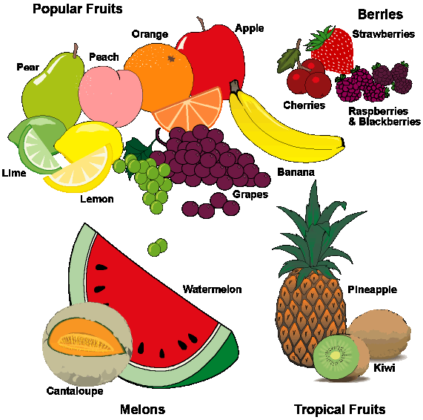

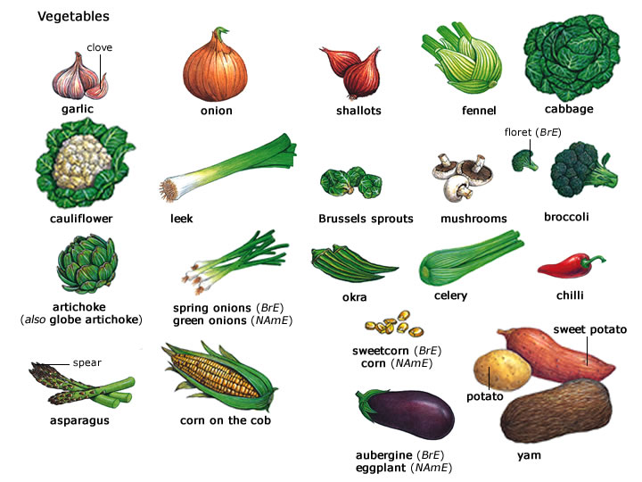
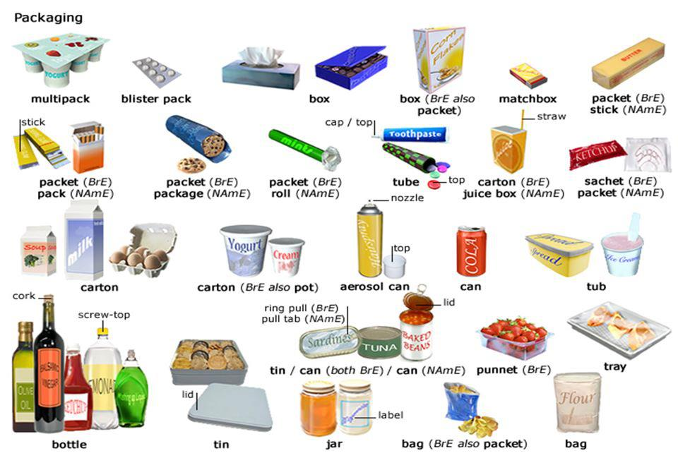
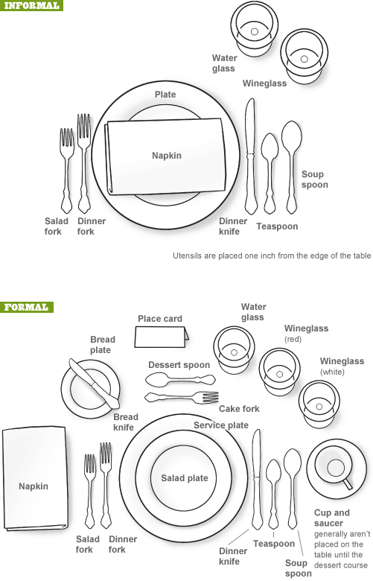
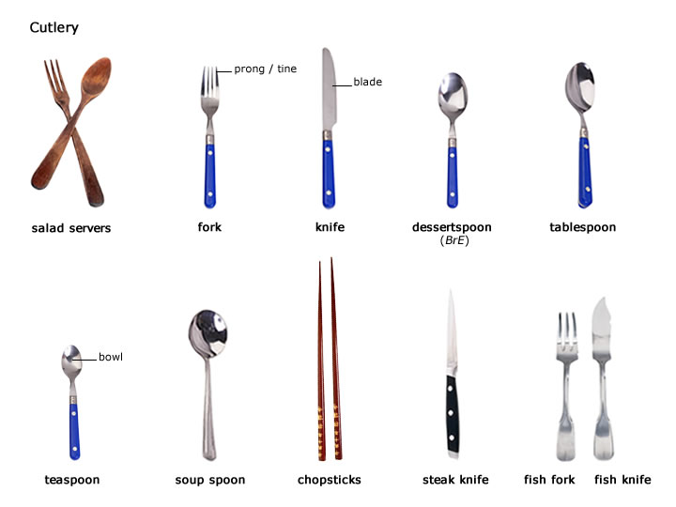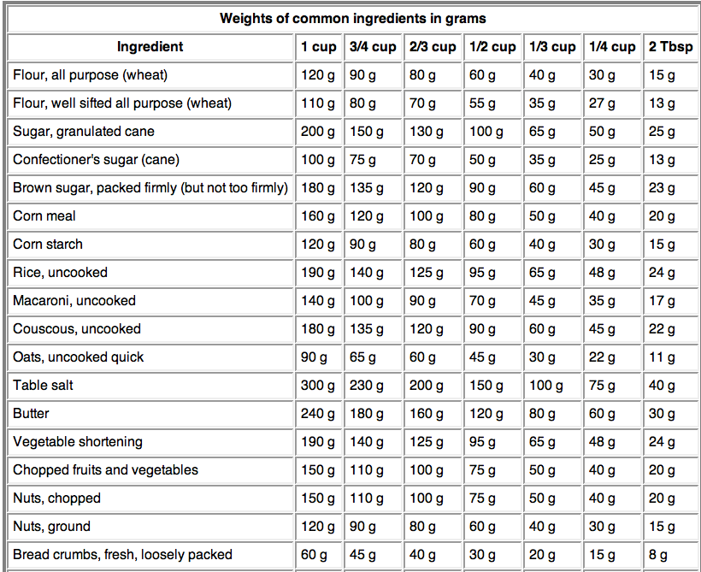

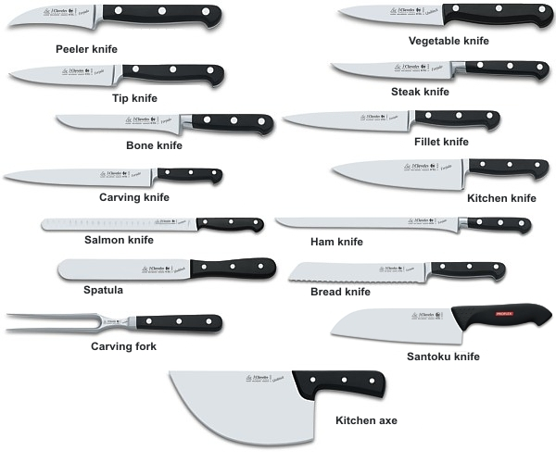

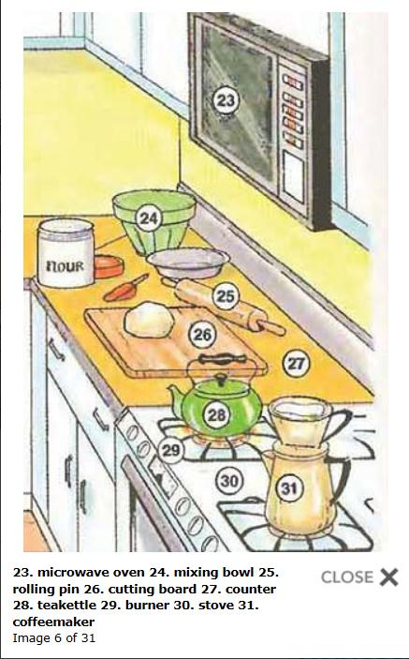

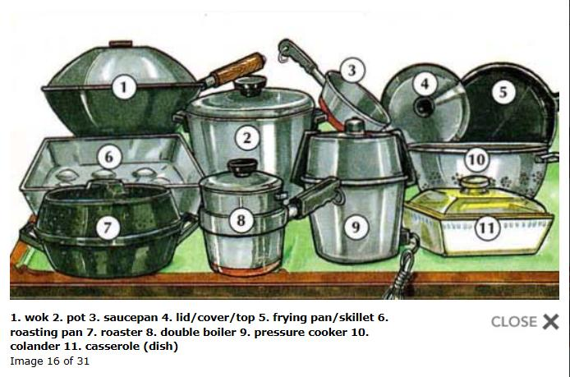
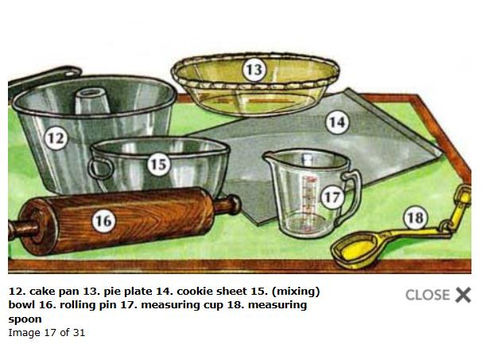
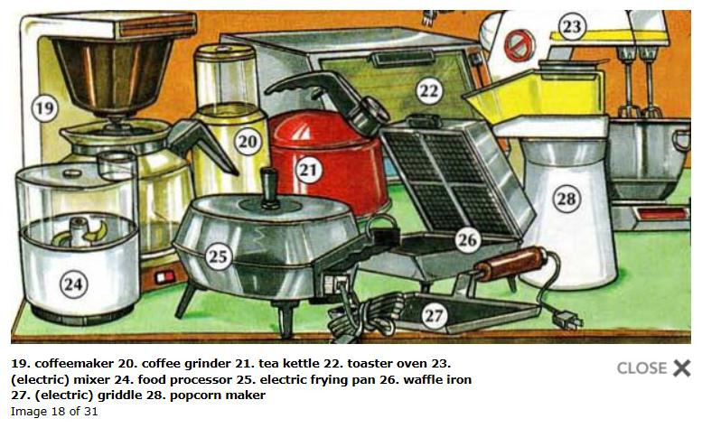
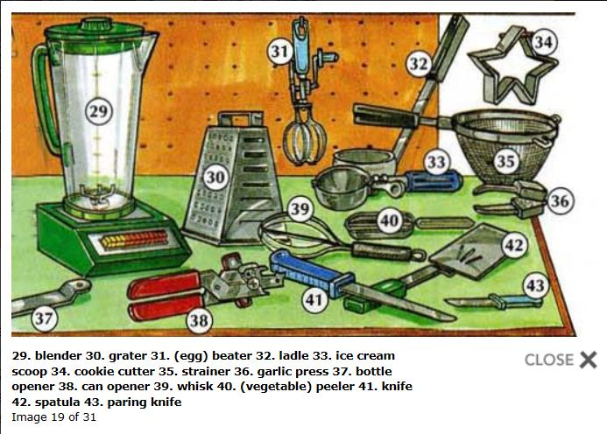

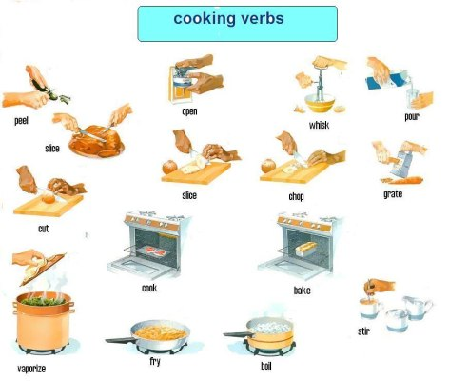

Використана література

http://www.thefreedictionary.com
http://englishwilleasy.com/english-through-pictures/place-english-through-pictures/kitchen-area/
http://ru.freepik.com/free-photos-vectors/fruits
http://www.ikonet.com/en/visualdictionary/food-and-kitchen/kitchen/kitchen-utensils/miscellaneous-utensils.php
http://visual.merriam-webster.com/food-kitchen.php
http://www.infovisual.info/01/051_en.html
http://www.bildwoerterbuch.com/en/food-and-kitchen/food/
http://dictionary.cambridge.org/
http://lingvopro.abbyyonline.com/en
http://dictionary.reference.com/browse/chameleon
http://oald8.oxfordlearnersdictionaries.com/dictionary/tablespoon
http://www.fruitsinfo.com/spring-fruits.html#api
http://englishwell.info/english-lessons/
http://forum.say7.info/topic6024.html

